TOPIC 1: THERMAL EXPANSION
Expansion is the increase in size on heating of a substance.
Contraction is the decrease in size on cooling of a substance.
Temperature is the degree of coldness or hotness of a body. Temperature is a measure of the average kinetic energy of the molecules of a substance. The SI unit of temperature is Kelvin (K). However, the commonly used unit for measuring temperature is degree Celsius$\left(℃\right)$.
Differences between heat and temperature
- Heat is a form of energy which passes from a body of high temperature to a body of low temperature. The SI unit of heat is Joule (J).
- Temperature is the degree of hotness or coldness of a body. Or temperature is a measure of the heat energy of the molecules in a body.
THERMAL EXPANSION IN SOLIDS, LIQUIDS AND GASES
- Thermal expansion in solids.
Activity
- In groups of four carry out the ball and ring experiment in the science laboratory. Have the ball pass through the ring while cold and then while hot. What do you notice?
- When cold the ball is expected to pass through the ring easily. When heated, the ball is expected not to pass through the ring.
- We conclude that heating must have increased the diameter of the ball such that it could not fit through the ring. On cooling, its size reduces and it now could fit.
Particle Behavior during Thermal Expansion in Solids
When a solid is heated the molecules vibrate with larger amplitude about their fixed positions. This makes them to collide with each other with larger forces which push them far apart. The distance between the molecules increases and so the solid expands.
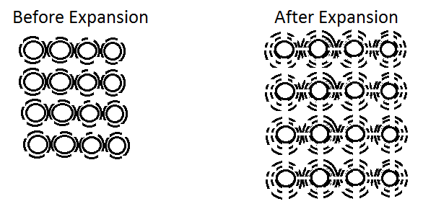
- Thermal expansion in liquids.
Liquids expand more than solids for the same amount of heat applied because liquid have relatively weaker intermolecular forces than solid.
Experiment
Aim: to demonstrate thermal expansion in liquids.
Apparatus: water bath, paraffin, alcohol, heater, water, similar test tubes with fitted similar capillary tubes through the corks.
Procedure
- Label the three test tubes as A, B, and C; and fill them with alcohol, paraffin, and water respectively.
- Cork the test tubes and put them in water bath as shown in the figure below.
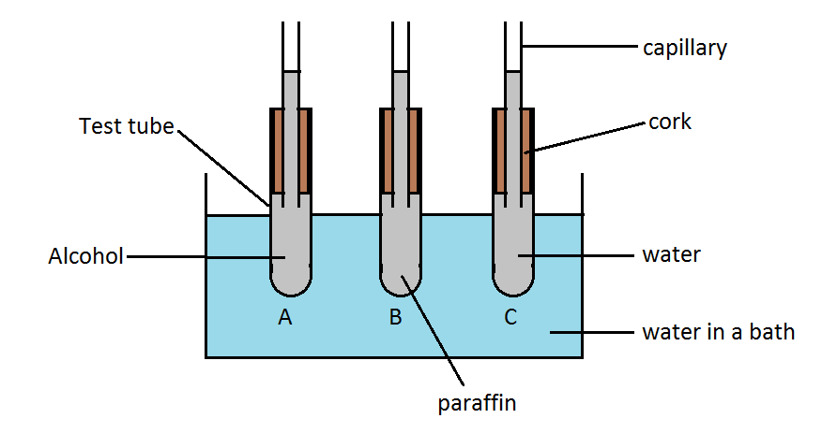
- Heat some water to a boiling point using the heater in a separate bath and place it in a water bath.
- Tie the three test tubes A, B and C together and place them inside the water bath while stirring the hot water to ensure even distribution of heat in contact with tube A, B and C.
- Observe the level of the liquids in the test tubes after 3 minutes.
Expected Results
- The level of the liquids in the three test tubes falls slightly at first then start rising again up the capillary tubes after sometime.
- Alcohol rises to the highest level in the capillary tube followed by paraffin then water as shown in the figure below.
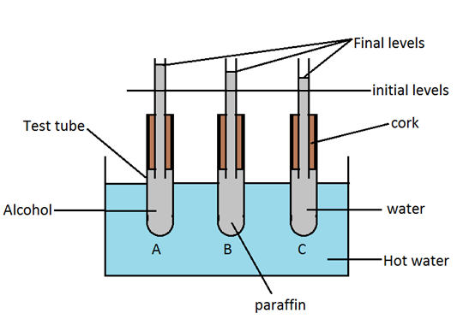
Discussion
- Heat from the water bath reaches the test tubes first making them to expand and increase in volume hence the liquid levels fall.
- After sometime, the heat reaches the liquids and they start expanding.
- Alcohol expands more than paraffin, while paraffin expands more than water.
Conclusion
Liquids expand on heating and contract on cooling.
Explanation of thermal expansion in liquids in terms of particle behavior
Liquid molecules are loosely packed and more freely than solids. The force of attraction between their molecules is weaker than in solids. On heating, the speed of the molecules increases in liquids. The collisions between the molecules increases the distance between them causing the liquid to expand i.e. increase its volume.
- Thermal expansion and contraction of gases.
Gases expand more than liquids and solids for the same amount of heat applied because molecules of gas move furthest on heating.
Experiment
Aim: to demonstrate expansion in gases.
Apparatus: a thin glass flask, a rubber stopper, a long narrow glass tube and a balloon.
Procedure
- Take a thin glass flask and the balloon tied on it as shown in the figure below. Immense them in the water bath as shown below.
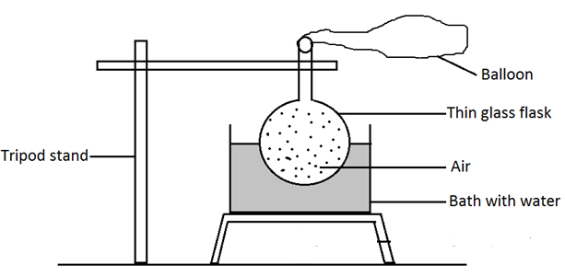
- Heat the apparatus placed on the tripod stand as shown in the figure below and observe what happens?
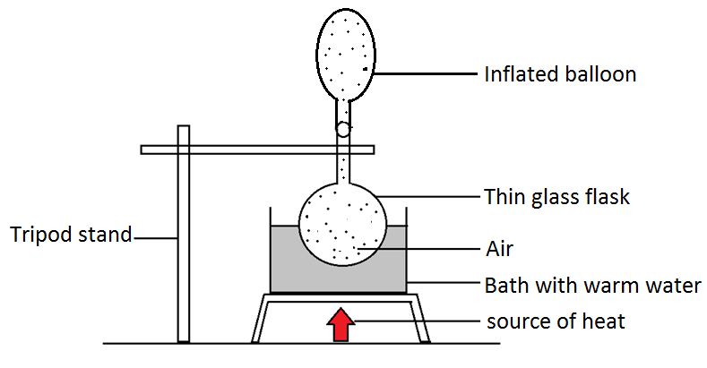
Expected results
On heating the balloon is inflated hence bulges.
Discussion
On heating the air in the thin glass flask expand, increasing volume in flask and in the balloon hence inflating the balloon.
Conclusion
Gases expand on heating and contract on cooling.
Explanation of thermal expansion in gases in terms of particle behavior
The intermolecular forces in the gases are weakest compared to those in liquids and solids. The forces of attraction between the molecules of a gas are very weak (almost negligible). Hence, the molecules move freely in all directions. When a gas is warmed, the molecules gain more kinetic energy and move far apart hence its volume increases.
Note: different gases have the same rate of expansion when heated equally under the same pressure and same quantity of those gases.
Unusual (anomalous) expansion of water
When water is heated at$0 ℃$ its volume decreases (contracts) as temperature rises from$0℃ to 4 ℃.$ Beyond$4 ℃$, water expands like other liquids. This unusual behavior of water when it is heated from$0℃ to 4 ℃$ is referred to as anomalous (abnormal) expansion of water. Thus, a fixed mass of water has a minimum volume at$4 ℃$.
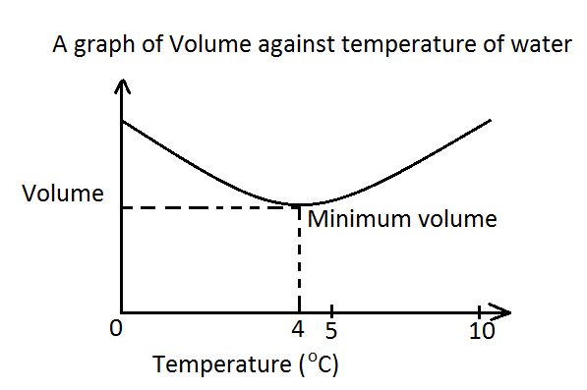
At$4 ℃$, volume of water is minimum while density of water is maximum.
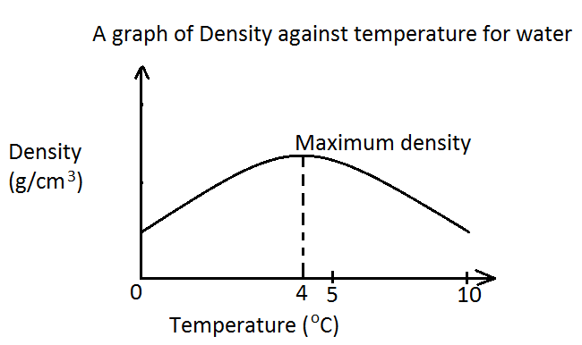
Effects of anomalous expansion of water
- Survival of aquatic organisms in freezer of lakes and ponds.
In cold weather when the temperature of the atmosphere falls below$0 ℃$, water in a lake or pond freezes and ice is formed. The volume of a fixed mass of water is minimum at$4 ℃$ hence density of water is maximum at this temperature. As the temperature of air above the lake falls from$10 ℃ to 4 ℃$, the density of water increases. This denser water at the top sinks to the bottom of the lake and remains there in liquid form. The water on the top freezes to ice at$0 ℃$ and floats. The fish and other aquatic animals and plants survives in the liquid water at$4 ℃$ below the ice during the cold weather.
- Bursting of water pipes.
Water pipes can burst when the water flowing through them cools from$4 ℃ to 0 ℃$ and freezes to ice because the volume of water increases.
- Weathering of rocks.
When water freezes in the cracks of a rock, the volume of water increases on cooling from$4 ℃ to 0 ℃$ causing rocks to break into small pieces.
Applications of thermal expansion
- Loose fitting of electrical cables: to give room for expansion and contraction as the weather changes.
- Separating stuck tumblers/glasses: stuck tumblers can be easily separated by placing the tumblers upright in warm water and pouring very cold water in the inner tumbler in order to make outer tumbler expand and inner one contract.
- Tooth filling: dental procedures include filling cavities using some material. The material is put in cavity at a high temperature and as it cools it sets and hardens to fill the gap.
- Removing tight bottle caps: a metallic bottle top that is too tight to unscrew can be made to fit loosely by placing it in hot water for some time.
- Gaps and rollers in bridge construction: steel structures such as bridges and roofs are fixed at one end while the other end rests on rollers. The end on the rollers provides the structure with room for expansion.
- Gaps in fences: metallic sheet fences must have gaps to allow for expansion during hot weather.
- Metal riveting: riveting involves rivets being driven into metals being joined together while hot. As they coil, they contract to give a tight fit.
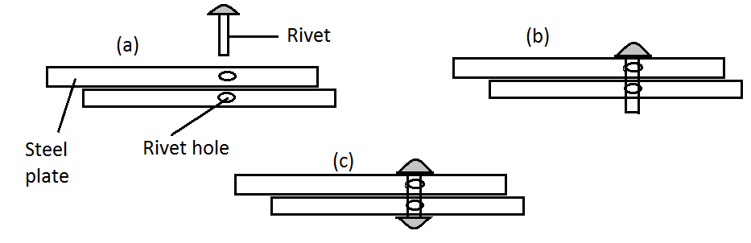
- Shrink fitting of axles into gear wheels: Axles are shrunk by cooling in liquid nitrogen at $-196 ℃$ until the gear wheel can be slipped onto them. On regaining normal temperature, the axles expand to give a very tight fitting.

TOPIC 2: NEWTON’S LAWS OF MOTION
- Newton’s first law of motion (law of inertia)
Newton’s first law of motion (law of inertia) states that a body at rest or in uniform motion will continue to be in that state unless acted up on by an external force. Or Newton’s first law of motion (law of inertia) states that a body continues in a state of rest or of uniform motion in a straight line unless it is acted up on by an external (unbalanced) force.
Experiment
Aim: to demonstrate inertia on card being pulled slowly and suddenly.
Apparatus: a coin, a beaker and a smooth cardboard.
Procedure
- Place a coin on a smooth cardboard and place it over a beaker.
- Pull the card away slowly and observe what happens to the coin.
- Repeat the experiment but this time pull the card away suddenly as in figure (b) and observe what happens.
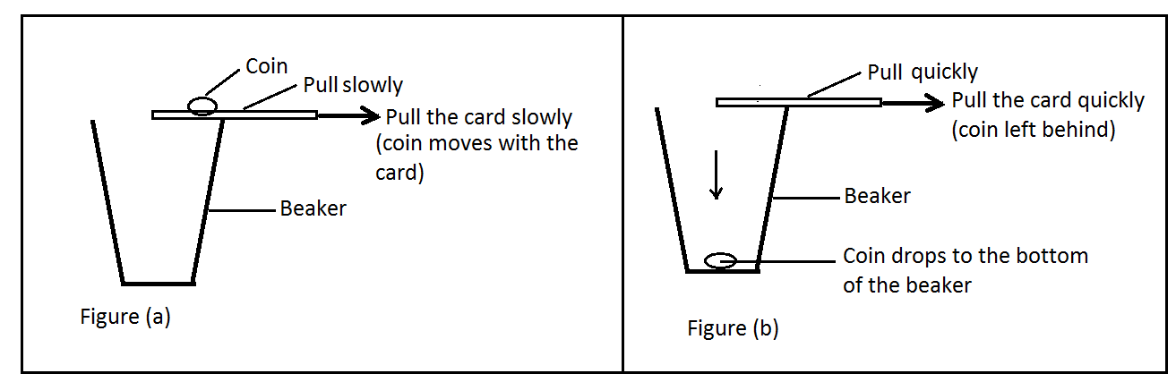
Observation
When the card is pulled slowly the coin moves together with the card. However when the card is pulled suddenly, the coin is left behind and drops vertically down into the beaker.
Discussion
When the card is pulled slowly, the frictional force between the card and the coin makes the two to move together. When the card is moved suddenly the coin resists motion and does not move with the card.
Conclusion
The reluctance of a body to change its state of motion is called inertia (Latin word meaning Laziness).
From the law of inertia, force is defined as the quantity which produces motion of a body at rest or that which alters its existing state of motion.
Mass and Inertia
Experiment
Aim: to investigate the relationship between mass and inertia of a body.
Apparatus: string, hook, heavy stone and light stone.
Procedure
- Suspended the heavy stone and a light using the string as shown in figure (a) below.
- Push the heavy stone towards one side. Release the stone to swing and then try to stop the stone from moving.
- Repeat the steps (1) and (2) with the light stone as shown in figure (b) below.
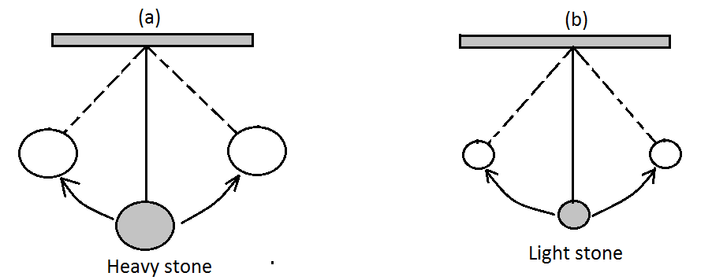
- Which stone is easier to start moving and to stop moving?
Observation (expected results)
The lighter stone is easier to start moving and to stop moving. The heavier stone is difficult to start or stop moving i.e. it requires a larger force.
Conclusion
Mass of a body is a measure of its inertia. A body with a large mass has a large inertia than a body with less mass. Note that when the mass of a body is pulled by the force of gravity the mass is called gravitational mass while when there is no gravitational pull, the mass of a body is called inertia mass.
Momentum
Activity: to illustrate momentum
Take two nails and drive them into pieces of wood using a light hammer. Hit the first one gently and the second nail very hard. What happens in each case? Repeat the experiment using a heavy hammer.
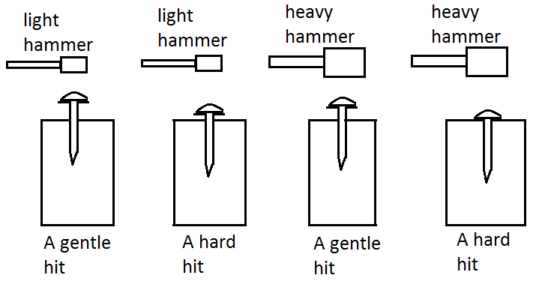
Observation
We note that the nail penetrates into the wood more when the nail is hit hard. A hard hit using a heavy hammer drives the nail deepest into the wood.
Conclusion
To drive the nail into the wood, a certain rate of motion (velocity) and mass of the hammer was required. A quantity involving both motion and mass of a body is called momentum.
Momentum of an object is the product of the mass and the velocity of the object. i.e.
$$Momentum, p=mass, m ×velocity, v which imply that:p=m×v$$
SI unit of momentum is${kgm}/s$. Momentum is a vector quantity. The direction of momentum is the same as that of the velocity.
Worked Examples on Momentum
Example 1
A car of mass 600 kg moves with a velocity of$40 m/s$. Calculate the momentum of the car.
Solution
$$momentum=mass ×velocity=600 kg ×40m/s=24 000 {kgm}/s in the direction of velocity.$$

Example 2
A body A of mass 4 kg moves to the left with a velocity of$7m/s$. Another body B of mass 7 kg moves to the right with a velocity of$6 m/s$.
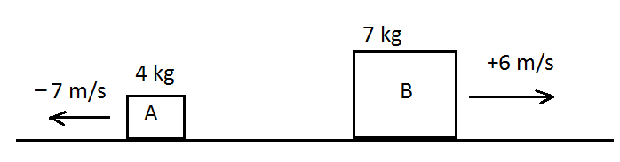
- Calculate the momentum of A?
- Calculate the momentum of B?
- Calculate the total momentum of A and B?

Solution
Let us assign$+ve sign$ to indicate movement to the right and$a-ve sign$ to indicate movement to the left.
- $Momentum of A=4 kg ×-7m/s=-28{kgm}/s$
- $Momentum of B=7 kg ×+6m/s=+42{kgm}/s$
- $Total momentum=momentum of A+momentum of B$
$=-28{kgm}/s+42{kgm}/s$
$$=+14{kgm}/s$$
$$=14{kgm}/s to the right.$$

Impulse
- When a force F acts on an object for a very short time, t, it produces an impact which is referred to as impulse on the object.
- Impulse is the product of force and time i.e. $Impulse=Force \left(F\right)×time \left(t\right)$
$$∴Impulse=Ft$$
- SI unit of impulse is Newton – second (Ns).
- When an impulsive force acts on an object it produces a change in momentum of that object. The velocity of that object changes from an initial value (u) to a final value (v) but its mass (m) remains constant.
- Experiments have shown that the impulse acting on the object is equal to the change in momentum it produces on the object. i.e.
$$Impulse=change in momentum$$
$Ft=mv-mu$
Worked examples on impulse and change in momentum
Example 1
A hammer strikes a metal rod with a force of 20 N. If the impact lasts$0∙4s$, calculate the impulse due to this force.

Solution
$$Impulse=force ×time=20N ×0∙4s=8 Ns$$

Example 2
A body of mass$0∙3 kg$ moving with a uniform velocity of${3 m}/s$ is acted on by a force of$1∙8 N$ in the direction of the motion for 2 seconds. What is its final velocity?

Solution
Let the final velocity be V. $Initial momentum of the body=0∙3 kg×{3 m}/s=0∙9{kgm}/s$. $final momentum of the body=0∙3 kg×V$
$$Impulse=Force ×time=1∙8N ×2s=3∙6Ns$$
$$Impulse=change in mementum$$
Note: ${1 kgm}/s=1 Ns$
$$\overset{⇒}{} Ft={mv}_{f}-{mu}_{i}$$
$$3∙6 {kgm}/s=0∙3kg×v-{0∙9kgm}/s$$
$$3∙6 {kgm}/s+ {0∙9kgm}/s=0∙3kg×v$$
$${4∙5 kgm}/s=0∙3kg×v$$
$$v=\frac{{4∙5 kgm}/s}{0∙3kg}={15m}/s$$
$$∴final velocity \left(v\right)= {15m}/s$$

Example 3
Find the change in momentum of a ball of mass 100g which strikes a vertical wall with a horizontal velocity of${ 12 m}/s$ and rebounces horizontally at${ 8 m}/{s.}$ If the ball is in contact with the wall for $0∙004 seconds,$ determine its impulsive force.

Solution
$$Initial momentum of a ball=0∙1 kg×{12 m}/s={1∙2 kgm}/s$$
$$final momentum of a ball=0∙1 kg×{8 m}/s={0∙8 kgm}/s$$
$$Let the direction be of final momentum.$$
$$\overset{⇒}{} Final momentum=+0∙8 Ns while initial momentum=-1∙2Ns$$
$$change in momentum=Final-initial$$
$$change in momentum=+0∙8-\left(-1∙2Ns\right)$$
$$change in momentum=+0∙8+1∙2Ns$$
$$change in momentum=2Ns$$
$$Impulse=change in mementum$$
$$Ft=mv-mu$$
$$F=\frac{mv-mu}{t}=\frac{2 Ns}{0∙004s}=500N$$

Example 4
A marble of mass$0∙0002 kg$ was dropped onto a floor from a height of 2m and rebounced to a height of$0∙8m$ at an initial upward velocity of${4 m}/s$. Find the impulse of the floor on the marble. If the contact lasted$0∙005s,$ find the impulsive force on the marble. $\left(Take g={10 m}/{s^{2}}\right)$

Solution
Let the velocities just before and after contact with the floor be$v_{1} and v_{2}$ respectively.

After dropping for 2m, the velocity of the marble just before hitting the floor is given by the formula:
$$V_{1}=U^{2}+2aS$$
$$V_{1}=?, U=0 m/s, a=g={10m}/{s^{2}}, S=2 m$$
$$V_{1}^{2}={\left({0 m}/s\right)}^{2}+2\left({10m}/{s^{2}}\right)\left(2m\right)$$
$$V_{1}^{2}=40{m^{2}}/{s^{2}}$$
$$V_{1}=\sqrt{40{m^{2}}/{s^{2}}}$$
$$V_{1}=6∙3246 m/s$$
$$The initial upward velocity after rebounce is, V_{2}={4 m}/s$$
$$Impulse of the floor on the marble=change in momentum of marble$$
$$impulse={mV}_{2}-{mV}_{1}$$
Consider direction of rebouncing as positive.
$$Impulse={mV}_{2}-\left({-mV}_{1}\right)$$
$$Impulse=0∙002kg×{4m}/s-\left(-0∙002kg×{6∙325m}/s\right)$$
$$Impulse=8×{10}^{-3}Ns+0∙01265 Ns$$
$$Impulse=0∙02065 Ns$$
$$Impulsive force=\frac{change in momentum \left(impulse\right)}{time interval}$$
$$Impulsive force=\frac{0∙02065 Ns}{0∙005 s}=4∙13N$$

- Newton’s Second Law of Motion
Newton’s second law of motion states that the rate of change of momentum is directly proportional to the resultant force and it takes place in the direction in which the force acts.
Mathematically, the law is represented as follows:
$$Force \left(F\right)∝\frac{change in momentum}{time taken}$$
$$Force \left(F\right)∝\frac{final momentum-initial momentum}{time taken}$$
$$Rate of change of momentum=\frac{mv-mu}{t}=m\left(\frac{v-u}{t}\right)$$
$$But \frac{v-u}{t}=acceleration (a)$$
$$Thus, F∝ma$$
$$F=Kma, where K is a constant of proportionality. Experiments show that K=1,$$
$$∴F=ma--------\left(1\right) or$$
$$∴F=\frac{m\left(v-u\right)}{t}-----(2)$$
If mass is 1 kg and acceleration is ${1m}/{s^{2}}$, then the force is 1N. This is the definition of 1 newton i.e. 1 newton is the force which when it acts on a mass of 1 kg it gives it an acceleration of${1m}/{s^{2}}$ .
Worked examples on Newton’s Second Law of motion
Example 1
An object of mass 4 kg accelerates to${5m}/{s^{2}}$. Calculate the resultant force.

Solution
$$F=ma, ∴ F=4 kg×{5m}/{s^{2}}=20N$$

Example 2
A car of mass 900 kg is towed by a break down truck along a level road. They accelerate at${0∙6 m}/{s^{2}}$. Calculate the tension in the rope.
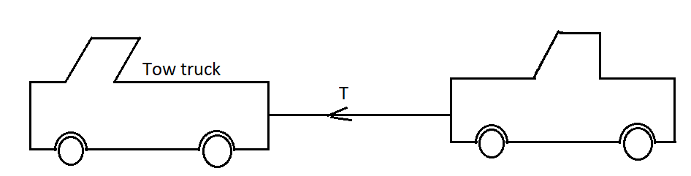

Solution
$$Tension=resultant force.$$
$$Using acceleration, Resultant force, F=ma$$
$$F=900 kg×{0∙6 m}/{s^{2}}=540N$$
$$Tension=540N$$

Example 3
What is the force required to increase the velocity of a mass of 4 kg from$from {2m}/s to {10m}/s in 2 seconds$?

Solution
$$u={2m}/s, v={10m}/s, t=2 seconds$$
$$v=u+at$$
$$a=\frac{v-u}{t}=\frac{{10m}/s-{2m}/s}{2s}$$
$$a=\frac{{8 m}/s}{2s}={4 m}/{s^{2}}$$
$$F=ma, m=4kg, a={4 m}/{s^{2}}$$
$$F=4 kg×{4 m}/{s^{2}}={16 kg m}/{s^{2}}$$
$$Force=16 N$$

Example 4
A motorcycle of mass 100 kg slows down with a braking force of 250 N until it comes to a complete stop. What is the retardation produced?

Solution
$$Retardation= -acceleration$$
$$Force=mass ×retardation$$
$$250N=100 kg×-acceleration$$
$$-a=\frac{250 \left({kg m}/{s^{2}}\right)}{100 kg}=-{2∙5 m}/{s^{2}}$$
$$∴Retardation is {2∙5 m}/{s^{2}}$$

Example 5
A force of 12 N acts on a body of mass 5kg. There is a resistance of 7 N directly opposing the force. What is the acceleration produced?

Solution
$$Net force=12 N-7 N=5 N$$
$$F=ma$$
$$5N=5kg×a$$
$$a=\frac{{5 kg m}/{s^{2}}}{5 kg}={1 m}/{s^{2}}$$

- Newton’s Third Law of Motion
Experiment
Aim: to demonstrate action and reaction force.
Apparatus: two spring balances, a rigid support with a hook.
Procedure
- Hook one end of a spring balance A to a rigid support.
- Pull the other end until the spring shows a reading. Take note of the reading.
- Repeat the experiment but use a second similar spring B instead of the wall.
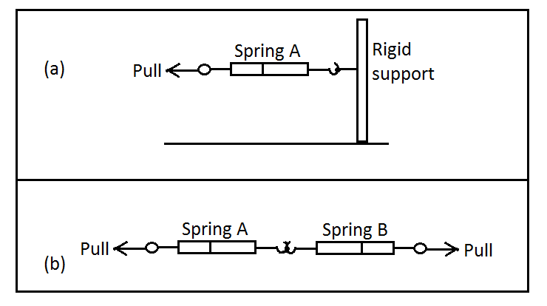
- Pull the two springs until the reading on spring A is the same as before.
- What reading is shown by spring B?

Expected observation
The rigid support was being pulled with a certain force, but it was not moving. When two springs were pulled they had the same reading.
Conclusion
The reading in spring B is the same as in spring A. The two forces are equal in size but are in opposite direction. This shows that when spring A is pulled away from the wall, the wall also pulled the spring A with an equal and opposite force.
Newton’s third law of motion states that whenever a body exerts a force on another body, the other body exerts an equal but opposite force on the first body. Or it states that for every action there is an equal and opposite reaction force.
Worked examples on Newton’s Third Law of motion
Example 1
A man stands on a weighing machine in a lift. The weighing machine reads 600 N with the lift stationary. When the lift is ascending, the machine reads 640 N, 600 N and then 560 N. Find the acceleration during each stage.

Solution
At any instance, two equal forces act on a man. The two forces are
- Weight of the man$\left(mg\right)$ acting downwards.
- Reaction (R) force acting upwards by the weighing machine.
When the lift is stationary,$acceleration=0$ , $thus resultant force=0.$
Lift being stationary,
$$Reaction force=weight of man$$
$$R=mg$$
$$\overset{⇒}{ }R-mg=0$$
When the reaction (R) is 600 N
$$600N-{10N}/{kg}×m=0$$
$$\frac{600 N}{{10N}/{kg}}=\frac{{10 N}/{kg}×m}{{10 N}/{kg}}$$
$$m=60 kg$$
$$∴mass of the man is 60 kg.$$
When the weighing machine indicates a reaction of 640 N, the resultant upward force on the man is
$$640N-600N=40N$$
By Newton’s 2nd law

$$F=ma, ∴ 40N=60 kg×a$$
$$a=\frac{40N}{60kg}={0∙67 m}/{s^{2}}$$
The lift is accelerating upwards at${ 0∙67 m}/{s^{2}}$ at this point.
When the lift indicates a reaction of 600 N, the resultant force upwards is zero.
$$∴F=ma, 0=60 a$$
$$a=\frac{0}{60}={0 m}/{s^{2}}$$
Thus, the lift is moving upwards with a constant speed.
When the machine indicates an upward reaction of 560 N, resultant force upward is:
$$560N-600N=-40N$$
$$F=ma$$
$$-40N=60 kg ×a$$
$$a=\frac{- 40N}{60kg}={- 0∙67 m}/{s^{2}}$$
The lift is moving upwards with a negative acceleration or retardation of${ 0∙67 m}/{s^{2}}$

Example 2
A boy stands on a weighing machine in a lift descending with an acceleration of${ 3 m}/{s^{2}}$. If the machine reads 340 N, find the mass of the boy.

Solution
The motion is downward, therefore downward action is$+ve$ while upward reaction is$-ve$
$$∴Net force=mg-R.$$
But Force (F)=ma
$$ma=mg-R$$
$$ma-mg=-R$$
$$m\left(a-g\right)=-R$$
$$m\left({3 m}/{s^{2}}-{10 N}/{kg}\right)=-340N$$
$$m\left({-7 m}/{s^{2}}\right)=-340N$$
$$m=\frac{-340N}{{-7 m}/{s^{2}}}=48∙57kg$$

Example 3
Two masses of 6 kg and 3 kg are attached to both ends of a light inextensible string which passes over a smooth pulley. Find the acceleration of the system and the tension in the string if the system is released from rest. $\left({take g=10m}/{s^{2}} \right)$

Solution
When the system is released from rest, the heavier mass, which is the 6kg mass, moves downwards pulling the 3kg mass upwards. Let T, be the tension in the string and a common acceleration of the system.
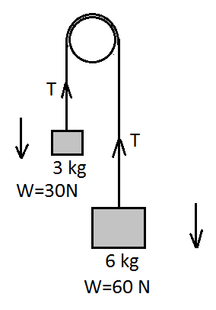
For 6 kg mass, we have
$weight-Tension=Net force$
$$60N-T=ma$$
$$60N-T=6 kg×a$$
$$60N-T=6a-------------(i)$$
For the 3 kg mass, we have
$Tension-weight=Net force$
$$T-30N=ma$$
$$T-30N=3 kg×a$$
$$T-30N=3a-------------(ii)$$
Add equation (i) and (ii)
$$T-T-30N+60N=3a+6a$$
$$30N=9a$$
$$a=\frac{{30 kg m}/{s^{2}}}{9kg}={3∙3 m}/{s^{2}}$$
Substitute for the value of a in equation (ii)
$$T-30N=3 kg ×\left({3∙3 m}/{s^{2}}\right)$$
$$T-30N=9∙9 kgm/{s^{2}}$$
$$T=30N+9∙9 kgm/{s^{2}}$$
$$T=39.9N which is approximately 40N$$
$$Hence, the acceleration of the system is{ 3∙3 m}/{s^{2}} and the tension in the string is 40N$$

Example 4
A mass of 9 kg resting on a smooth horizontal table is connected by a light inextensible string, passing over a smooth pulley at the edge of the table, to a mass of 7 kg hanging freely. Find the common acceleration and the tension in the string when the system is released. $\left({take g=10m}/{s^{2}} \right)$

Solution
Let T be the Tension in the string and “a” the common acceleration of the system when it is released from rest.
Applying, $F=ma$, to the 7 kg mass.
$$weight-T=Net force$$
$$7 kg ×{10N}/{kg}-T=7 kg×a$$
$$70-T=7a------------------(i)$$
For the 9 kg mass, weight is not considered because the mass is moving horizontally. Also the table is is smooth so friction is negligible.
$$∴Force \left(Tension\right)=ma$$
$$Tension=9kg×a$$
$$T=9a---------------------(ii)$$
Substitute for T in (i)
$$70-\left(9a\right)=7a$$
$$70-9a=7a$$
$$70=9a+7a$$
$$a=\frac{70}{16}=4∙375m/{s^{2}}$$
$$Hence, T=9\left(4∙375\right)=39∙375N$$
$$∴The common acceleration is 4∙375m/{s^{2}} and the tension is 39∙375N.$$
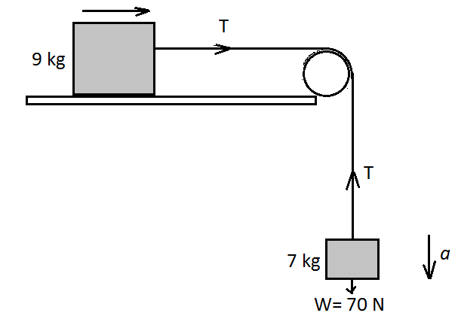

Some common experiences due to Newton’s third law of motion
- When walking a person exerts a backward force on the ground while the ground exerts a forward push on the person.
- When a gun is fired, the bullet travels in one direction while the gun recoils backwards.
- A balloon will always move in the opposite direction when the air inside is released.
- The water sprinkler works on action and reaction principle.
Conservation of linear momentum
- Consider two objects A and B of masses$m_{A} and m_{B}$ moving in the same direction with different velocities.
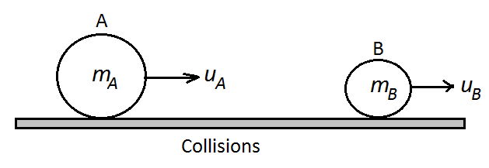
- On collision, A pushes B with a Force$F_{A}$ and B reacts by pushing A with an equal and opposite force${ F}_{B}$. That is
$$F_{A}=-{ F}_{B}$$
- Since the time spent in colliding is the same, A experiences an impulse${ -F}_{B}t$ from B while B also experiences an impulse${ F}_{A}t$ from A i.e.
$${-F}_{B}t={ F}_{A}t---------------------------(i)$$
$$since impulse=change in momentum=mv-mu$$
- Let the final velocities of A and B be$V_{A} and{ V}_{B}$respectively then
$$-F_{B}t=\left(m_{A}V_{A}-m_{A}U_{A}\right)----------------------\left(ii\right)$$
$$F_{A}t=-\left(m_{B}V_{B}-m_{B}U_{B}\right)----------------------\left(iii\right)$$
Equating equation (ii) and (iii)
$$m_{A}V_{A}-m_{A}U_{A}=-\left(m_{B}V_{B}-m_{B}U_{B}\right)$$
$$m_{A}V_{A}-m_{A}U_{A}=-m_{B}V_{B}+m_{B}U_{B}$$
$$m_{A}V_{A}+m_{B}V_{B}=m_{A}U_{A}+m_{B}U_{B}$$
$${But m}_{A}U_{A}+m_{B}U_{B}=total momentum before collision and$$
$$m_{A}V_{A}+m_{B}V_{B}=total momentum after collision$$
$$∴Total momentum before collision=Total momentum after collision$$

The law of conservation of momentum
The law of conservation of momentum states that when two or more bodies collide their total momentum remains constant provide no external forces are acting.
Collisions
The two types of collisions are elastic collisions and inelastic collisons
- Elastic collisions.
When the total kinetic energy is conserved after collision the collision is said to be Elastic. This is only possible within atoms. However, the collision between two smooth marble balls is appropriately elastic.
Activity
Take a rubber ball and bounce it on a hard surface. Notice how high it bounces each time it hits the ground. Does it always reach the same height?
Observation
You will notice from the activity that the rubber ball nearly reaches the height it was bounced. This shows that initial energy it acquired is equal to the final energy. When bodies collide and the kinetic energy of the system does not change (is conserved) the collision is said to be elastic. The following takes place during elastic collisions:
- The time of impact is negligible.
- Momentum is conserved i.e.
$$initial momentum=final momentum$$
$$m_{1}U_{1}+m_{2}U_{2}=m_{1}V_{1}+m_{2}V_{2}$$
- Kinetic energy is conserved i.e.
$$initial kinetic energy \left(KE\right)=Final kinetic energy (KE)$$
$${\frac{1}{2}m}_{1}{U_{1}}^{2}+\frac{1}{2}m_{2}{U_{2}}^{2}=\frac{1}{2}m_{1}{V_{1}}^{2}+\frac{1}{2}m_{2}{V_{2}}^{2}$$

- Inelastic collisions.
Inelastic collisions are collisions where the total kinetic energy is not conserved. A completely inelastic collision is one which two bodies stick together after collision.
Activity
Take lumps of plasticine and form them into balls. Roll the plasticine lumps down an inclined plane (inclined both sides to form a V-shape) and watch what happens when they collide.
Observation
The plasticine lumps collide and stick together. After this they may move together or stop depending on the gradient of your inclined plane. In this type of collision kinetic energy is not conserved. The final kinetic energy is less than the initial kinetic energy. Some of the initial kinetic energy is mainly transformed to work done to deform the body and produce heat and sound. The following takes place during inelastic collisions:
- The time of impact is measurable and therefore all the collisions that take place in nature qualify to be inelastic.
- Momentum is conserved for the bodies that stick together
$initial momentum=m_{1}U_{1}+m_{2}U_{2}$
$$final momentum=\left(m_{1}+m_{2}\right)V$$
$$∴m_{1}U_{1}+m_{2}U_{2}=\left(m_{1}+m_{2}\right)V$$
Worked examples on momentum and collision
- Elastic collisions
Example 1
A Cannon of mass 800 kg which started from rest fired a cannon ball of mass of 3 kg at a velocity of${120 m}/{s.}$ Find the recoil velocity of the cannon?

Solution
$$m_{1}=3 kg, U_{1}={0 m}/s, m_{2}=800 kg, U_{2}={0 m}/s, V_{1}={120 m}/s and V_{2}=?$$
$$total initial momentum=total final momentum$$
$$m_{1}U_{1}+m_{2}U_{2}=m_{1}V_{1}+m_{2}V_{2}$$
$$\left(3 kg ×{0 m}/s\right)+\left(800 kg× {0 m}/s\right)=\left(3 kg × {120 m}/s\right)+800 kg × V_{2}$$
$${0 kgm}/s+{0 kgm}/s={360 kg m}/s+800 kg ×V_{2}$$
$${0 kgm}/s={360 kg m}/s+800 kg ×V_{2}$$
$$-800 kg ×V_{2}={360 kg m}/s$$
$$\frac{-800 kg ×V_{2}}{-800 kg}=\frac{{360 kg m}/s}{-800 kg}$$
$$V_{2}=-0.45m/s$$
$∴The cannon recoiled backwards at a velocity of 0.45m/s.$ The negative value in the velocity shows that the cannon moved in the opposite direction.

Example 2
A smooth sphere of mass 5 kg moves a long a smooth linear groove at ${7 m}/{s.}$ It meets a similar sphere of mass 2 kg moving in the same groove but in the opposite direction at${ 2 m}/{s.}$ Given that the lighter sphere has a velocity twice that of the heavier sphere, after impact, calculate these velocities?

Solution
After impact the velocities of the spheres are
$$velocity of the heavier sphere=V$$
$$velocity of the lighter sphere=2V$$
$$momentum before collision=momentum after collision$$
$$m_{1}U_{1}+m_{2}U_{2}=m_{1}V_{1}+m_{2}V_{2}$$
$$\left(5 kg ×{7m}/s\right)+\left(2 kg× {-2 m}/s\right)=\left(5 kg × V\right)+\left(2 kg × 2V\right)$$
$$\left(35 m/s\right){-4 kg m}/s=\left(5 kg × V\right)+\left(4 kg ×V\right)$$
$${31 kg m}/s=\left(5 kg+4 kg\right)V$$
$${31 kg m}/s=9 kg V$$
$$V=\frac{{31 kg m}/s}{9 kg}$$
$$V=3∙4 m/s$$
$$∴2V=2×3∙4m/s=6∙8m/s$$
$$∴The velocity of the 5 kg sphere after impact is 3∙4 m/s and the velocity of the 2 kg$$
$sphere$ $after impact is 6∙8m/s$.

Example 3
A trolley with mass 200 g moves at ${10 m}/s$ and collides with a stationary trolley of mass 150 g. What will be the new velocity if the approaching trolley stops while the stationary trolley moves?

Solution
$$total initial momentum=total final momentum$$
$$m_{1}U_{1}+m_{2}U_{2}=m_{1}V_{1}+m_{2}V_{2}$$
$$\left(200 g ×{10m}/s\right)+\left(150 g× {0 m}/s\right)=\left(200 g ×{0 m}/s \right)+\left(150 g ×V_{2}\right)$$
$$\left(2000 gm/s\right)=\left(150 g ×V_{2}\right)$$

$$V_{2}=\frac{{2000 gm}/s}{150 g}$$
$$V_{2}=13∙33 m/s$$

Example 4
When a gun shoots a bullet, the gun always jerks backwards due to recoil of the spring inside it. What would be the recoil velocity of a rifle with mass $3∙5 kg$ when it shoots a bullet of mass 50 g at a speed of ${1400 m}/s?$

Solution
Initially the total momentum of the gun and the bullet is zero.
$$m_{1}U_{1}+m_{2}U_{2}=m_{1}V_{1}+m_{2}V_{2}$$
$${0 kgm}/s=\left(3∙5 kg × V_{1}\right)+\left(\frac{50}{1000} kg × {1400 m}/s\right)$$
$${0 kgm}/s=3∙5 kg × V_{1}+\left(0∙05 kg ×{1400 m}/s\right)$$
$${0 kgm}/s=3∙5 kg × V_{1}+{70 kgm}/s$$
$$-3∙5 kg × V_{1}={70 kgm}/s$$
$$\frac{-3∙5 kg ×V_{1}}{-3∙5 kg}=\frac{{700 kg m}/s}{-3∙5 kg}$$
$$V_{1}=-20m/s$$

Note that the minus sign shows that the velocity was backward than forward.

- Inelastic collisions
Example 1
A mass of 3 kg moving with a velocity of ${4 m}/s$ collides with another mass of 2 kg which is stationary. After collision the two masses stick together. Calculate the common velocity for the two masses.

Solution
$$m_{1}=3 kg, U_{1}={4 m}/s, m_{2}=2 kg, U_{2}={0 m}/s, and common velocity, V=?$$
$$momentum before collision=momentum after collision$$
$$m_{1}U_{1}+m_{2}U_{2}=\left(m_{1}+m_{2}\right)V$$
$$\left(3 kg ×{4 m}/s\right)+\left(2 kg× {0 m}/s\right)=\left(3 kg+2 kg\right)V$$
$$12 kg{ m}/s+12 kg{ m}/s=5 kg ×V$$
$$\frac{12 {kgm}/s }{5 kg}=\frac{5 kg ×V}{5 kg}$$
$$V=2.4m/s$$
$∴Common velocity 2∙4m/s.$

Example 2
A 5 kg moving with a velocity of ${10 m}/s$ collides with a 10 kg mass moving with a velocity of ${7 m}/s$ along the same line. If the two masses join together on impact, find their common velocity if they were moving
- In opposite direction.
- In the same direction.

Solution
- $m_{1}=5 kg, U_{1}={10 m}/s, m_{2}=10 kg, U_{2}={-7 m}/s$
$$m_{1}U_{1}+m_{2}U_{2}=\left(m_{1}+m_{2}\right)V$$
$$m_{1}U_{1}+m_{2}U_{2}=\left(m_{1}+m_{2}\right)V$$
$$\left(5 kg ×{10 m}/s\right)+\left(10 kg× {-7 m}/s\right)=\left(5 kg+10 kg\right)V$$
$$50 kg{ m}/s-70 kg{ m}/s=15 kg ×V$$
$$-20 kg{ m}/s=15 kg ×V$$
$$V=\frac{{-20 kg m}/s}{15 kg}$$
$$V=-1∙33 m/s$$
$$The minus sign means that the joined mass moves to the left.$$

- $m_{1}=5 kg, U_{1}={10 m}/s, m_{2}=10 kg, U_{2}={+7 m}/s$
$$m_{1}U_{1}+m_{2}U_{2}=\left(m_{1}+m_{2}\right)V$$
$$\left(5 kg ×{10 m}/s\right)+\left(10 kg× {7 m}/s\right)=\left(5 kg+10 kg\right)V$$
$$50 kg{ m}/s+70 kg{ m}/s=15 kg ×V$$
$$120 kg{ m}/s=15 kg ×V$$
$$V=\frac{{120 kg m}/s}{15 kg}$$
$$V=+8 m/s$$
$$∴The plus sign means that the joined mass move to the right.$$

Example 3
A taxi of total mass 1500 kg travelling at $20 ms^{-1}$ collides with a stationary car of mass 500 kg.
- Assuming the collision is inelastic, calculate:
- The common velocity after collision.
- The kinetic energy before collision.
- The kinetic energy after collision.

- How do the initial kinetic energy compare?

Solution

- Let mass of taxi be$m_{t}$
Let mass of car be${ m}_{c}$
Let initial velocity of taxi be${ U}_{t}$
Let initial velocity of taxi be${ U}_{c}$
$$\left(m_{t}×{ U}_{t}\right)+\left({ m}_{c}×{ U}_{c} \right)=\left(m_{t}+{ m}_{c}\right)V$$
$$\left(1500kg×{20m}/s\right)+\left(500 kg×{0 m}/s\right)=\left(1500 kg×500kg \right)V$$
$$30 000{ kgm}/s=2000kg×V$$
$$V=\frac{30 000{ kgm}/s}{2000kg}= 15 ms^{-1}$$
- $initial kinetic energy= \frac{1}{2}m_{t}{u_{t}}^{2}$
$$initial kinetic energy=\frac{1}{2}×1500 kg×{\left({20 m}/s\right)}^{2}$$
$$initial kinetic energy=750 kg×{{400 m}^{2}}/{s^{2}}$$
$$initial kinetic energy={{300 000 kgm}^{2}}/{s^{2}}$$
$$initial kinetic energy=300, 000 J$$

- $Final kinetic energy=\frac{1}{2}\left(m_{t}+{ m}_{c}\right)V$
$$Final kinetic energy=\frac{1}{2}\left(1500 kg+500kg\right)×{\left({15 m}/s\right)}^{2}$$
$$Final kinetic energy=\frac{1}{2}×2000 kg×{{225 m}^{2}}/{s^{2}}$$
$$Final kinetic energy={{225, 000 kg m}^{2}}/{s^{2}}$$
$$Final kinetic energy=225, 000J$$

- The initial KE is greater than the final KE.

Example 4
Water jets out of a pipe of cross – section area${1∙5 cm}^{2}$ with a horizontal velocity of ${25 m}/s$. If it impinges on a vertical wall with no rebounces, with what force does it hit the wall?
$\left(Density of water={10}^{3}{kg}/{m^{3}}\right)$

Solution
Consider the momentum that is being destroyed every second
$$Volume of water jettng out of the pipe per second=area ×velocity$$
$$Volume of water jettng out of the pipe per second=\left(1∙5×{10}^{-4}m^{2}\right)×{25 m}/s$$
$$Volume of water jettng out of the pipe per second=3∙75×{10}^{-3}{m^{3}}/s$$
$$Mass of water jettng out per second={Volume }/s×Density$$
$$Mass of water jettng out per second=3∙75×{10}^{-3}{m^{3}}/s×{10}^{-3}{kg}/{m^{3}}$$
$$Mass of water jettng out per second=3∙75{kg}/s$$
$$Impulse=change in momentum$$
$$Ft=mv-mu$$
$$t=1 sec, m=3∙75 kg, u={25 m}/s and v={0 m}/s$$
$$F×1s=m\left(v-u\right)$$
$$F×1s=3∙75 kg\left({0 m}/s-{25 m}/s\right)$$
$$F=\frac{3∙75 kg×-{25 m}/s}{1 s}$$
$$F=\frac{-93∙75 {kg m}/s}{1 s}$$

$$F={-93.75 kgm}/{s^{2}}$$

Thus the force with which the water hits the wall is$93∙75N$

TOPIC 3: FRICTIONAL FORCE
Friction is the force that oppose the relative motion of two surfaces that are in contact. Some of the factors that affect friction between two surfaces are
- nature of the surfaces in contact and
- normal reaction force (R).
coefficient of solid friction
- consider a solid block being pulled over a horizontal surface by an applied force (F), frictional force$\left(F_{r}\right)$ acts in the opposite direction.
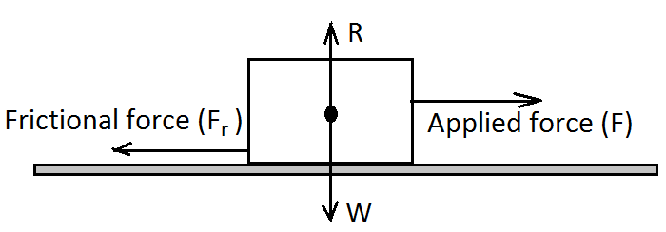
- When the block is about to move the solid friction is called Static friction.
- When the block is moving, friction force is reduced and is called dynamic friction.
Activity
Aim: to establish the relationship between frictional force and normal reaction.
Apparatus: a 50 g wooden block with rough surface, four 150 g masses, a rough bench and a spring balance.
Procedure
- Set up the apparatus as shown in figure below:
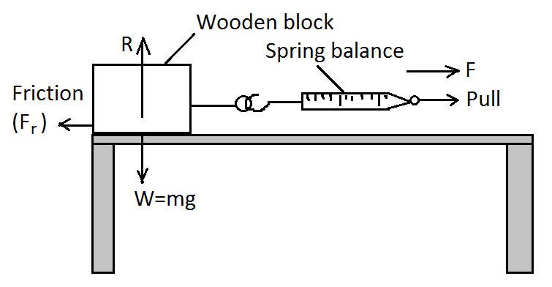
- Pull the string until the block is just about to move. Record the reading on the spring balance. $Frictional force=Applied force \left(F\right)at this moment.$
- Place one 50 g mass and pull the spring again. Record the reading on the spring balance.
- Repeat steps 2 and 3 for two, three and four masses on the block and record the readings of force, F on the spring.
Mass (g) | 50 | 100 | 150 | 200 | 250
Reaction, R (weight) | $$0∙5$$ | 1 | $$1∙5$$ | 2 | $$2∙5$$
Spring reading, F

- Draw a graph of F (N) against R (weight) (N).
Observation
We note the readings on the spring balance increase with increase of the mass. If a column of$F/R$ is added and completed in table above we will note that the value of$F/R$ is constant.
Discussion
When a graph of F against R is plotted, a straight line that is passing through the origin is obtained. i.e.
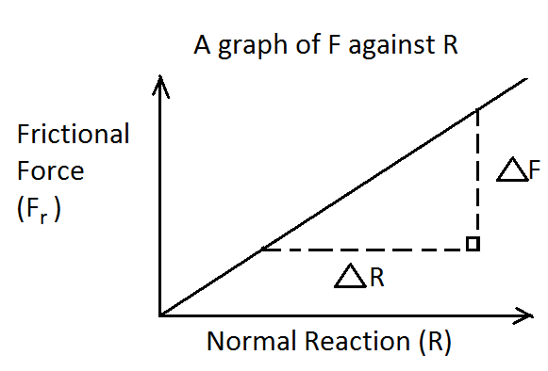
The gradient of the line,
$$Grad.=\frac{Change in F}{Change in R}$$
$$Grad.=\frac{∆ F}{∆ R}$$
Conclusion
From the graph, frictional force in solid is directly proportional to the weight of the solid i.e.
$$F∝W or F∝R$$
$$∴F_{s}=μ_{s}R, where F_{s}=static frictional force, { μ}_{s}=Coefficient of static friction$$
$$R=Normal reaction force \left(weight of the body\right).$$
$$F_{s}=μ_{s}N$$
$$μ_{s} has no units because forces in newton are dividing i.e. μ_{s}=\frac{F_{s} in newton}{R in newton}$$
Note that for a body to move, one has to apply a force larger than the limiting static frictional force$\left({ F}_{s}\right).$
Kinetic or dynamic friction$\left({ F}_{s}\right)$ is calculated by
$$F_{K}=μ_{K}R, where F_{K}=kinetic frictional force, { μ}_{K}=Coefficient of kinetic friction$$
Or $F_{K}=μ_{K}N$
Worked Examples on Static and Dynamic (Kinetic) Friction. (in solids)
Example 1
A force of 25 N limits the motion of a block of mass 50 kg which is being dragged on the horizontal ground. Calculate the coefficient of static friction force.

Solution
$$F_{s}=μ_{s}R$$
$$Normal Reaction \left(R\right)=weight of block$$
$$Normal Reaction \left(R\right)=mg$$
$Normal Reaction \left(R\right)=50 kg ×{10 N}/{kg}$
$$Normal Reaction \left(R\right)=500N$$
$$R=500N$$
$$F_{s}=25N$$
$$μ_{s}=\frac{F_{s}}{R}=\frac{25N}{500N}=0∙05$$

Example 2
A book of 200 g is resting on the surface of a table. If the coefficient of friction between the book and table is$0∙1$, calculate the friction force between the two.

Solution
$$F_{s}=μ_{s}R$$
$$R=weight$$
$$R=\frac{200}{1000}kg×{10 N}/{kg}=2N$$
$$μ_{s}=0∙1$$

$$F_{s}=0∙1×2N=0∙2N$$

Example 3
Figure below is a block of mass 200 kg being dragged at constant velocity with a force 40 N at angle$60°$ to the horizontal.
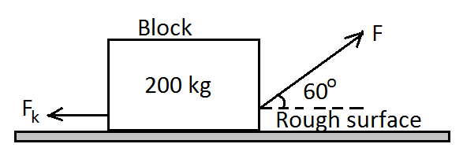
Determine the coefficient of kinetic friction $\left({ μ}_{K}\right)$

Solution
$$F_{K}=μ_{K}R$$
Since F is acting at an angle. We find its horizontal component
$$F_{H}=F\cos{θ}$$
$$F_{H}=40N×\cos{60°}$$
$$F_{H}=40N×0∙5$$
$$F_{H}=20N$$
$$∴ F_{K}=20N$$
$$R=weight=mg$$
$$R=200kg×{10 N}/{kg}$$
$$R=2000 N$$
$$μ_{K}=\frac{F_{K}}{R}=\frac{20 N}{2000 N}=0∙01$$

Viscosity
Viscosity is the measure of how easily a fluid flows. Fluid particles offer opposition to the motion of a body through the fluid. Frictional force in liquids is due to the viscosity of the liquid.
Activity
Aim: to show that fluids offer resistance to motion of objects through them.
Apparatus: stop watch, a ball bearing, water, glycerine and two same transparent buckets.
Procedure
- Allow the ball to fall in air at a height, h to the ground. Record the time taken.
- Repeat step 1) with the ball falling in water and glycerine and record their respective time.
Observation
We observe that the time taken by the ball to fall in air is shorter than the time it takes to fall in water. The time taken for the ball to fall in water is shorter than in glycerine.
Conclusion
- Fluids like air and liquids offer resistance to the movement of objects in them. This resistance differs from liquid to liquid and air to liquid.
- Fluid with high viscosity offer high frictional force than fluid with low viscosity.
Terminal velocity
Terminal velocity is the maximum downward velocity possible for a particular object falling through a fluid.
Experiment
Aim: to determine terminal velocity.
Apparatus: a long tube filled by a fluid (glycerin or oil), ball bearing and stop watch.
Procedure
- Fix same rubber bands around a long tube at equal distances. Drop a small steel ball bearing into the long tube containing glycerine/oil.
- Measure the time taken by the ball to move through the equal intervals.
- Determine the velocity of the ball as it descends into glycerine/oil. What can you say about the velocity of the ball?
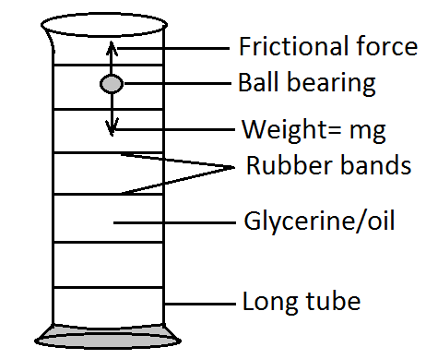
Expected results
You should have observed that the ball starts from zero and accelerates to a maximum value and then remains constant at this value, as the ball continues falling.
Discussion
When a body is falling in a fluid, three forces act on it:
- Weight of the body (W).
- Up thrust (U).
- Viscous drag (fluid friction), F.
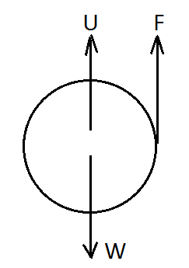
- Initially$W>U+F$ hence the body accelerates downwards.
- Fluid friction (F) increases as the body accelerates while W and U are constant so it reaches a point where$W=U+F.$
- At this point, the body moves at uniform (constant) velocity.
- The constant velocity is known as terminal velocity$\left(V_{t}\right)$
- Graph of the motion of the ball falling in liquid is:
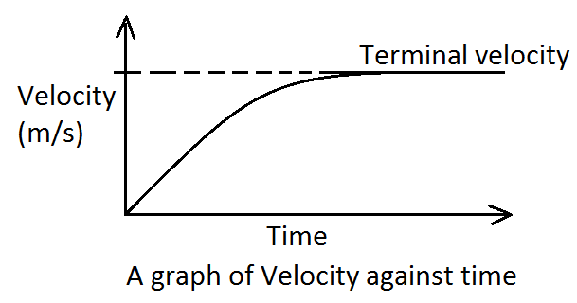
Air resistance
- Air offers resistance to movement of objects in air.
- Air resistance is also known as air friction i.e. friction opposing a moving body in air.
- Air resistance is a form of dynamic friction.
Worked Examples on Resistance of Motion
A car of mass 1000 kg is travelling under the action of forces as shown in the figure below:
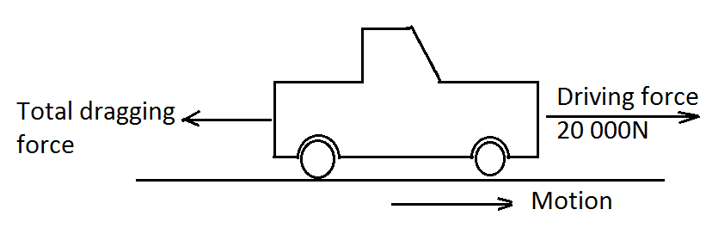
- State the size of the drag force when the car is travelling at a constant speed.
- If the car accelerates at${5 m}/{s^{2}}$ work out the total dragging force.
- The car continues accelerating at${ 5 m}/{s^{2}}$ but eventually reaches the highest constant speed. Explain?
Solution
- At constant speed,$Resultant force=0 N$
$$∴Total dragging force=Driving force=20 000N$$
- According to Newton’s 2nd law
$$resultant force=mass ×acceleration$$
$$Driving force-Total drag force=ma$$
$$20 000N-F=1000 kg ×{5 m}/{s^{2}}$$
$$F=20 000N-5000N$$
$$F=15 000N$$

- As the speed of the car increases, air resistance increases. At some point the total drag equals the highest driving force, hence the car cannot accelerate any further.
Free fall in Vacuum
An object falling in a vacuum does not experience air resistance and up thrust force opposing its motion. The only force acting on the body is its weight so the body accelerates downwards due to gravity. $∴ a=g.$
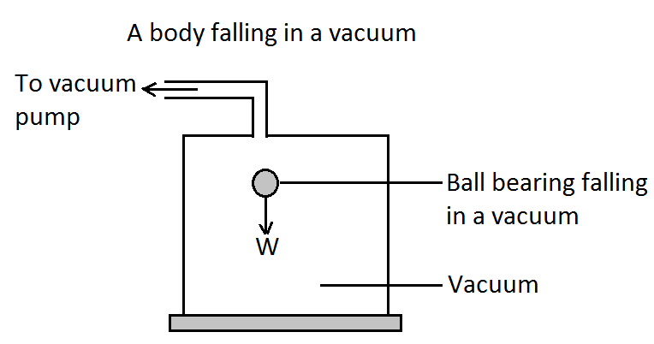
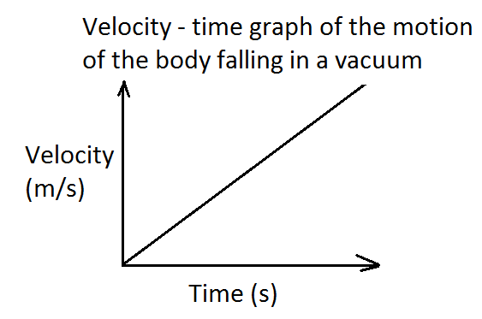

TOPIC 4: HOOKE’S LAW
Effects of force
Force can cause change in shape, size, motion and direction of an object.
Activity
To demonstrate effects of forces on bodies
- Take a rubber band and pull its two ends and see what happens.
- Take a piece of mattress and squeeze it. Observe what happens?
Observation
We notice that the rubber band increases in length and the piece of the mattress reduces in size.
Conclusion
We conclude that force can cause change in size and shape of an object.
Relationship between the applied force and the extension of the material used
Experiment
Aim: to investigate the relationship between the extension produced in a spring and the force applied.
Apparatus: a meter ruler, a spiral spring, a stand with clamp six 50 g masses.
Procedure
- Set up the apparatus as shown in figure (a) below. Note that the initial position$\left(x\right)$ of the pointer before the weight is loaded.
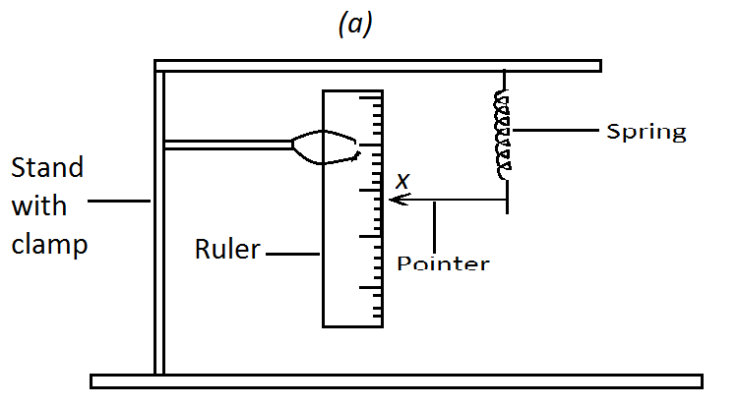
$$The intial pointer reading x= cm$$
- Load the spring with a 50g mass and record the new pointer reading. Unload the spring and observe what happens to the pointer.
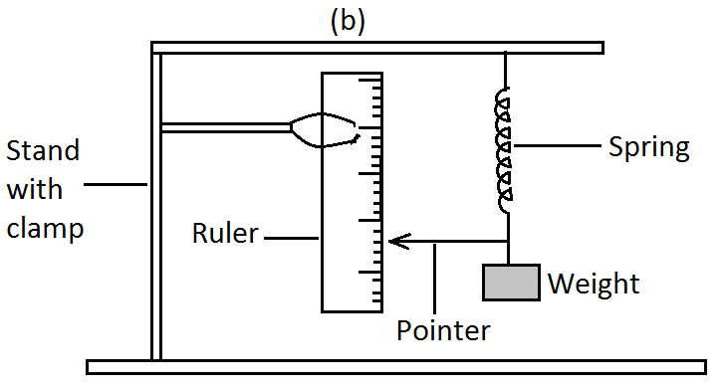
- Repeat step 2 with 100 g, 150g, 200g, 250g and 300g masses and record the readings in a table.
- Draw a graph of applied force against extension produced.
Discussion (observation)
The expected graph of Force (N) against extension (cm) obtained in the experiment is as follows:
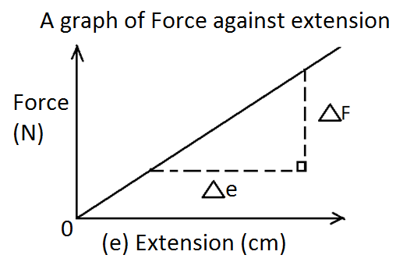
The graph of force against extension gives a straight line graph passing through the origin.
$$The spring constant, K=gradient=\frac{∆F}{∆e}$$
Conclusion
The graph shows that the extension produced is directly proportional to the force applied. Materials that are able to recover their original shape and size after unloading are said to be elastic.
Elastic limit
Elastic limit is the point beyond which a stretched spring or wire cannot attain its original length when the stretching force is withdrawn. When the spring is overloaded i.e. stretching force is exceeds elastic limit, the spring is said to have been permanently deformed. Below is a graph of force against extension after the spring has been permanently deformed.
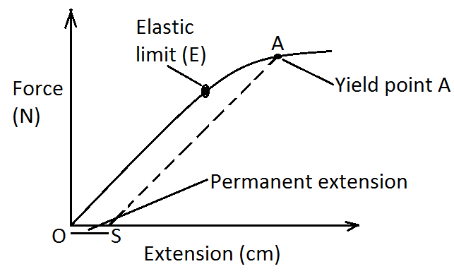
$$Along OE:elestic deformation=spring obeys Hooke^{'}s law.$$
$$Along EA:elestic deformation=Hooke^{'}s law is no longer obeyed.$$
$$Point E:yield point=material loses its elasticity and breakage occurs.$$
Hooke’s law states that provided the elastic limit is not exceeded, the extension of a spring is directly proportional to the load applied on the spring. Or
Hooke’s law states that the extension of an elastic material is directly proportional to the force applied provided that the elastic limit is not exceeded.
Mathematically Hooke’s law is expressed as follows: $F∝e which imply that F=Ke$ where K is a constant of proportionality called the spring constant. Hence$K=\frac{F}{e}$
The SI unit of the spring constant, K, is the${newton}/{meter} \left(N/m\right)$
Note that: rubber band does not obey Hooke’s law. Below is a graph of Load (force) against extension of rubber band.
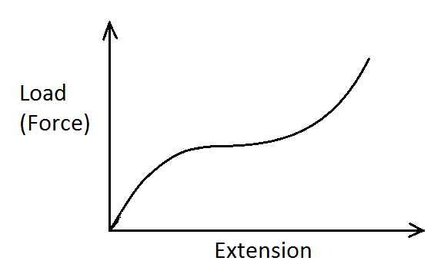
Worked examples on Hooke’s law with a single spring.
Example 1
A sack containing drugs was weighed on the spring balance which stretched by 3 cm. if the sack had a mass of 200 g, calculate the spring constant of the spring balance.

Solution
$$F=ke$$
$$F=mg$$
$$F=\frac{200}{1000}kg×{10 N}/{kg}=2N$$
$$e=\frac{3}{100}m=0∙03m$$
$$k=\frac{F}{e}=\frac{2N}{0∙03 m}={66∙67 N}/m$$

Example 2
A spring has a spring constant of${200 N}/m.$ If it is compressed by$0∙06$. Calculate the compressed force.

Solution
$k={200 N}/m, e=0∙06m$
$$F=ke$$
$F={200 N}/m×0∙06m=12N$

Example 3
A force of 12N extends a spring by 8 mm. Calculate the extension that is produced by the same spring if a force of 20N is hanged on it. (assume the elastic limit is not exceeded).

Solution
$$k=\frac{F}{e}=\frac{12 N}{8 mm}={1∙5 N}/{mm}, now when F=25N$$
$$Extension, e=\frac{F}{k}=\frac{25 N}{{1∙5 N}/{mm}}$$
$$e=16∙67 mm$$

Combination of springs in series and parallel
- Combination of springs in series
Experiment
Aim: to determine the spring constant of two springs arranged in series.
Apparatus: metre ruler, clamp and clamp stand, two springs of the same constant of proportionality, six masses of 50 g, 100 g upto 300 g.
Procedure
- Set up the apparatus as shown below. Record the pointer reading before loading the springs at$\left(x\right)$
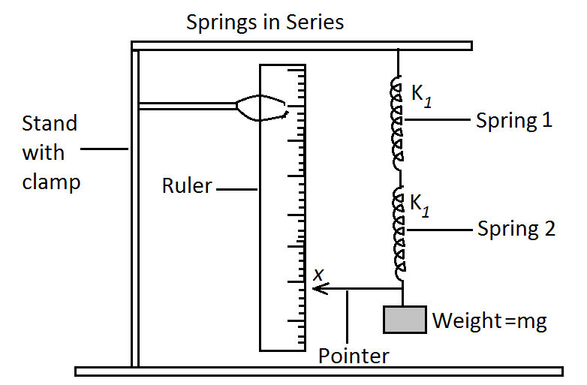
- Load the spring with a 50g mass and record the new pointer reading. Unload the spring and observe what happens to the pointer.
- Repeat step 2 with 100 g, 150 g, 200 g, 250 g and 300 g masses and record the readings in a table.
Mass (g) | Force (N) | Final reading  y (cm) | Extension, e  $$=y-x (cm)$$
50 | $$0∙5$$
100 | $$1∙0$$
150 | $$1∙5$$
200 | $$2∙0$$
250 | $$2∙5$$
300 | $$3∙0$$

- From the results draw a graph of the force applied against the extension and use your graph to determine the spring constant for the two springs in series.
Expected results
- A single spring produces an extension,$e$.
- For two identical springs arranged in series is expected to produce an extension of$2e$ for the same force.
Applying Hooke’s Law
$$F=k_{1}e-----for the single spring.$$
$$F=k_{s}×2e----for the two springs in series.$$
$$where F=applied force, { k}_{1}=spring constant for the single spring,$$
$$k_{s}=spring constant for the two springs connected in series.$$
Since the same force is used, then$k_{s}×2e={ k}_{1}×e$
$$∴ k_{s}=\frac{{ k}_{1}×e}{2e}$$
$$Hence k_{s}=\frac{1}{2}×{ k}_{1}=\frac{{ k}_{1}}{2}$$
Conclusion
In general the spring constant,$k_{s}$ for$n$ identical springs in series is given by the expression.
$${ k}_{s}=\frac{{ k}_{1}}{n} where { k}_{1}=spring constant for one spring and n=1,2,3,4, -------$$
$$\left(is number of springs\right)$$

- Combination of springs in parallel
Experiment
Aim: to determine the spring constant for two springs in parallel.
Repeat this experiment as in series but with the following set up:
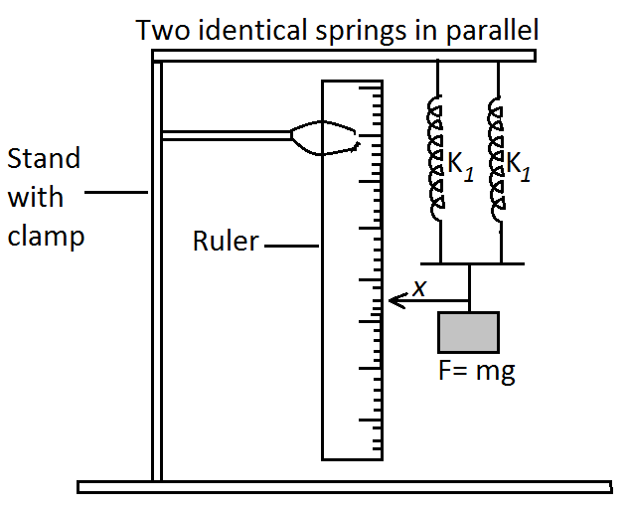
Expected results
- A single spring produces an extension,$e$.
- For two identical springs arranged in parallel is expected to produce an extension of$\frac{1}{2}e$ for the same force.
Applying Hooke’s Law
$$F=k_{1}e-----for the single spring.$$
$$F=k_{p}×\frac{1}{2}e----for the two springs in parallel.$$
$$where F=applied force, { k}_{1}=spring constant for the single spring,$$
$$k_{p}=spring constant for the two springs connected in parallel.$$
Since the same force is used, then$k_{p}×\frac{1}{2}e={ k}_{1}×e$
$$∴ k_{p}=2{ k}_{1}$$
Conclusion
In general the spring constant,$k_{p}$ for$n$ identical springs in parallel is given by the expression.
$${ k}_{p}=n{ k}_{1} where { k}_{1}=spring constant for one spring and$$
$$n=1,2,3,4, -----\left(is number of springs \right)$$
Note: parallel arrangement produces a stronger or stiffer spring system than a single spring.
Application of Hooke’s Law
- Calibration of spring balance which are used to measure weight of various substances.
- Elasticity in materials e.g. springs is applied in making spring beds, diving boards, etc.
- Stretching and compressing of spiral springs helps in designing spring shock absorbers or shock breakers.
- Elastic materials are used in making rubber bands, rubber shoes, etc.
Worked examples on springs in series and parallel connections
Example 1
Calculate the extension produced in 2 springs of spring constant${8 N}/m$ if they are arranged in series and a weight of$2∙4 N$ is hang from them.
Solution
In series arrangement,${ k}_{s}=\frac{{ k}_{1}}{n} , where$
$${ k}_{1}=spring constant of one spring, n=number of springs.$$
$$∴ { k}_{1}={8 N}/m and n=2$$
$$\overset{⇒}{ }{ k}_{s}=\frac{{8 N}/m}{2}={4 N}/m$$
By Hooke’s Law, $F={ k}_{s}×e$
$$\overset{⇒}{ }e=\frac{F}{{ k}_{s}}$$
$$e=\frac{2∙4 N}{{4 N}/m}=0∙6 m$$

Example 2
Figure A and B show two system of identical springs in series and parallel respectively. If each spring has a spring constant of${50 N}/{cm}$. Calculate the total extension produced by the load attached in each system. (assume the springs are weightless)
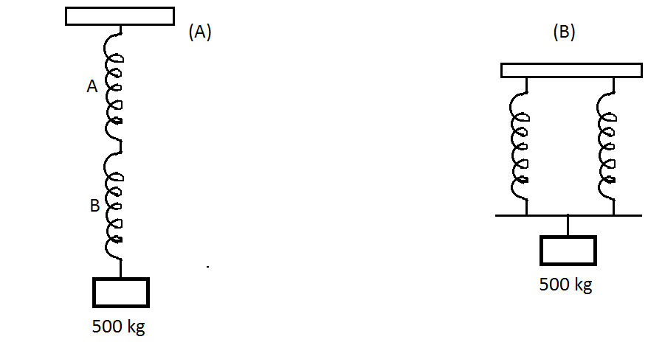
Solution
- $F=mg=500kg×\frac{10 N}{kg}=5000 N$
In series
$${ k}_{s}=\frac{{ k}_{1}}{n}$$
$${ k}_{1}={50 N}/{cm}, n=2$$
$${ k}_{s}=\frac{{50 N}/{cm}}{2}={25 N}/{cm}$$
By Hooke’s law,$F=k_{s}e$
$$e=\frac{F}{k_{s}}=\frac{5000 N}{{25 N}/{cm}}=200 cm$$

- $F=5000 N$
In parallel
$${ k}_{p}=n{ k}_{1} where { k}_{1}={50 N}/{cm}, n=2$$
$$\overset{⇒}{ }{ k}_{p}=2×{50 N}/{cm}={100 N}/{cm}$$
By Hooke’s Law, $F={ k}_{p}×e$
$$e=\frac{F}{{ k}_{p}}=\frac{5000N}{{100 N}/{cm}}=50 cm$$
Example 3
A student applies a force of 6 N to a herical spring and it extends by 12 cm. He then hangs the spring in parallel with an identical spring and attaches a load of 10 N. What is the new extension in each of the spring?
Solution
By Hooke’s Law,$F=k_{1}e F=6 N, e=12 cm$
$$k_{1}=\frac{F}{e}=\frac{6 N}{12 cm}=0∙5N/{cm}$$
$$∴for the two springs in parallel, { k}_{p}=n{ k}_{1}$$
$${ k}_{p}=2×0∙5N/{cm}$$
$${ k}_{p}={1 N}/{cm}$$
$$e=\frac{F}{{ k}_{p}}=\frac{10 N}{{1 N}/{cm}}=10 cm$$
Example 4
Figure below shows three identical springs with a spring constant of${5 N}/{cm}$ each. A weight of 30 N is hung on the lower springs set up. Find the total extension of the set up.
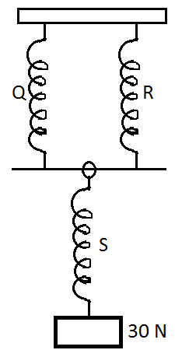
Solution
For spring S, ${ F}_{s}=30 N, k_{1}={5 N}/{cm}, e_{1}=?$
$$e_{1}=\frac{{ F}_{s}}{k_{1}}=\frac{30 N}{{5 N}/{cm}}=6cm$$
Spring Q and R share the load and are in parallel.
$∴{ k}_{p}=n{ k}_{1}, n=2, k_{1}={5 N}/{cm}$
$${ k}_{p}=2×{5 N}/{cm}$$
$${ k}_{p}={10 N}/{cm}$$
By Hooke’s Law,$F=k_{p}e_{p}$
$$e_{p}=\frac{F}{{ k}_{p}}=\frac{30 N}{{10 N}/{cm}}=3 cm$$
$$∴Total extension=e_{1}+e_{p}$$
$$∴Total extension=6cm+3 cm=9 cm$$
Alternatively in parallel
Since springs Q and R share the load
$$F_{q}=\frac{30 N}{2}=15 N, k={5 N}/{cm,} e_{q}=?$$
$$F_{q}=ke_{q}$$
$$15N={5 N}/{cm}×e_{q}$$
$$e_{q}=\frac{15 N}{{5 N}/{cm}}=3 cm$$

TOPIC 5: UNIFORM CIRCULAR MOTION
ILLUSTRATING CIRCULAR MOTION
ACTIVITIES
- Motion of drops of water on a rotating umbrella.
Apparatus: a wet umbrella.
Procedure: take an umbrella that is wet with water. With the umbrella open and its handle horizontal, rotate the handle in a circular manner. Rotate the handle faster and watch the motion of the umbrella and the drops of water on the cloth of the umbrella. What happens to the drops of water? Why?
Expected observation: initially the water drops move in a circular path with the cloth of the umbrella. The force of adhesion between the drops of water and the cloth makes the cloth and the drops of water to move together in a circular path. As the speed of the handle increases, the adhesive force of the drops of water give up and the drops of water breaks off from the cloth and fly off.
- Motion of a rotating mass attached to a spring balance
Procedure
- Take a disc with smooth surface and mount it horizontally, with a peg through its centre, so that it can rotate about a vertical axis. Attach one end of a string to a peg and the other end to a spring balance.
- Place the spring balance along the radius of the disc. Attach a mass (100g) to the other end of the spring balance using a string as shown below.
- Rotate the disc and observe what happens to the reading of the spring balance. What happens to the mass? Why?
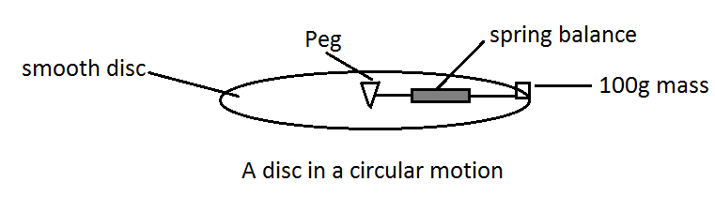
Expected observation
The mass moves outwards and the string tighten. The spring balance reads the force exerted by the string on the mass. When the speed increases, the reading increases. The balance is a measure of the force directed towards the centre.
- Motion of a roating ball attached to a string.
Apparatus: a small ball and a string.
Procedure:
- Tie a small ball to one end of a string. Grip the free end of the string with one hand and rotate it in a circular manner, above the head, so that the ball moves in a horizontal circle.
- Rotate the hand faster and then release the string. What happens to the ball as the string is released? Explain?
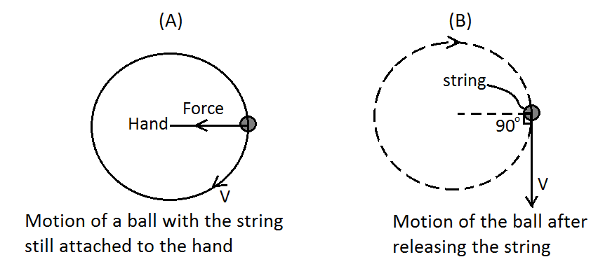
Expected observation
The pull of the hand on the string provides a force directed towards the centre and the ball is kept in a circular path of constant radius. When the string is released, suddenly there is no tension in the string and the ball having uniform velocity flies off along the tangent, at the point of release.
CONCLUSION
All the above activities illustrate the motion of a body in a circle of certain radius. If the radius sweeps equal angles in each second, then the angular velocity of the body is uniform and the body is said to execute uniform circular motion.
ANGULAR DISPLACEMENT
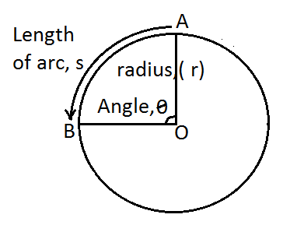
Consider the figure above where an object moves round from position A to position B on a circumference of a circle with centre O and radius, r.
Assume that the object takes time, t to move from position A to position B through an arc length, s. The object moves through the angle, $θ$, which is the difference in final and initial angle from A to B.
Angular displacement is the angle through which a body moves in circular path. Angular displacement is measured in radian (rad.).

THE RADIAN
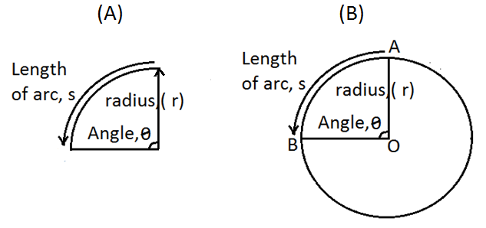
If a circle of radius r is fixed at one end (centre) and the other end (circumference) is moved around the fixed end in a circular path of arc length s as in figure A above, the angle $θ$ through which the radius r rotates is defined as:
$Angle of rotation, θ=\frac{length of arc, s}{radius of arc, r}$
That is to say
$$θ=\frac{s}{r}$$
Radian is the unit used to measure angle of rotation measured by taking the ratio of arc length, s covered against radius, r.
For example in a circle of radius (r) 2cm and swept arc length (s) of 3cm, then the angle $θ$ in radians is found as follows:
$angle, θ=\frac{s}{r}=\frac{3cm}{2cm} radians$
$$angle, θ=1∙5 radians or 1∙5 rad$$

For one complete rotation, length of the whole circumference is$2πr$. For a circle of radius,$r$
$$one complete rotation, θ=\frac{2πr}{r} radians=2π Radians$$
In degrees, $one complete rotation, θ=360°$
$$∴2π Radians=360°$$

WORKED EXAMPLE ON RADIAN AND DEGREES
The radius of a particle moving along a circular path sweeps through an angle of$60°$ at the centre of the circle. Calculate the angular displacement of the particle in radians?

Solution
$$360°=2π Rad$$
$$60°=x$$
$$\overset{⇒}{}x×360°=60°×2π Rad$$
$$\overset{⇒}{} x=\frac{60°×2π Rad}{360°}$$
$$∴angular displacement in radians=\frac{π}{3}rad$$

ANGULAR VELOCITY
Angular velocity$(ω)$ is the rate of change of angular displacement. i.e. $ω=\frac{θ}{t}$
SI units of angular velocity are radians per second$\left({rad}/s\right)$. Other units of angular velocity are degrees per second$\left({dgrees}/{sec}\right)$ or revolutions per minute$\left({rev}/{min}\right)$.
RELATIONSHIP BETWEEN ANGULAR VELOCITY AND FREQUENCY
For one complete circular motion (rotation/revolution/oscillation)
- $θ=2π Rad.$
- $time taken(t)=Period=T$
- $f=\frac{1}{T} or T=\frac{1}{f}$
$$Since angular velocity \left(ω\right)=\frac{θ}{t}$$
$∴ ω=\frac{2π}{T} , substiting T with \frac{1}{f}$ gives
$$ω=2π÷\frac{1}{f} which implies that ω=2πf$$
$$∴angular velocity=2π×frequency \left(f\right)or ω=2πf$$

RELATIONSHIP BETWEEN ANGULAR VELOCITY AND LINEAR (TANGENTIAL) VELOCITY
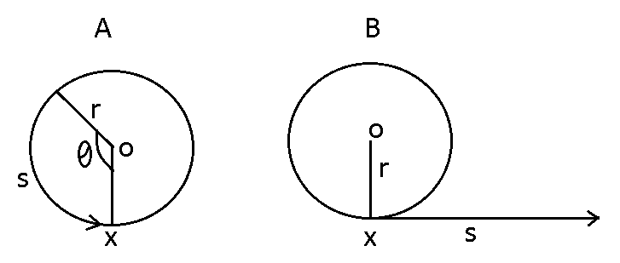
Consider a body that was moving in circular motion as shown in figure (A) above, its angular velocity is given by $ω=ϑ/t$.
If the body is released at point X covering displacement, s in time, t as shown (B) above then linear or Tangential velocity, v is given by$linear velocity\left(v\right)=\frac{displacement \left(s\right)}{time \left(t\right)} which in short is, v=\frac{s}{t}$
Now from$θ=\frac{s}{r} implies that s=rθ$
$$s=rθ$$
$$\frac{s}{t}=\frac{rθ}{t} (dividing by t both sides)$$
$$linear velocity \left(v\right)=r×angular velocity$$

$$Hence, v=rω$$

WORKED EXAMPLES ON ANGULAR VELOCITY AND LINEAR VELOCITY
EXAMPLE 1
Calculate the angular velocity of a second hand of a clock.
Solution
$Angular velocity, ω=\frac{θ}{t}$
For one complete rotation, second clock take, $t=60s and θ=2π rad$
$$ω=\frac{2π rad}{60s}=\frac{π}{30}{rad}/s$$

EXAMPLE 2
A bicycle wheel makes 300 revolutions per minute (rpm. Calculate the angular velocity of the wheel.
Solution
The wheel makes 300 rev. in 1 min. Therefore in each second the wheel makes
$\frac{300 rev}{60 s}={5 rev}/s$
$$1 revolution=2π rad$$
$$∴{5 revolutions}/s=5 ×{2π rad.}/s$$
$$∴{5 revolutions}/s={10π rad}/s.$$
$$Hence angular velocity, ω={10π rad}/s$$

EXAMPLE 3
A ball tied to a string is rotated at uniform speed in a circle of radius 10 cm. It takes$1∙5 s$ to describe an arc of length 6 cm. calculate its
- Tangential velocity.
- Angular velocity.
- Periodic time.
Solution
- $linear velocity, v=\frac{displacement(s)}{time taken (t)}$
$$s=6 cm and t=1∙5s, v=\frac{6cm}{1∙5s}={4cm}/s$$
- $since v=rω , it implies that ω=\frac{v}{r}=\frac{{4cm}/s}{10cm}={0∙4 rad}/s$
- $ω=\frac{2π rad.}{T}, hence T=\frac{2π}{ω}=\frac{2π rad.}{0∙4{rad.}/s}=5π seconds.$

EXAMPLE 4
The wheel of a car of radius 20 cm is rotating at a frequency of 20 Hz. Calculate the linear speed of the car.
Solution
Angular velocity of the wheel
$$ω=\frac{θ}{t}=\frac{2π}{T}=2πf$$
$$∴ω=2π×20 Hz=40π {rad}/s$$
$$linear, v=radius, r×angular velocity, ω$$
$$∴v=20 cm×40π {rad}/s$$
$$Hence, the lenear speed of the car=800π {cm}/s$$

CIRCUALR MOTION AND CENTRIPETAL FORCE
ACTIVITY
AIM: To describe centripetal force.
APPARATUS: String, spring balance and mass.
PROCEDURE
- Tie a mass to a string leaving about 1 m length of the string.
- Whirl the mass round and round your head with your arm stretched and feel the force that is acting on your hand.
- In which direction is the force that acts on your hand?
- Why does the mass not move out of the circle?
- Whirl the mass round more strongly.
- How do you compare the force acting on your hand between low and high circular speed.
- If you were to let the string go, would the mass continue to move with circular motion? Explain what would happen.
- Discuss why the mass in circular motion is in constant acceleration. In which direction is
- The acceleration that keep the circular motion.
- The resultant force that causes the motion.

EXPECTED OBSERVATION
- The string pulls out on the hand at one end. On the other end the string pulls inward on the mass. These two forces are equal and in opposite direction according to Newton’s third law.
- The resultant (unbalanced) force that acts on the ball changes its motion, by directing it towards the centre of its circular path.
- Consider the mass at position A under circular motion as shown in the figure below.
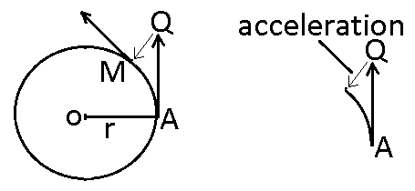
- If the mass is let go at A, it would move in a straight line towards Q. instead the mass has followed circular path AM. In other words it can be said that the mass has moved from Q to M towards the centre of its circular path.
- The unbalanced inward force that acts on a body in circular motion is called centripetal force. The role of the centripetal force is only to change the direction of motion of the ball towards the centre
- This centripetal force causes an acceleration towards the centre which can be obtained by using Newton’s second law,$F=ma$

DEF: Centripetal force is the force which acts on an object towards the centre of the circle to make an object move in a circle. Or centripetal force is the force acting on an object in circular motion, directed towards the circular path centre.
FACTORS THAT AFFECT MAGNITUDE OF THE CENTRIPETAL FORCE (F)
- Speed of revolution (v) of a body undergoing circular motion. The force, F required to keep the body in a circular path of constant radius is directly proportional to the square of the speed of revolution.$F∝v^{2}$.
- Radius (r) of the circular path. The force F needed is inversely proportional to the radius (r) of the circular path, when the speed of revolution of the body is constant.$F∝\frac{1}{r}$
- Mass (m) of a body undergoing circular motion. The force F required is directly proportional to the mass undergoing circular motion. $F∝m$
If we combine the three variations as joint variation we get$F∝\frac{{mv}^{2}}{r}$
$$∴F=\frac{{Kmv}^{2}}{r} where K is the constant of proportionality$$
$$Experiments show that K=1, hence, centripetal force, F=\frac{{mv}^{2}}{r}$$
Where, F= centripetal force, m=mass of the object, v= linear speed along the circular path in $m/s$ and r = the radius of the circular path.

CENTRIPETAL FORCE IN TERMS OF ANGULAR VELOCITY
Linear velocity, $v=rω$, where$ω$ is angular velocity substituting for $v$ in $F=\frac{{mv}^{2}}{r} gives$
$$F=mrω^{2}$$

CENTRIPETAL ACCELERATION
Newton’s second law of motion gives, $F=ma$
Centripetal force gives, $F=\frac{{mv}^{2}}{r}$
Equating the above two equations gives
$$ma=\frac{{mv}^{2}}{r}$$
$$Hence, Centripetal acceleration, a=\frac{v^{2}}{r}$$

CENTRIFUGAL FORCE
This is a force that tends to throw objects in circular motion outwards from the centre of orbit. Objects with larger masses tend to move outwards more than the objects with smaller masses.
WORKED EXAMPLE ON CENTRIPETAL FORCE
A car of mass 1200 kg has to make a circular turn of radius 30m. If it is moving with uniform speed of $10 m/s$
- Calculate the Centripetal force acting on the car.
- Calculate the acceleration of the car towards the centre of its orbit
Solution

$$Centripetal force, F=\frac{{mv}^{2}}{r}=\frac{{1200 kg ×\left(10m/s\right)}^{2}}{30 m}=4 000 N$$

$$a=\frac{v^{2}}{r}=\frac{{\left(10m/s\right)}^{2}}{30m}=3∙33m/{s^{2}}, alternatively, a=\frac{F}{m}=\frac{4 000 N}{1200 kg}=3∙33m/{s^{2}}$$

APPLICATIONS OF UNIFORM CIRCULAR MOTION
- When a car is going round a circular path on a horizontal road, the centripetal force required for the circular motion is provided by the frictional force between the tyres and the road.
- A car cornering on a banked road (road raised gradually from the centre to the edge). By banking a curve at the optimum angle, the normal force, n can provide the necessary centripetal force without the need of friction force.
- Planets in orbit. Planets and satellites move in uniform circular motion. They are kept in orbit by the centripetal force between them and the body around which they are orbiting.
- A cyclist going around a curve leans inwards to provide the necessary centripetal force, so as to be able to go along the curved track.
- The conical pendulum. It consist of a mass m revolving in a horizontal circle of radius R at the end of a cord of length L. The vertical component of tension T is equal to the weight of the mass while the horizontal component of the tension T generates the centripetal force for the circular motion.

TOPIC 6: MOMENTS OF FORCES
Moment of force about a point is the product of force and the perpendicular distance from the point to the line of action of the force. The moment of a force about a point is either clockwise or anticlockwise about the point e.g.
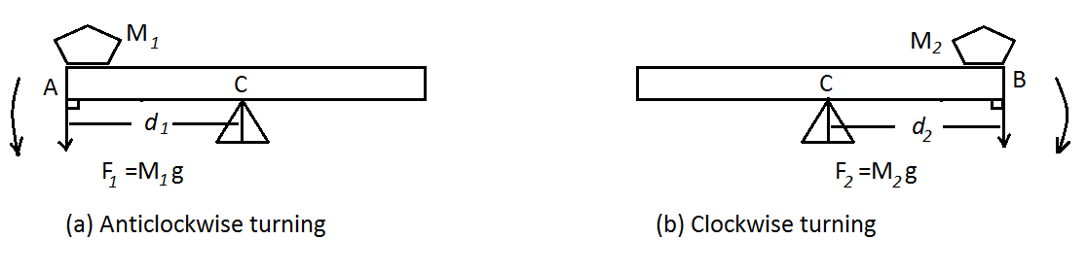
- $Anticlockwise moment about point C=F_{1}×d_{1}$
- $Clockwise moment about point C=F_{2}×d_{2}$
In general, mathematically, Moment of a force about a point = force × perpendicular distance from the point to the line of action of the force. i.e. $Moment of force about a point=F×d$
SI unit of moment is newton metre (Nm). Moment of a force is a vector quantity since it has both magnitude and direction.
Worked example on moment of a force
Calculate the moment of the force about the fulcrum when a pet dog of mass 10 kg is at a distance of$1∙2 m$ from the fulcrum of the seesaw as shown below:
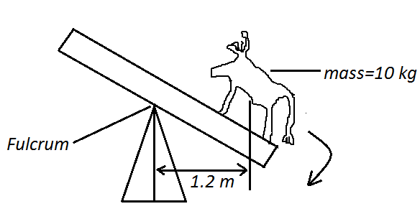
Solution
$$F=mg=10 kg×{10N}/{kg}$$
$$F=100N$$
$$Moment of the force about the fulcrum=force ×⊥distance from the fulcrum$$
$$Moment of the force about the fulcrum=100N×1∙2m$$
$$Moment of the force about the fulcrum=120 Nm in the clockwise direction.$$
The principle of moments
The principle of moment gives the relationship between two moments that are at the same turning point (fulcrum).
Experiment
Aim: to investigate the principle of moments.
Apparatus: A metre ruler, string, three 100 g mass and support/clamp.
Procedure
- Suspend a uniform meter ruler from a firm support/ clamp, at the 50 cm mark i.e. at its mid-point P using a string.
- Suspend a 100 g mass at a point A as in figure (b). observe what happens.
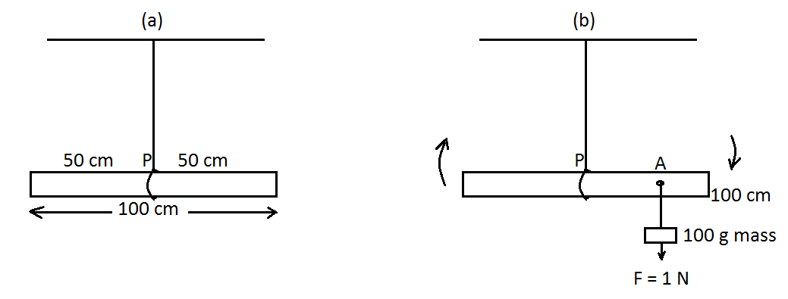
Observation
The meter ruler turns in the clockwise direction. There is a moment of force in the clockwise direction due to the force acting vertically downwards at point A.
$$Moment of the force in the clockwise direction=Force×perpendicular distance$$
$$Moment of the force in the clockwise direction=1∙0 N×distance PA$$
- Now suspend a 200 g mass at a point B near the 0 cm mark as in figure (c) below. What has happened? The system turns in the anticlockwise direction. Now adjust the position of B till the system balances horizontally as shown in figure (d) below.
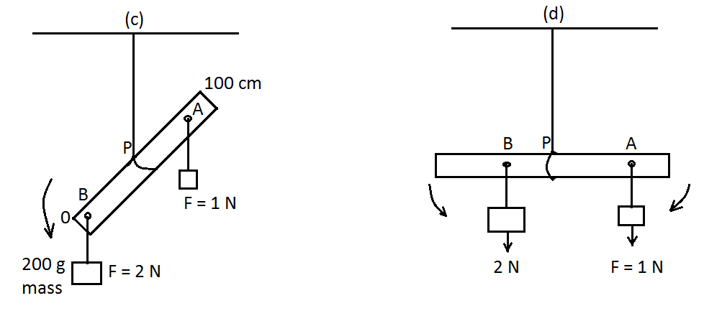
Moment due to the 2 N force about P is$2N×PB$ in the anticlockwise direction. Measure the distance PA and PB. Compare the values of$1∙0×PB and 2∙0×PB.$ What can you say about these values? We note that the two moments are equal in magnitude and opposite in direction. The clockwise moment of the 1 N force about point P is equal to the anticlockwise moment of the 2 N force about point P.
Principle of moments with more than two forces
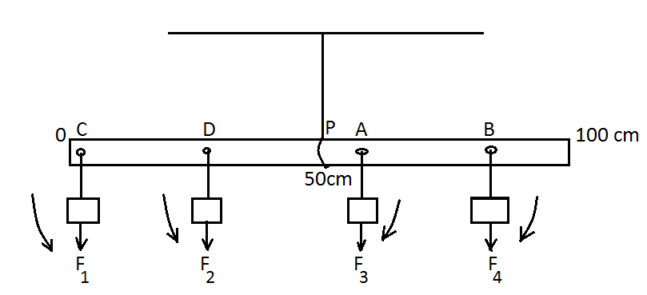
- Adjust the masses$F_{1} and F_{2}$ until the system is balanced horizontally as in the above figure.
- Calculate the moments about point P.
Results
- $The sum of the clockwise moments=F_{3}×PA+F_{4}×PB$
- $The sum of the anticlockwise moments=F_{1}×PC+F_{2}×PD$
- We observe that the system is balanced
$$∴ F_{3}×PA+F_{4}×PB=F_{1}×PC+F_{2}×PD$$
$$Hence, \left(sum of clockwise moments\right)=\left(sum of anticlockwise moments\right).$$
- When a body is balanced under the action of a number of forces, it is said to be in equilibrium.
The principle of moments states that when a body is in equilibrium under the action of forces, the sum of clockwise moments about any point is equal to the sum of anticlockwise moments about the same point.
Worked examples on principle of moments
Example 1

A uniform meter ruler is pivoted at its centre P and 3 masses are placed at A,B and C as shown in the figure below. Find the value for the weight W of the mass M placed at C so that the matre ruler is balanced horizontally.
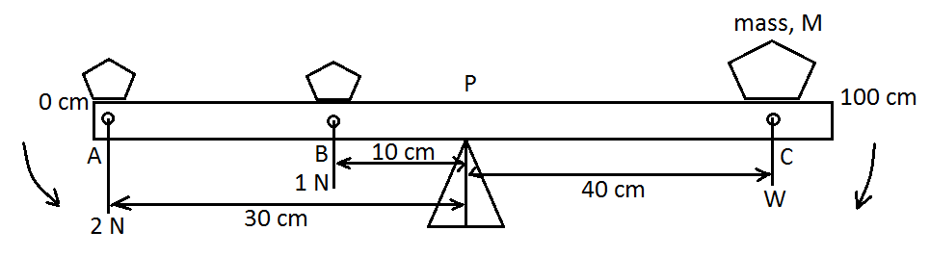

Solution
Taking moments about P, when the metre ruler is in equilibrium
$$sum of the clockwise moments about point P=sum of the anticlockwise moments about P$$
$$W×0∙4 m=\left(2∙0 N×0∙3 m\right)+\left(1∙0 N×0∙1 m\right)$$
$$W=\frac{\left(2∙0 N×0∙3 m\right)+\left(1∙0 N×0∙1 m\right)}{0∙4 m}$$

$$W=\frac{0∙6 Nm+0∙1 Nm}{0∙4 m}$$
$$W=\frac{0∙7 Nm}{0∙4 m}=1∙75 N$$

Example 1
The uniform plank of wood in figure below is balanced at its centre by the forces shown. Determine the value of W in kg.
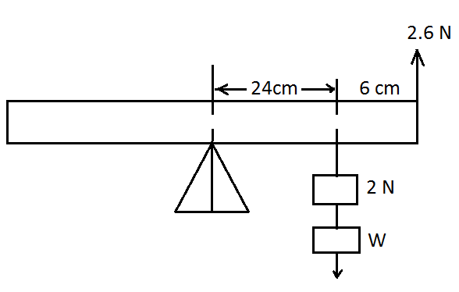

Solution
Note: the$2∙6 N$ produces an anticlockwise moment.
$$sum of clockwise moments=sum of anticlockwise moments$$
$$0∙24m×\left(2+W\right)=2∙6 N×0∙30 m$$
$$0∙24m×2N+0∙24W=0∙78 Nm$$
$$0∙48 Nm+0∙24W=0∙78 Nm$$
$$0∙24W=0∙78 Nm-0∙48Nm$$
$$W=\frac{0∙3 Nm}{0.24 m}=1∙25N$$
$$In kg 1∙25N=\frac{1∙25 }{10} kg=0∙125 kg$$

Couple
Parallel forces which act in the same direction are called like parallel forces. Parallel forces which act in the opposite directions are called unlike parallel forces. If two equal unlike parallel forces act on a body at different points form a couple as in the figure below.
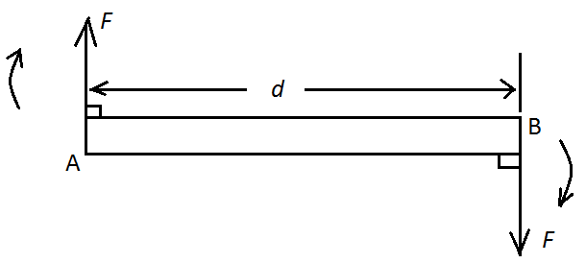
A couple produces a turning effect on a body.
Moment of a couple
The figure below shows a couple acting on bar AB.
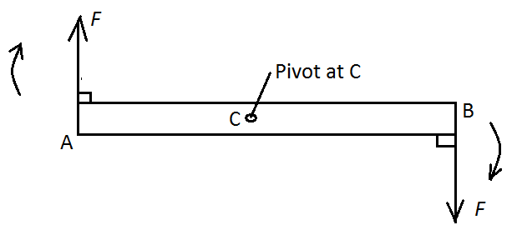
$$Moment of force about point C acting at point A=F×AC in the clockwise direction$$
$$Moment of force about point C acting at point B=F×BC in the clockwise direction$$
$$The moment of the couple=\left(F×AC\right)+\left(F×BC\right)$$
$The moment of the couple=F\left(AC+BC\right)$, but, $AB=AC+BC$
$$The moment of the couple=F×AB$$
$$The moment of the couple=F×Arm of the couple$$
The moment of the couple is also known as the torque.
The moment of the couple (Torque) is the total rotating effect of a couple and is given by the product of one of the forces and the perpendicular distance between the forces.
Example on Torque
In figure below, each force is 4 N and the arm of the couple is 20 cm. Calculate the moment of the couple.
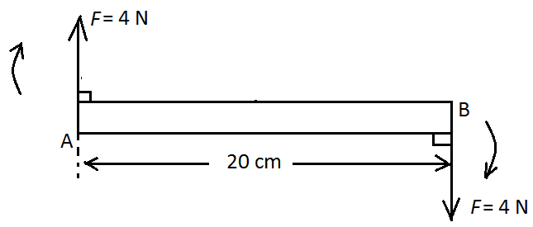
Solution
$The moment of the couple (torque)=F×perpendicular distance$
$$The moment of the couple \left(torque\right)=4N×0∙20m$$
$$The moment of the couple \left(torque\right)=0∙80 Nm.$$
Some common examples of a couple
- Forces applied by hands to turn a steering wheel of a motor car or handle of a bicycle.
- A water tap being opened or closed.
- A cork being removed from the mouth of a bottle using a cork – screw.
- Spanner unscrewing a nut.
Centre of mass of a body
Sir Isaac Newton showed that bodies experience a force of gravity exerted on them by the earth. This force of gravity is always directed towards the earth’s centre and is called the weight of the body. How is the weight distributed throughout the body?
Experiment
Aim: to investigate where the weight of a body acts from.
Apparatus: a table and a thin rectangular card and a ruler.
Procedure
- Place a thin rectangular card near the edge of the bench top.
- Pull the card slowly away from the bench until it is just about to slip down when released.
- Using a ruler, mark and draw the line AB along which the card balances.
- Repeat steps (1) to (3) with the other side of the card, mark and draw the line CD along which the card balances.
- The line AB and CD intersect at a point, mark it M.
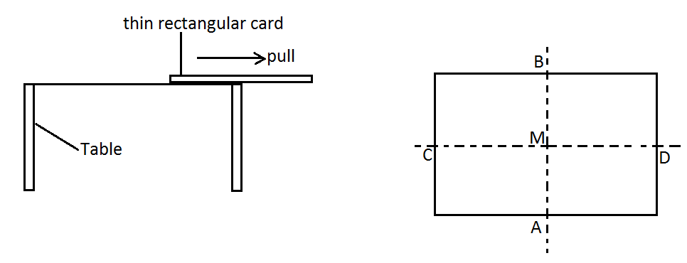
- Now try to balance the card with the point M placed at the tip of your fore finger. The card is observed to balance horizontally on the finger.
Observation
The cardboard balances horizontally at a certain point only.
Discussion
Point M is called centre of mass of the cardboard. This is the point where the whole mass of the card is concentrated.
The centre of mass of a body is the point where the whole mass of the body appears to be concentrated.

Experiments show that bodies with uniform cross section area and density have their centres of mass located at their geometrical centres. For example
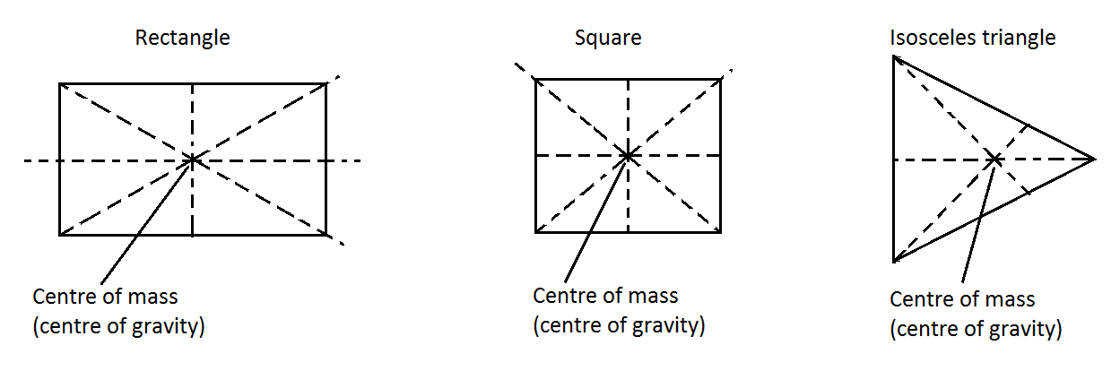
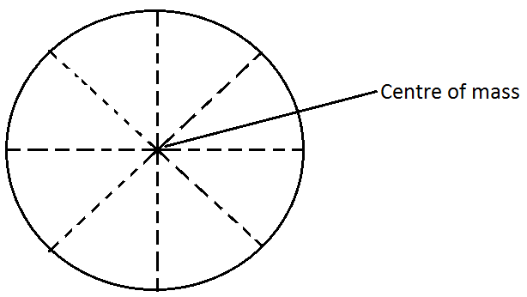
Centre of mass of lamina
A lamina is a body whose thickness is very small compared with the other dimensions of the body. For example the covers of the book, the leaf blade are all lamina.
Experiment
Aim: to determine the centre of mass of an irregular lamina using a plumbline.
Apparatus: an irregular lamina, plumbline, a drawing pin.
Procedure
- Make three holes P, Q and R on an irregularly shaped lamina as close as possible to the edges and far away from each other. The holes should be large enough to allow the lamina turn freely when supported by a drawing pin.
- Suspend the lamina on the clamp using the drawing pin each hole at a time.
- Suspend a plumbline (a thin thread with a small weight at one end) from the point of support, P as shown in the figure below. Draw the line of the plumbline on the lamina by marking two points A and B far apart and joining them.
- Repeat the procedure above with the support Q and mark the point M where the two lines intersect.
- Check the accuracy of your method by suspending the lamina at R.
- The plumbline pass through M as in figure (b) below. Check the results again by balancing the lamina about point M.
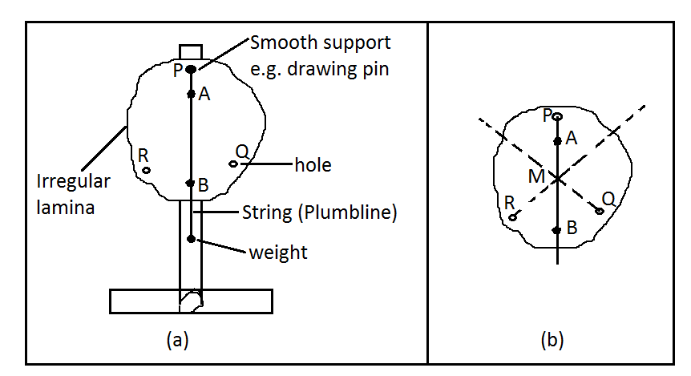
Observation
The lamina balances horizontally. Point M is the centre of mass of the lamina.
Conclusion
The experiment above also proves that when a body is freely suspended it rests with its centre of mass vertically below the point of suspension.
Experiment
Aim: to find the centre of mass of a lamina using a straight edge.
Apparatus: an irregular lamina and a prism.
Procedure
- Balance a lamina on the edge PQ of a prism as shown in the figure below. Mark the points A and B on the lamina and join them.
- Repeat the experiment for another position and note the points C and D on the lamina. Join C and D.
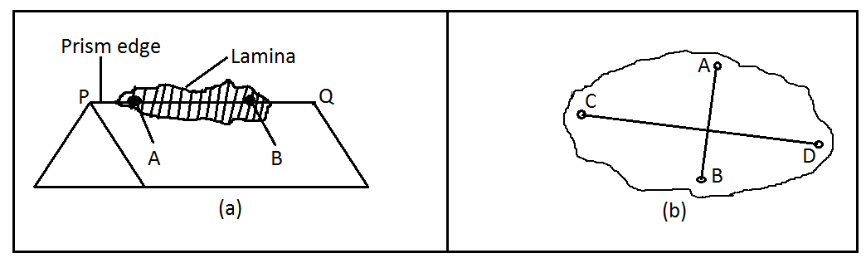
Conclusion
The lines AB and CD intersect at M, the centre of gravity of the lamina.
Applications of moment of a force
- Opening or closing a door.
- Opening a bottle using a bottle opener.
- A pair of scissors or garden shears in use.
- A wheel barrow being used to lift some load.
- A screwdriver being used to tighten/loosen a screw.

TOPIC 7: MAGNETISM
MAGNETISATION AND DEMAGNETISATION
Magnetization is the process of making a magnetic material become a magnet.
METHODS OF MAGNETISATION
- Stroking or touching method
- Single stroking
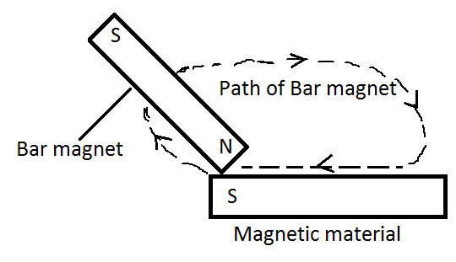
A single magnet is moved (stroked) on top of a magnetic material to be magnetized for several times in one direction. For each stroke the bar magnet is raised up to start another stroke on the other end. The poles on the new magnet will be as shown in the figure above where the end part has opposite pole to that of the permanent magnet on the side used for stroking.
- Double stroking
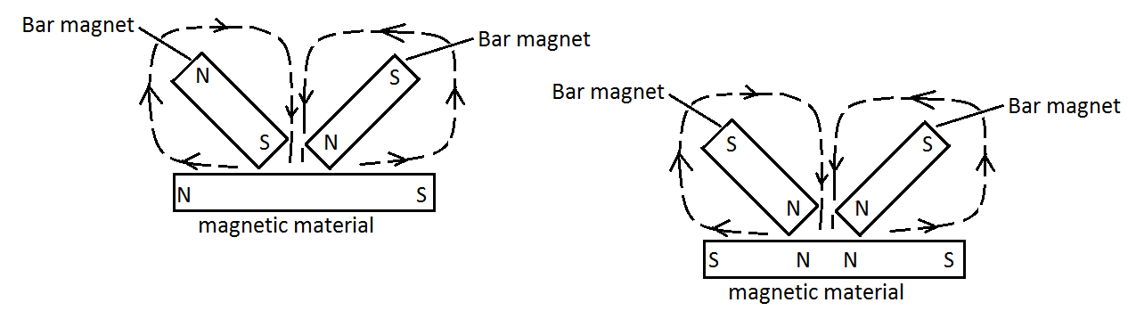
In double stroking two magnets are used to stroke a magnetic material at the same time always starting from the centre. Each magnet is moved outwards and raised enough at the ends of the object as shown in the figure above. The poles on the new magnets are in such a way that the stroking end picks a pole that is opposite to the magnet at its end as shown above.

- Electric method
Experiment:
Aim: making a magnet by electrical method.
Apparatus: cells in a cell holder, ammeter, a copper wire, switch, a hollow non-metal tube (e.g. Manila paper) and steel needle and connecting wires.
Procedure
- Using an insulated wire, wind a number of turns around a hollow tube. This is called a solenoid.
- Place a steel knitting needle and pass a direct current (DC) through the turns of the solenoid as shown in the figure below:
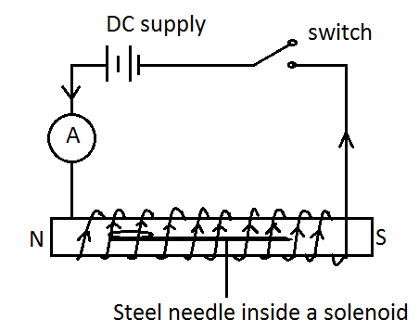
- Switch off the current and remove the needle.
- Test for polarity of the needle by using another magnet.
- Repeat the experiment but with electric current direction reversed.
Observation
The polarity of the magnet produced depends on the direction of the electric current.
Conclusion
The current flowing in a coil has a magnetic effect. It induces magnetism to the steel needle. Such a magnet is known as an electromagnet because it doesn’t last long after removing the current.
- Hammering
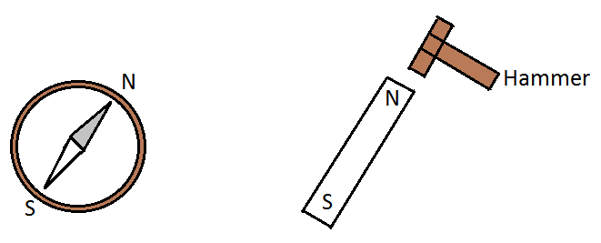
Striking a ferromagnetic material with a hammer several times while keeping the material positioned in north – south orientation when this is done. The earth’s magnetic field will reposition the dipoles and domains to north – south direction and hence form a weak magnet.
- Induction method
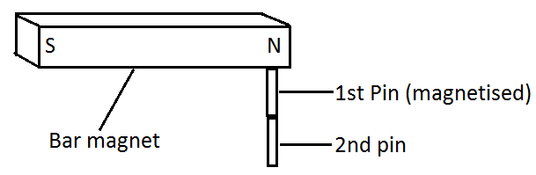
Consider that you have two pins that are ferromagnetic. If you attach the first pin to the magnet it is attracted to the magnet. Attach the second pin to the pin on a magnet. It is observed that the second pin is attracted to the first pin. We say that the first pin becomes magnetized by the magnet through the process called induction. This magnetism is immediately lost after removing the magnet on the pins.
DOMAIN THEORY OF MAGNETISATION AND DEMAGNETISATION
Domain theory states that inside a magnet there are small regions in which the magnetic direction of all dipoles are aligned in the same directions.
A dipole is the smallest particle of a magnetic material. It is equal to an atom in electric conductors.
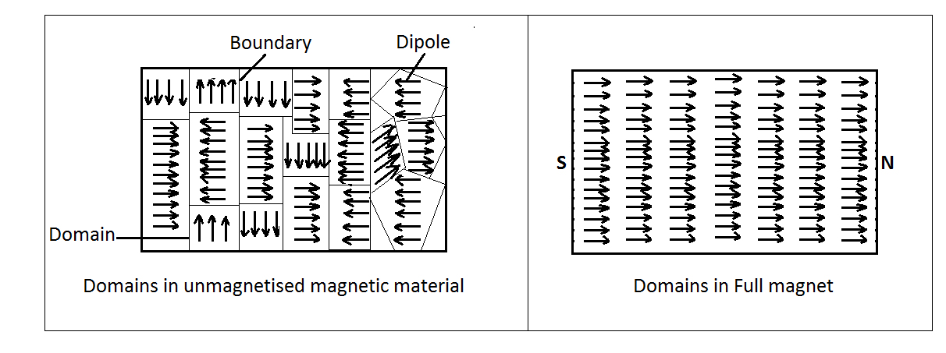
DEMAGNETISATION
Demagnetization is the process of removing magnetism from a magnet.
METHODS OF DEMAGNETISATION
- Self-demagnetization
The walls of the domain slowly returns to their original state with time as this is a more stable state, hence the material becomes demagnetized. This is because free poles at the end repel each other and gradually alter the alignment of the dipoles. Self – demagnetisation can be avoided by storing the magnet using soft iron keepers across their ends. This makes the dipoles to lie in closed loops with no free poles.
- Hammering or dropping the magnet on hard surface
Hammering uses mechanical vibrations to turn the domains around and make them lose their direct orientation.
- Heating
When heating the atoms vibrate rapidly. It is these vibrations that disturb domain orientation.
- Alternating current
The magnet is put inside the solenoid connected to alternating current. When the current is switched on even for a moment the magnet loses its magnetism. Alternating current has magnetic field which keeps on changing directions. As the field changes directions, the domains are also made to change their orientation quickly to and fro and this disturbs their arrangement.

TOPIC 8: ELECTROMAGNETISM
Electromagnetism involves magnetic force produced when electric current pass through a conductor. The conductor becomes an electromagnet.
An electromagnet is a soft-iron core that is magnetized temporarily by passing a current through a coil of wire wound on the core.
Magnetic field due to a straight current-carrying conductor
Experiment: the aim is to show the magnetic field pattern due to a straight current – carrying conductor.
Apparatus: a long straight wire, stand and clamp, rheostat, iron fillings, cardboard, switch and d.c source.
Procedure
- Set up the apparatus as shown below:
- Sprinkle iron fillings on the card and close the switch.
- Tap the card gently and observe the pattern formed by the iron fillings. You may use the variable resistor to vary the current, I.
Observation
When the card is tapped, the iron fillings settle in concentric circles round the wire. This suggests that there is a magnetic field around the wire.
Conclusion
The current in the conductor produces magnetic field around the conductor. Therefore the magnetic field around a straight current– carrying conductor:
- forms a pattern of concentric circles around the conductor.
- lies in a plane which is perpendicular to the wire.
- is strongest closer to the wire.
- increases as current in the wire increases.
- has a direction that depends on the direction of current through the wire.
The direction of the magnetic field around a current – carrying wire can be determined by using the magnetic compass or right hand grip or corkscrew rules.
- With a magnetic compass, the north – seeking pole of the compass needle points in the direction of the magnetic field lines. If move the compass around the wire, the needle will always align itself in a direction that is perpendicular to the radius of the circle around the wire as shown in the figure below.
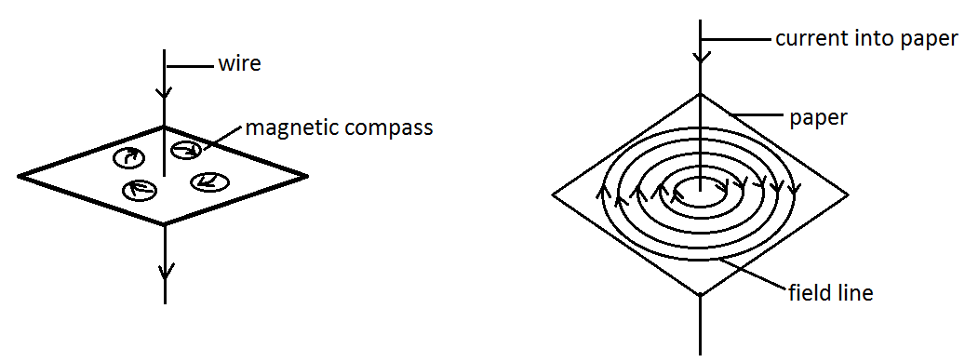

- Right hand grip rule (thumb rule) and right hand corkscrew rule.
- Right hand grip rule states that if you are holding a conductor in your right hand with the thumb pointing in the direction of the current, the other fingers will point in the direction of the magnetic field due to the current in the conductor.
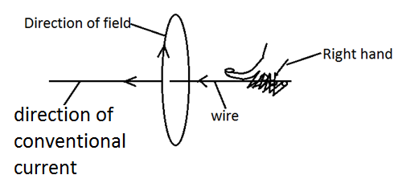
- Right hand corkscrew rule states that if you are holding a screw in your right hand with the screw pointing in the direction of the current then turn the screw clockwise so that it advances in the direction of the current, the rotation of the screw gives the direction of the field due to the current in the conductor.
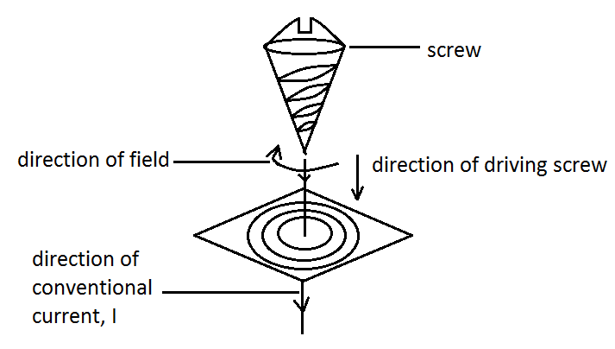
MAGNETIC FIELD DUE TO CURRENT IN A LOOP
When current flows into a loop, a magnetic field is created around the loop. The figure below shows a magnetic field pattern produced by a current flowing in a loop.
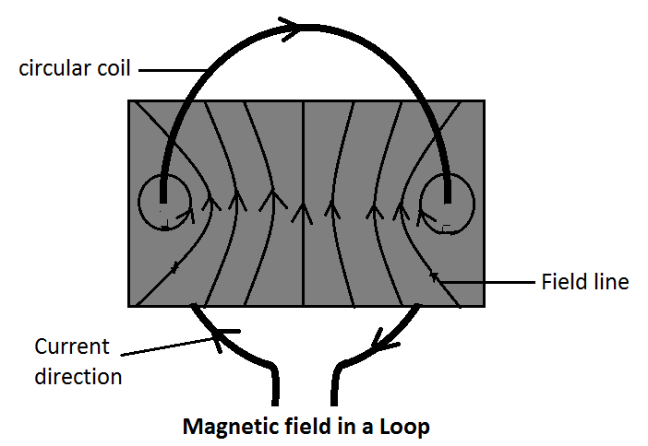
The field pattern around the coil produces two magnetic poles. One is the North pole and the other faces the South pole.
MAGNETIC FIELD DUE TO A CURRENT – CARRYING SOLENOID
A solenoid is a long cylindrical coil made up of a number of turns of a closely packed wire. It is made up of several turns of wire. A magnetic field pattern is produced around a solenoid when a current is flowing through it as shown in the figure below. The solenoid behaves like a magnet with the N and S poles. In a solenoid the iron fillings arrange themselves in a particular pattern like dipoles of a magnet as in the figure below. Note that the strength of the magnetic field in a solenoid can be increased by: increasing the number of turns in a solenoid or increasing the amount of current flowing in a solenoid or placing a ferromagnetic material e.g. iron in a solenoid.
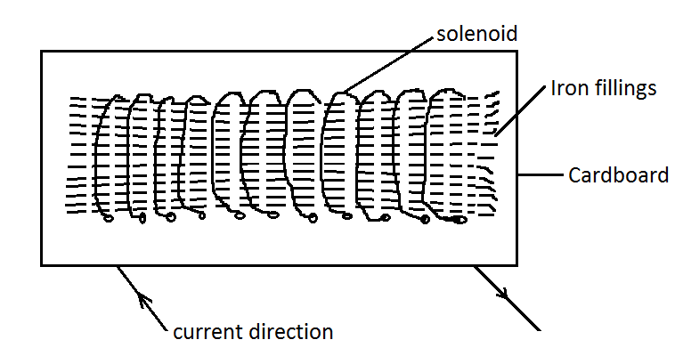
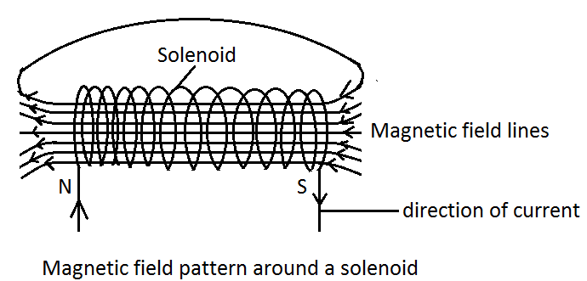
Simple electromagnet
An electromagnet is a device made by coils of insulated wire wound on a magnetic material and then current passed through the coils.
Applications of electromagnets
Electromagnetism is applied in various devices like
- The electric bell
When the current is switched on, the electromagnet becomes magnetized and attracts the soft iron armature. Then the hammer hits the gong. The movement breaks the circuit at the point where the contact (adjusting) screw joins the iron armature to the spring so that the current stops flowing and switches off the electromagnet. The spring pulls the armature back so that contact is made. This process continues until the switch is off.
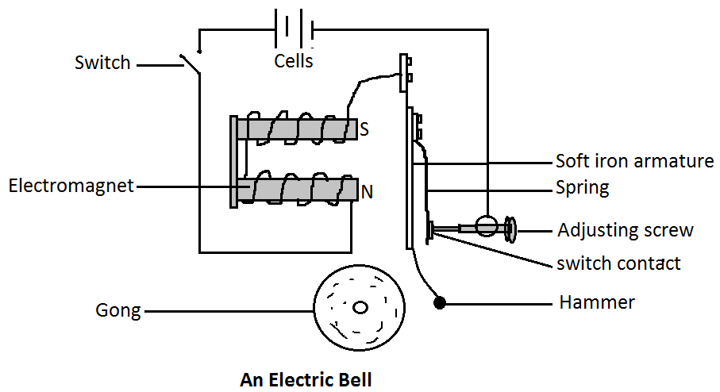
- The telephone receiver
The telephone receiver, also commonly referred to as the earpiece works on the same principle as the electric bell. When a person speaks into the microphone on the other end of the line an electric current is set up in the earpiece receiver having the same frequency as that of the sound waves in the microphone. As the current in the earpiece is varying the diaphragm made of the springs of magnetic alloy vibrates accordingly. A similar sound to the one in the microphone is reproduced in the receiver (earpiece).
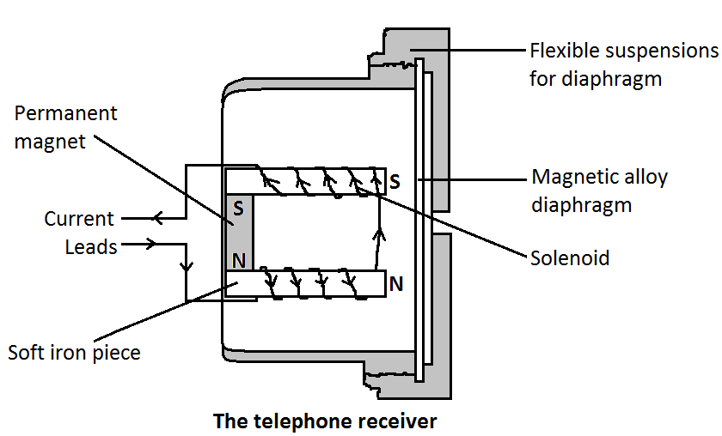
- Magnetic relay
A relay is a device that acts as a switch by using an electromagnet. It is an important device where heavy dangerous current has to be switched on or off without coming too close to the electricity, like current to starter motor of a vehicle. When input circuit is switched on, the electromagnet becomes magnetic which attracts iron armature. The armature is attached to a spring which pushes the copper metal into contact, in the process closing the switch of the main heavy current circuit. The return spring pull out the contacts when the relay switch is switched off.
- Circuit breakers
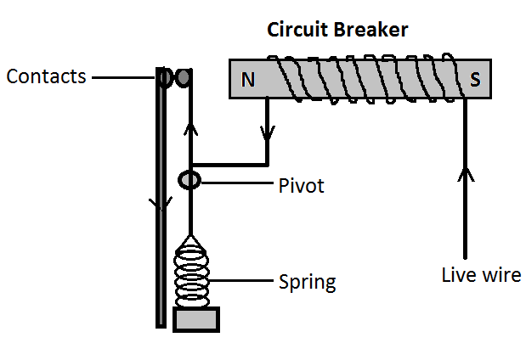
The figure above is a circuit breaker which has an electromagnet that stays magnetic as long as the power is on. When current rises, the magnetic field of the electromagnet also becomes stronger. When too much current flows the strength of the electromagnet is so strong that it is enough to pull iron out of contact and in the process open the circuit and electric current stops.
FORCE ON A CURRENT-CARRYING CONDUCTOR IN A MAGNETIC FIELD (MOTOR EFFECT)
Experiment
Aim: to demonstrate the force on a current-carrying conductor (motor effect)
Apparatus: two strong magnets, current carrying conductor and tripod stand
Procedure
- Arrange the apparatus as shown in figure (a) below. AB is a flexible wire loosely held between the poles of strong magnets.
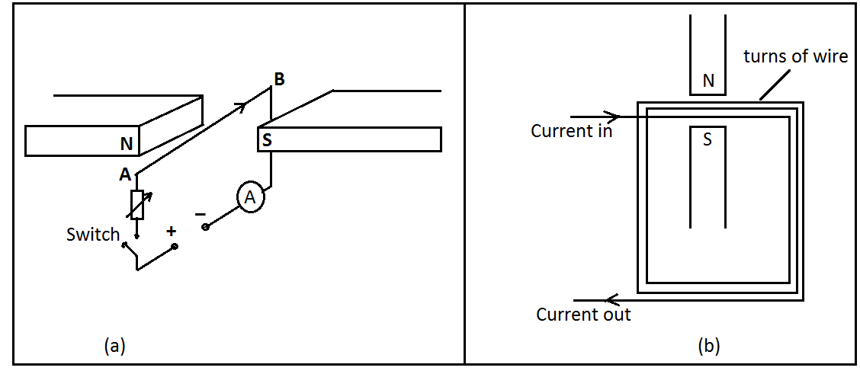
- Close the switch and observe what happens to the wire. Repeat the experiment with a larger current and observe what happens to the wire.
- Repeat the experiment using stronger magnets but with the same initial current and observe what happens to the wire.
- Repeat the experiment using two or more turns of wire in the magnetic field carrying the same current in the same direction as shown in figure (b) above.
- Repeat the experiment with the circuit connection to the battery interchanged and what happens.
Discussion
The results of the above experiments show that the wire in the magnetic field experiences a force. The force on the wire increases when:
- The current is increased.
- Stronger magnets are used.
- The number of turns of the wire in the magnetic field was increased.
The wire moves in the opposite direction when the battery connection is interchanged. When the experiment is repeated with the flexible wire and AB kept at an angle less than$90°$ to the magnetic field, the force on the conductor is found to decrease.
Conclusion
From the above experiment we can conclude that a current carrying conductor placed in a magnetic field experiences a force. This is called the motor effect.
Fleming’s left hand rule states that when the thumb, the first finger and the second finger of the left hand are held at right angles to each other, the First finger points in the direction of the Field, the seCond finger points in the direction of the Current and the Thumb points in the direction of the Thrust (force) on the conductor.
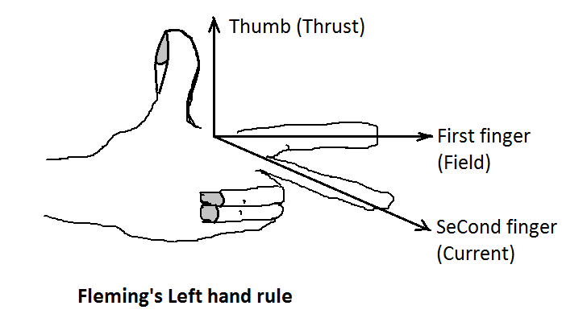
Fleming’s left hand rule is used to find the directions of magnetic field, current and force (thrust) on a current carrying conductor in a magnetic field.
Application of electric motor effect and Fleming’s left hand rule.
A simple d.c electric motor
An electric motor is a device which converts electrical energy to mechanical energy. Examples of devices which use electric motors include electric drill, vacuum cleaner, electric shaving machine, electric bell, electric fan, etc.
A simple electric motor consists of a rectangular coil of wire placed between the poles of a strong magnet as shown in the figure below. The end of each wire is connected to a section of a split ring called the commutator. The commutator rotates with the coil. Two carbon brushes are fixed just by touching the commutators. Current enters the coil through the brushes. According to Fleming’s left hand rule, wire AB experiences a force downwards while wire CD experiences an upward force. The forces in opposite directions cause the loop ABCD to rotate in anticlockwise direction. To make sure that the coil continues in the same direction, the commutator reverses the current flow in the coil every half-cycle.
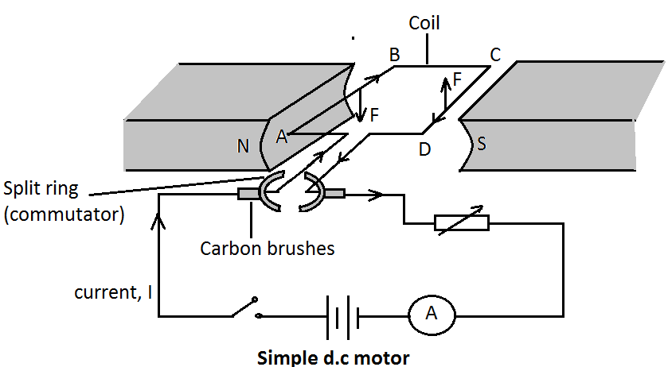

TOPIC 9: ELECTROMAGNETIC INDUCTION
Electromagnetic induction is a phenomenon in which electric current is induced whenever a conductor move at right angles to the magnetic force between the north pole and south pole.
DEMONSTRATION OF ELECTROMAGNETIC INDUCTION
EXPERIMENT 1
Aim: to induce an electromotive force in a conductor (wire)
Apparatus: U – shaped magnet, galvanometer and copper.
Procedure
- Connect a copper wire XY to a sensitive centre zero galvanometer as in figure below:
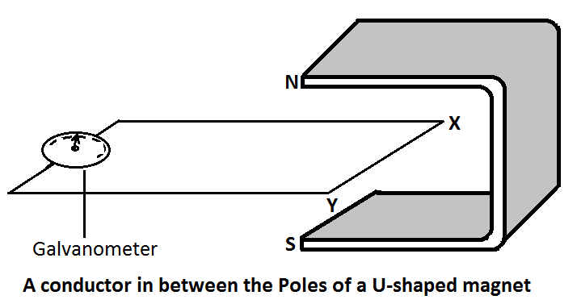
- Place the wire in between the poles of a magnet as shown in figure above and observe the galvanometer reading.
- Quickly pull the wire horizontally away from the poles and stop.
- Quickly re – introduce the wire in between the poles of the magnet and stop.
- Repeat the experiment, keeping the wire stationary and moving the magnet.
- Repeat the experiment by first moving the wire vertically up and down and then repeat by moving the magnet.
What happens to the galvanometer pointer in each case?
Observation
- When the wire XY is stationary, the pointer does not move. When the wire is moved out, the pointer shows a deflection in one side but returns to the zero position once the wire stops.
- When the wire is re –introduced in between the poles, the pointer deflects but in the opposite direction. However, when the wire stops, the pointer once again returns to the zero position.
- Similar effects are observed when the magnet is moved instead of the conductor. However, no deflection is observed when the wire or the magnet is moved vertically up or down.
Conclusion
For a current to flow in a circuit, there must be a driving force called electromotive force (e.m.f). From this experiment, we conclude that whenever there is relative motion between a wire and a magnet, an electromotive force is induced in the wire and hence a current flows in the circuit. This motion is such that the wire cuts the magnetic field lines of force as in the figure below.
Direction of magnetic field, induced current or emf and motion of a wire can be found by using Fleming’s right hand rule.
Fleming’s right hand rule states that if the thumb and the first two fingers of the right hand are mutually perpendicular to each other, the First finger points in the direction of the Field and the thuMb in the direction of Motion of the conductor, then the SeCond finger points in the direction of the induced Current.
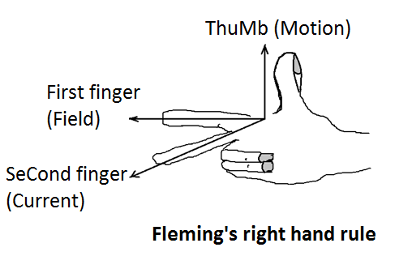
EXPERIMENT 2
Aim: to induce an electromotive force in a coil using a magnet.
Apparatus: insulated copper wire, bar magnet, galvanometer, connecting wires.
Procedure
- Make a coil using the insulated copper wire.
- Connect the ends of the coil to a sensitive centre zero galvanometer.
- Quickly introduce a bar magnet into the coil and stop as shown in the figure below.
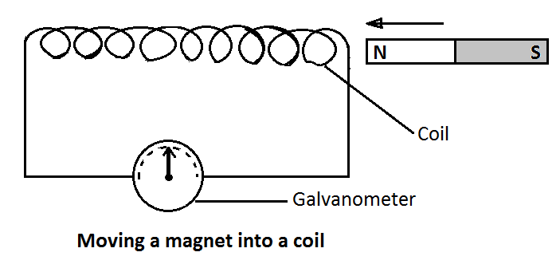
- Withdraw the magnet quickly from the coil and stop.
- Repeat the experiment by moving the coil and keeping the magnet stationary. Observe what happens to the pointer of the galvanometer in each case.
- Move both the coil and the magnet in the same direction at the same speed. What happens to the pointer of the galvanometer?
Observation
- When the magnet is introduced into the coil, the pointer deflects to one side and returns to zero position when the magnet is brought to rest.
- When the magnet is withdrawn from the coil, the pointer deflects to the opposite direction. However when the magnet stops, the pointer returns to zero position.
- Similar effects are observed when the coil moves instead of the magnet.
- No deflection is observed when both the coil and the magnet are moved at the same speed in the same direction.
Conclusion
From this experiment, we conclude that an electromotive force is induced whenever there is relative motion between the coil and the magnet hence a current flows in the coil.
Factors affecting the magnitude of the induced electromotive force
The magnitude the induced e.m.f. depends on:
- The speed with which the magnet is plunged into the coil.
- The strength of the magnet. The stronger the magnet the higher the induced e.m.f.
- The number of turns in the coil. The more the turns the higher the induced e.m.f.
- Softness of the iron core. The induced e.m.f. is much higher in the presence of a soft iron core than a hard one.
The laws of electromagnetic induction
- Faraday’s law
Faraday’s law states that the electromotive force induced in a conductor is directly proportional to the rate of change of the magnetic flux linked to the conductor.
- Lenz’s law
Lenz’s law states that the direction of the induced current is such that it opposes the change producing it.
Generators
Generators make use of electromagnetic induction and they are based on the principle that a current can be induced in a coil by rotating it in a magnetic field. Generators can either be d.c. generator or a.c. generator.
A simple d.c. generator
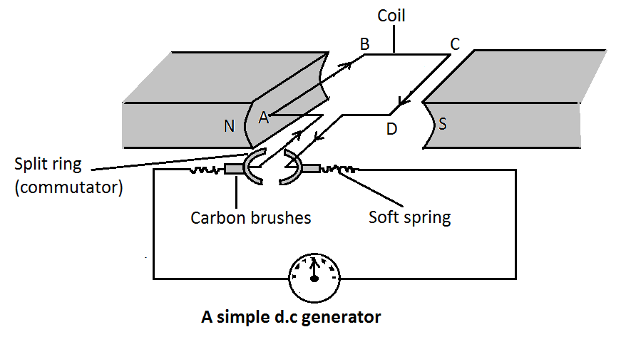
A simple d.c. generator has a rectangular coil of a conductor wire placed between two poles of permanent magnet and whose ends are connected to two split – rings called commutators. The split –rings makes contact with carbon brushes which connect them to an external circuit. Two light springs are used to make the carbon brush press lightly on the split – ring.
When a coil is rotated about its axis by energy from burning fuel, it cuts across the magnetic field of the permanent magnet, causing current to be induced. This induced current causes a deflection on the galvanometer. When the coil passes through the vertical position, the two halves of the split – ring change from one brush to another. This change over between the brushes and the two halves split-ring helps to maintain the flow of the current in the same direction.
A simple ac generator
This is a modification of the d.c. type. In an a.c. generator, the split-rings (commutator) are replaced by two slip rings, thus the direction of the current in the coil changes after every half rotation. This is because each carbon brushes remain on the same ring when the coil is rotating without interchanging positions as shown in the figure below.
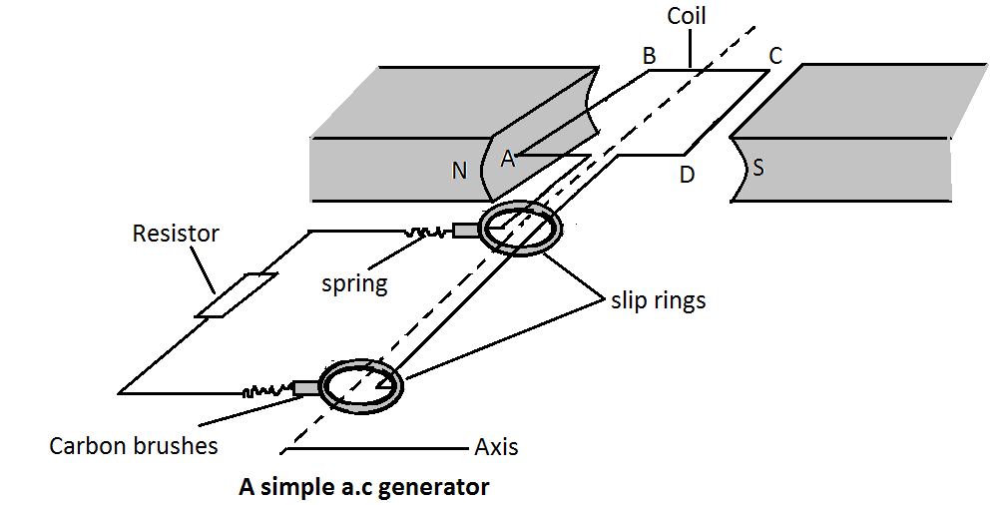
The alternating current produced is illustrated by the diagram and graph below.
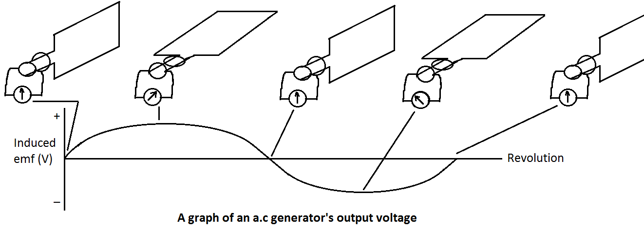
Mutual induction
Mutual inductance is the induction of an electromotive force in a coil of wire by changing the current in a different coil.
Explaining mutual induction
An electric current creates a magnetic field around the conductor through which it flows. When the current is switched on and off in the primary coil, the strength of the field (magnetic flux) keeps changing from zero to maximum and back to zero. Alternating current does this automatically without being switched on and off as it fluctuates from zero to maximum. The change in magnetic flux induces a current in the secondary coil. Thus, an a.c input in the primary coil induces an a.c. output in the secondary coil as shown in the figure below. Thus, the change in the number of magnetic field lines threading the secondary circuit induces an electromotive force in the secondary circuit in an opposite direction in accordance with Lenz’s law. Note that the induced electromotive force in the secondary circuit has the same frequency as the electromotive force in the primary circuit.
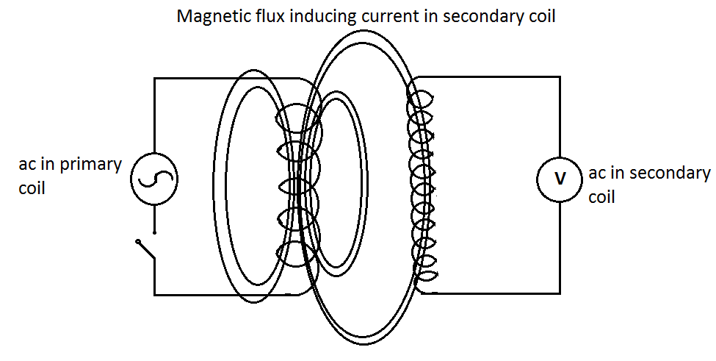
Transformers
A transformer is an electric device which is used to step up or step down electromotive force (voltage) by applying the principle of electromagnetic induction. A transformer consists of two coils (solenoids). The coil that is connected to the power supply is called the primary coil and the one that is connected to the load (output) like resistor, bulb etc is called the secondary coil. The two coils are not directly connected to each other but are wound on the same soft iron core as shown in figure (a) below. Energy is continuously transferred from the primary coil to the secondary coil as long as the switch is on in the primary circuit. Figure (b) below shows a circuit symbol of a transformer.
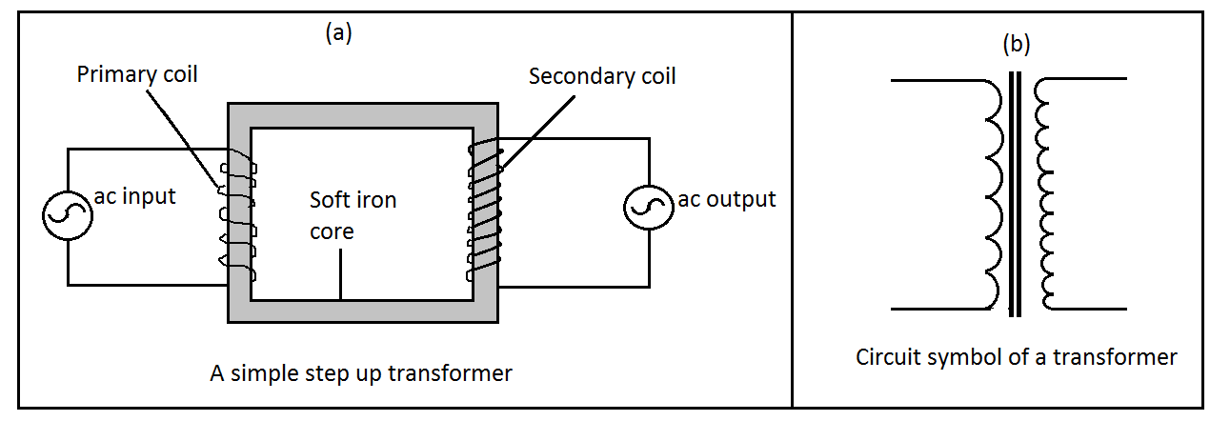
How a transformer works?
When alternating current passes through the primary coil it produces an alternating magnetic field in the core. The magnetic lines of force rise and fall. This causes the lines of force to cut the secondary coil. The cutting of lines of force on the secondary coil induces emf in the secondary coil. The process is called mutual inductance.
The amount of emf induced in the secondary coil depends on the turns ratio in the two coils.
The turns ratio of transformer is given as
$$\frac{Number of turns in the primary coil}{Number of turns in the secondary coil}=\frac{Voltage in the primary coil}{Voltage in the secondary coil}$$
$$\frac{N_{P}}{N_{S}}=\frac{V_{P}}{V_{S}}$$

$$\frac{Number of turns in the primary coil}{Number of turns in the secondary coil}=\frac{Current in the secondary coil}{Current in the primary coil}$$
$$\frac{N_{P}}{N_{S}}=\frac{I_{s}}{I_{p}} \left(for ideal transformers\right)$$

Types of transformers
- A step – up transformer
Is a transformer that transforms low voltage to high voltage or step up voltage. It has greater number of turns in the secondary coil than in the primary coil. $N_{S}>N_{P}$
- A step – down transformer
Is a transformer that transforms high voltage to low voltage or steps down voltage. It has less number of turns in the secondary coil than the primary coil.$N_{S}<N_{P}$
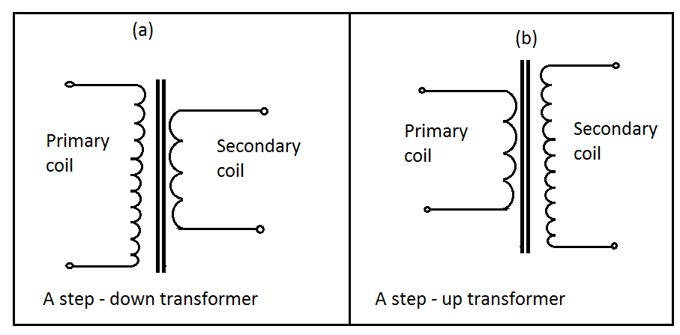
Efficiency of a transformer
Transformer transfer electrical energy from one circuit to the other. The energy supplied per second to the primary coil is called the power input. While the energy obtained per second from the secondary coil is the power output. In an ideal transformer, the power output is equal to power input. The term efficiency is used to indicate how effective a transformer is in transferring the input energy to output energy. The efficiency of a transformer is the ratio of the power output to power input expressed as a percentage.
$$Efficiency=\frac{Power output}{Power input}×100\%$$

For an ideal transformer

$$Power input=Power output=V_{S}I_{P}$$
$$V_{P}I_{P}=V_{S}I_{S}$$

$$∴ \frac{V_{S}}{V_{P}}=\frac{I_{P}}{I_{S}}$$

WORKED EXAMPLES ON TRANSFORMERS
EXAMPLE 1
A step-down transformer is connected to a 240 V alternating current power supply. The primary coil has 1000 turns. How many turns should the secondary coil have so as to operate a 12V alternating current toy car?
Solution
$$\frac{N_{P}}{N_{S}}=\frac{V_{P}}{V_{S}} it implies that \frac{12 V}{240 V}=\frac{N_{S}}{1000 turns} which implies that N_{S}=50 turns$$
EXAMPLE 2

An alternating electromotive force of 240V is applied to a step – up transformer having 200 turns on its primary coil and 4 000 turns on its secondary coil. The secondary current is$0∙2A.$ Calculate the
- Secondary electromotive force.
- Primary current.
- Power input.
- Efficiency.
Solution
- $\frac{V_{P}}{V_{S}}=\frac{N_{P}}{N_{S}}$ it implies that $V_{S}=\frac{N_{s}}{N_{p}}×V_{P}$=$\frac{4 000turns × 240V}{200 turns}=4800V$
- $\frac{I_{s}}{I_{p}}=\frac{N_{P}}{N_{S}}$ it implies that $I_{P}=\frac{N_{s}}{N_{p}}×I_{s}=\frac{4000 turns × 0∙2 A}{200 turns}=4∙0A$
- $Power input=I_{P}×V_{P}=4∙0 A×240 V=960 W$
- $efficiency=\frac{Power output}{Power input}×100\%$
$$efficiency=\frac{I_{s}×V_{s}}{960 W}×100\%=\frac{0∙2×4800}{960}×100\%=100\%$$

EXAMPLE 3
A transformer has an input coil of 60 turns. When this coil connected to a 240 V source, the output voltage is found to be 4800V. The output power is 3600W. If the efficiency of the transformer is$80\%:$
- Calculate the output current.
- Calculate the input current.
Solution
- $P_{out}=V_{s}I_{s}$
$$3600=4800 ×I_{s}$$
$$I_{s}=\frac{3600}{4800}=0∙75A$$

- $Efficiency \left(Eff\right)=\frac{P_{out}}{P_{in}}×100\%$

$$Efficiency \left(Eff\right)=\frac{V_{s}I_{s}}{V_{s}I_{s}}×100\%$$
$$80\%=\frac{4800 ×0∙75}{240×I_{P}}×100\%$$
$$80=\frac{360 000}{240I_{P}}$$
$$I_{P}=\frac{360 000}{240×80}=18∙75 A$$
Factors that affect the efficiency of a transformer
The energy supplied in the primary circuit of a transformer is lost in a number of ways.
- Resistance of the coils
As the current flows in the coils, the wires heat up and energy is lost in form of heat. This method of losing energy is called joule – heating.
To minimize energy loss in this way, thick copper wires of low resistance are used where large currents are to be carried.
- Eddy currents
When the magnetic field changes, small amount of current called eddy currents are induced in the core of the transformer. This heats up the core and energy is lost in form of heat.
To minimize this loss of energy, the core is laminated and insulated between the laminations. This reduces the magnitude of the eddy currents.
- Hysteresis losses
The magnetization and demagnetization of the core by the alternating magnetic field requires energy. This energy heats up the core and is lost as heat energy. This method of losing energy is called hysteresis loss.
To minimize this loss of energy, the core is made of a soft magnetic material that is easy to magnetise and demagnetize .e.g. soft iron.
- Flux or magnetic leakage
Not all the magnetic field lines of force due to the primary coil may link the secondary coil resulting in what is called flux leakage.
To reduce this loss, the core is designed in such a way that almost all the magnetic effect due to the primary coil is transferred to the secondary coil e.g. using a loop.
Note: It is not possible to completely reduce energy losses in transformers so very large transformers are filled with oil to reduce overheating.
ELECTRIC POWER TRANSMISSION
The electrical energy generated at a power station is delivered to consumers through cables. Electrical energy is distributed to consumers all over the country through the National Grid system. A grid is a network of cables most supported by structures called Pylons. Due to the electrical resistance (R) of the transmitting cables, some electric power is lost in form of heat in the transmission cables. Lost power in cables is calculated by$P=I^{2}R$.
To reduce power loss in transmission cables:
- Very thick transmission wires are used.
- The transmission wires are made of metals like copper that are very good conductors of electricity hence having very low electrical resistance.
- Electric current is transmitted at very high voltage and very low current.
From a generating station, electric power is generated at a certain high voltage (for example at Nkula, 3 300 V) and stepped up in a step – up transformer to a higher voltage (for example at Nkula to 60 000 V) then sent over a long distance on the super grid. Later the voltage is stepped down in a step – down transformers at substations, for distribution to industries. The voltage going to homes and schools is further stepped down to 240 V in step – down transformers.
Power losses in cables

Consider that the power station can produce 25 000W of electricity at one end of the line

- Transmission at low voltage and high current (e.g. at 250 V and 100A with a $1 Ω$resistance cable)
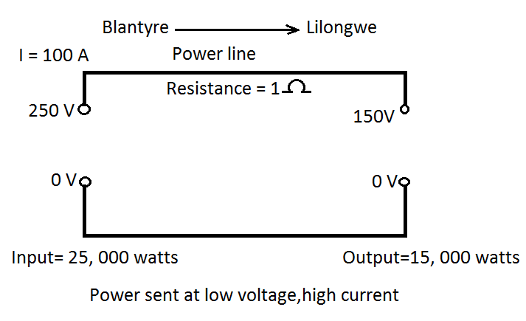
$$Power loss=I^{2}R={\left(100A\right)}^{2}×1Ω=10 000 W$$
$$Power output=power produced-power loss=25 000W-10 000W=15 000W$$

- Transmission at high voltage and low current (e.g. at 12 500 V and 2A with a $1 Ω$resistance cable)
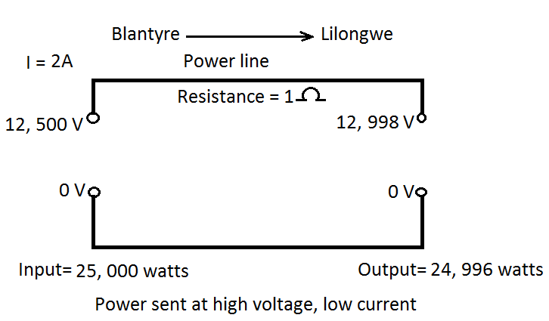
$$Power loss=I^{2}R={\left(2A\right)}^{2}×1Ω=4 W$$
$$Power output=power produced-power loss=25 000W-4W=24 996W$$

Dangers of the high voltage transmission
Due to the high voltage in the transmission cables, a strong electric field is set up between the cables and the earth. Air, an insulator under normal conditions, may start to conduct electricity especially on rainy days. People or animals in the vicinity may get electrocuted.
Environmental impact of power generation and transmission
Hydroelectric power
- Dislocation of people living around place where a dam has to be constructed.
- Releasing carbon dioxide during construction and flooding of the reservoir.
- Disrupting the aquatic ecosystems and animal life.
- Can cause flooding if the dam wall collapses.
- The dam becomes the breeding site for mosquitoes.
Nuclear power
- Emission of radioactivity to the environment which possess health problems to people around it.
- Accidental nuclear explosions in nuclear power plants destroy properties and kill many lives.
Fossil fuels
- Emissions of gases like carbon monoxide and carbon dioxide which can cause pollution and global warming.
- Burning of some fossil fuels lead to production and release of gases like sulphur dioxide and nitrogen oxide that contribute to smog and acid rain.
Solar power
- Requires large area, causes land wastage.
Biomass
- Biomass requires large area, causes land wastage.

TOPIC 10: INTRODUCTION TO DIGITAL ELECTRONICS
Good conductors are materials that allow an electric current to pass through them easily. Examples include copper, zinc, silver, mercury, etc.
Semiconductors are materials that have their conductivity between conductors and insulators. Examples include silicon and germanium.
Insulators are materials that do not allow en electric current to flow through them at all. Examples include paper, wood, plastics, etc.
The electrical conductivity of materials may be explained by studying how electrons are held or locked up in the crystal lattice. Band theory is one of the theories that explain the electrical behavior of materials.
Band theory
Band theory is a theory which explains why conductors, semiconductors and insulators are different in conduction. The difference in conduction of conductors, semiconductors and insulators is due to the difference in the number of free electrons, the conduction band, and the difference in the forbidden gap. In band theory, materials are considered to contain two bands in which electrons may be found. These bands are the fixed or valence band and conduction band. The two bands are separated by a gap called forbidden gap.
Conduction band
It is an imaginary shell or energy level outside the valence band into which free electrons move . it consists of free electrons. It is the conduction band electrons that conduct electricity.
Fixed or valence band
This is the outer shell, which is always full of electrons.
Forbidden gap
This is the gap between the valence band and the conduction band.
Arrangement of the three bands in materials
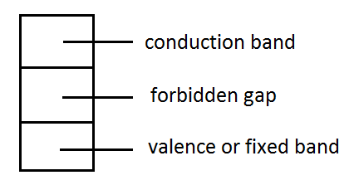
Conductors (metals)
- The valence band is broad and very close the conduction band.
- Have a narrow forbidden gap or not at all.
- In metals the conduction band is filled with free electrons under normal conditions.
- Electrons require just a little energy to move the atom electronic current.
Semiconductors
- Have no electrons in the conduction band under normal conditions.
- The forbidden gap is bigger than in conductors but smaller than in insulators.
- At room temperature some electrons gain thermal energy and cross the forbidden gap to the conduction band making the material a fair conductor.
- As the temperature is increased, more electrons move to the conduction band and hence its conductivity is increased.
Insulators
- The forbidden gap is very wide than in semiconductors and conductors.
- Electrons require a lot of energy to leave the valence band and jump into the conduction band. In most insulators attempt to promote the electrons to the conduction band ends up breaking down the material.
- The conduction band is empty hence insulators cannot conduct electric current.
BANDS OF MATERIALS UNDER NORMAL CONDITION
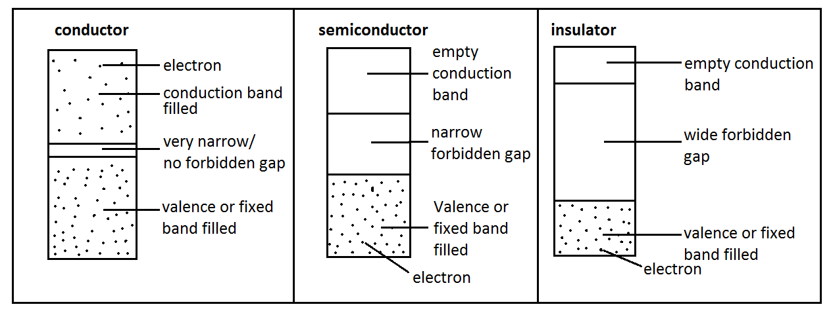
Intrinsic (natural) and extrinsic (artificial) semiconductors
There are two types of semiconductors which are intrinsic or natural semiconductors and extrinsic or artificial semiconductors.
- Intrinsic semiconductors
- These are semiconductors that occur naturally.
- As temperature increases they increase their conductivity from within internally.
- Examples include silicon and germanium.
- They are made from the same type of element.
- Their electrical conductivity is mainly due to electron – hole pair movement.
Silicon atom has four valence electrons as shown below and uses all the four electrons for bonding.
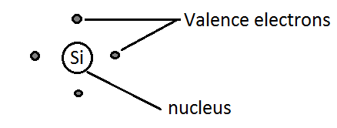
Figure A below shows the silicon lattice and figure B shows a hole and a free electron as temperature increases.
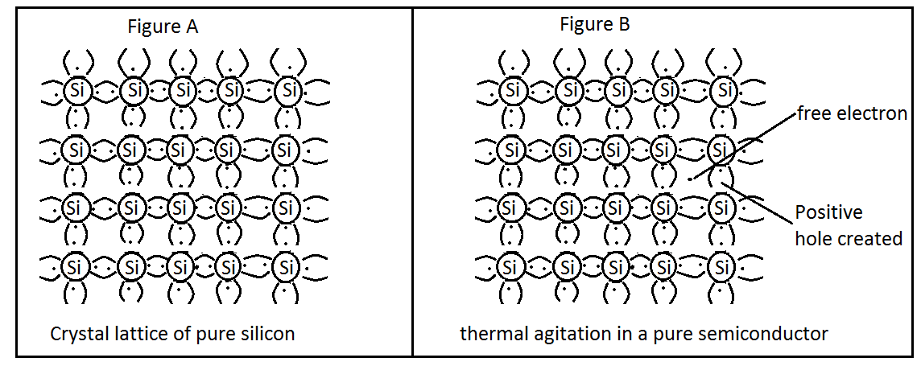
- Extrinsic semiconductors
- These are semiconductors artificially made by improving pure semiconductors.
- They are formed by adding a small amount of impurity to a pure semiconductor.
- Depending on the type of impurity added, there are two types of extrinsic semiconductors: n – type and p – type semiconductors.

Doping in semiconductors
Doping is the introduction of an impurity to a pure semiconductor in order to improve its conductivity. The impurities that are used in doping process are elements with three valence electrons or elements with five valence electrons.
- n – type semiconductors
This is a semiconductor which is formed when a semiconductor is doped with an element of group five like phosphorus, nitrogen, etc. The four valence electrons are bonded with other elements in the lattice of the semiconductor while the firth valence electron remains as a free electron in the lattice. The resulting semiconductor has more electrons making it to be negative hence n – type.
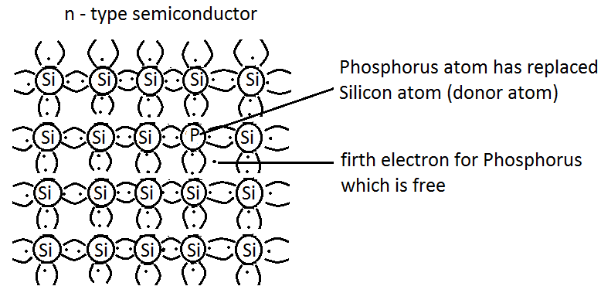
- p – type semiconductors
This is a semiconductor which is formed when a semiconductor is doped with an element of group three like boron, indium, etc. The three valence electrons are bonded with three elements in the lattice of the semiconductor leaving a hole (gap) in the lattice as the fourth element remains unbonded. The resulting semiconductor has more positives making it to be positive hence p – type.
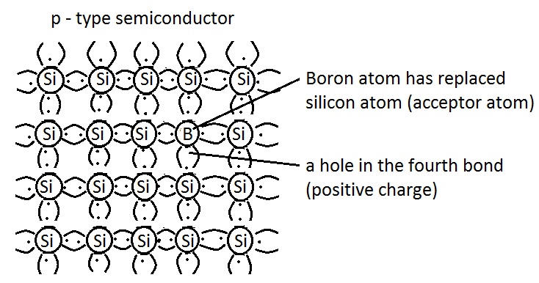
Electronic components
p – n junction
When a p – type semiconductor and a n – type semiconductor of the same material like silicon are joined together they form a p – n junction. In a p – n junction, electrons are attracted to the p – type side while holes are attracted to the n – type. These charges migrate on either side of the junction by diffusion. Hence, few atoms on the p – side are converted into negative ions. Similarly, few atoms on the n – side get converted to positive ions. Due to this, a large number of positive ions and negative ions accumulate on the n – side and p – side respectively depleting the junction. The region so formed is called a depletion layer. As a result of the presence of these positive and negative ions, a static electric field called a barrier potential is created across the p – n junction. It is called a barrier potential because it acts as a barrier and opposes the flow of positive and negative charges across the junction. The p – side becomes the anode and the n – side becomes the cathode.
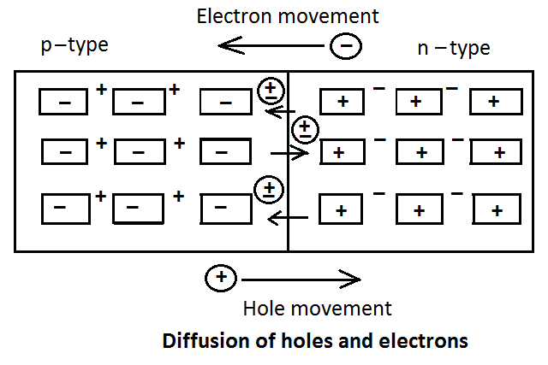
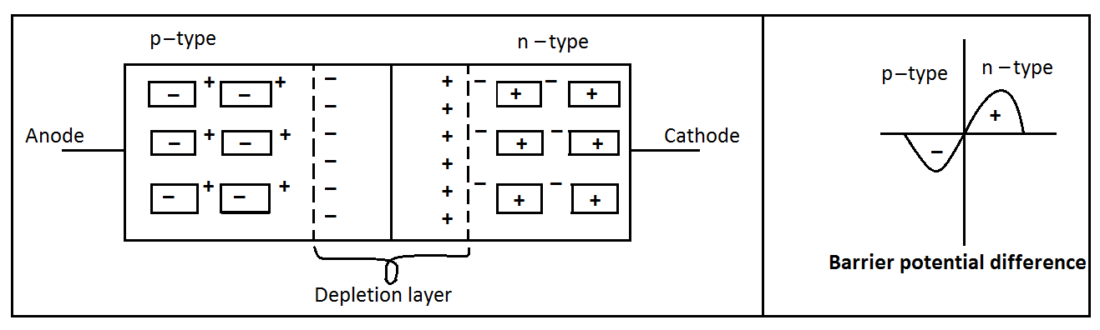
- P – n junction diode
A diode is a device which changes alternating current to direct current. It allows current to flow in one direction only. Diodes are electronic parts made by joining together p – type and n – type materials forming a p – n junction.
Symbols of a diode
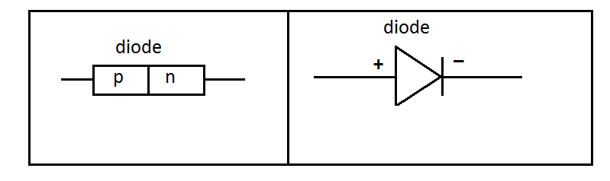
Forward biasing a diode
A diode is said to be forward biased when its positive terminal connected to the positive side of the power supply while its negative terminal is connected to the negative side of the power supply. P – type is connected to the positive side of the supply while n – type is connected to the negative side of the supply.
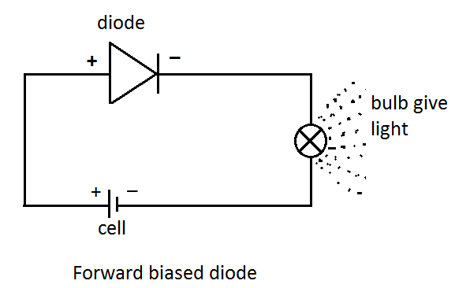
The figure below is a sketch of current – voltage characteristics for a forward biased diode.
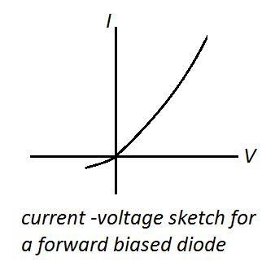
Reverse biasing a diode
A diode is said to be reverse biased when its positive terminal is connected to the negative side of the power supply while its negative terminal is connected to the positive side of power supply. P – type is connected to the negative side of the supply while n – type is connected to the positive side of the supply.
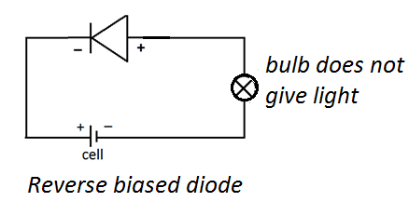
Application of p – n junction diode
- Protecting electrical devices in a circuit.
Some devices that operating on direct (d.c), break down when large voltages are connected in reverse/opposite order to the supply terminals of the devices. To protect such devices, a diode is usually connected in series with them and in reverse bias. This ensures that the device is protected by offering very high resistance to flow of the current in the reserve direction when the terminals are interchanged.
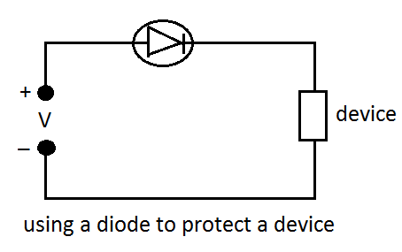
- Rectification
A diode changes alternating current to direct current.
- Zener diodes
Some special types of diodes called Zener diodes are used to protect d.c devices by regulating the voltages applied across the devices. When the p.d increases or abruptly surges to values that would damage the device, the Zener diode (Dz) breaks down and conducts. This protects the device by short circuiting it. When the p.d falls to normal the diode returns to normal.
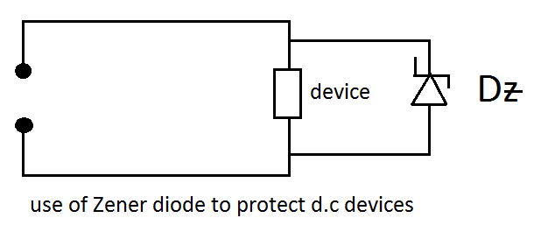
Half –wave rectification by a single diode
- When a resistor is connected to an AC supply and then a Cathode Ray Oscilloscope (CRO) connected across the resistor, the CRO shows how voltage alternate as current changes direction in the resistor as shown in the figure below.
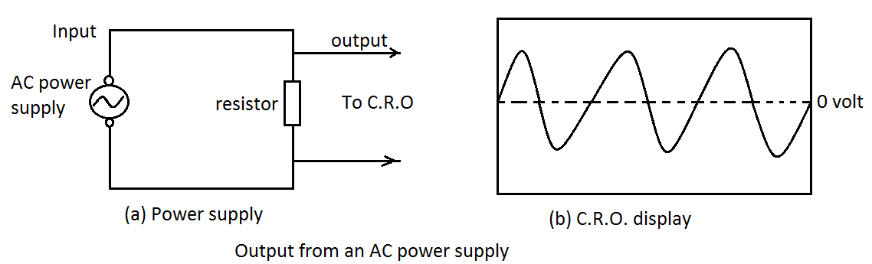
- If a diode is connected in the above connection. The current flows in both the circuits in only one direction. Half of the wave is cut off. The process of allowing only half of the wave to produce current that flows in one direction is called half – wave rectification. Although the alternating current is converted into direct current, the magnitude varies from zero to a maximum value and from maximum to zero, with some intervals when no current flows at all. Hence a varying direct current is obtained across the resistor. In a half – wave rectification, half of the input energy is wasted. To avoid this waste, full – wave rectification is required.
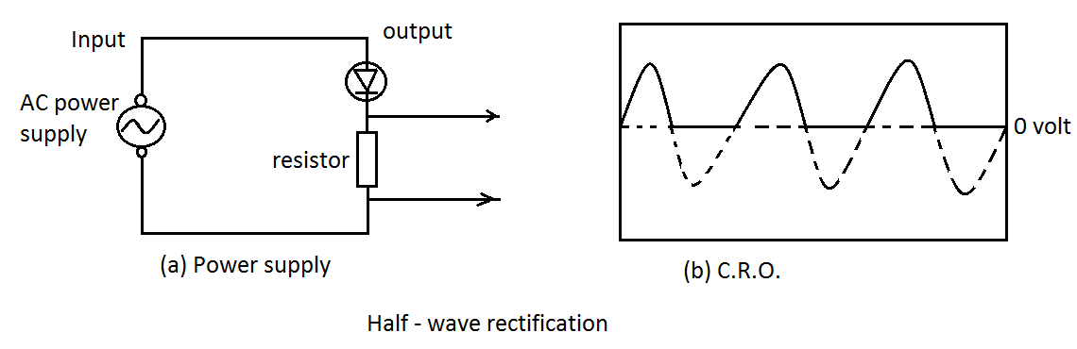
Full – wave rectification using two diodes and a centre tapped transformer
Diagram of a rectification using two diodes
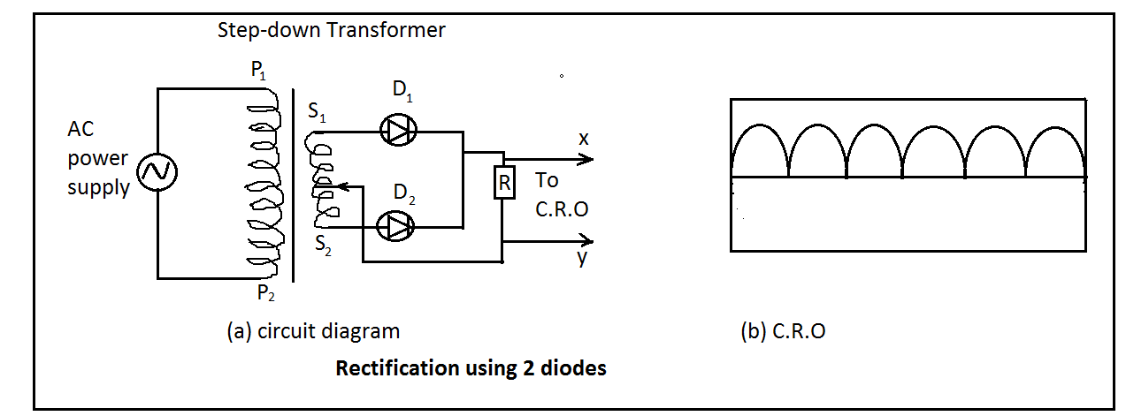
During the first half cycle,${ S}_{1}$ is positive and diode${ D}_{1}$ is forward biased. However, during the second half cycle${ S}_{2}$ becomes positive and diode${ D}_{2}$ becomes forward biased with respect to diode${ D}_{1}$ which now will be reverse biased. In this case, irrespective of the polarities of input terminals, the current flows through the resistor continuously. We conclude that the alternating current has been fully rectified to a varying direct current.
- Transistors
A transistor is a three terminal device formed by merging three pieces of extrinsic semi – conductors. The three terminals of a transistor are the base (b), collector (c) and emitter (e). the following are the two types of transistors with their symbols.
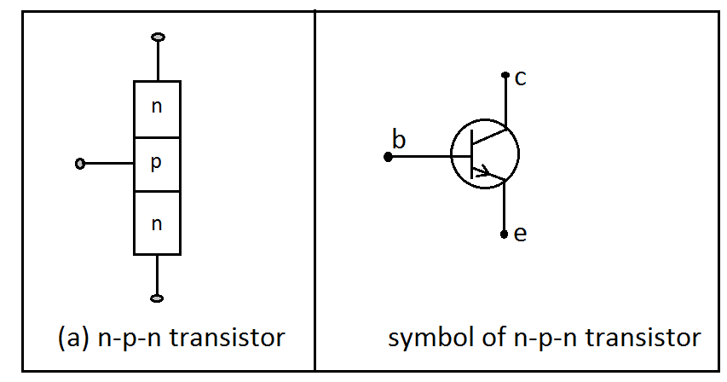
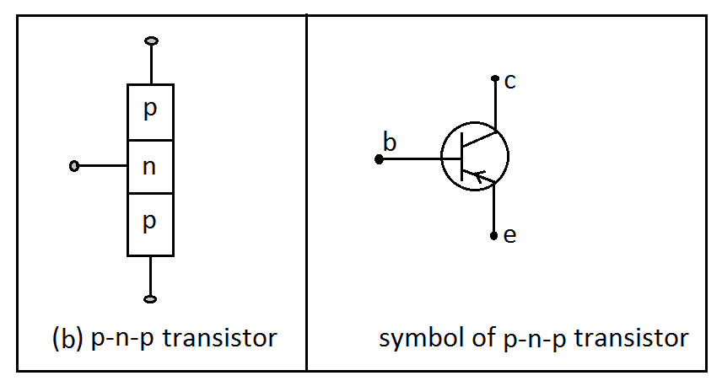
In the symbols above, the arrows indicate the direction of convectional current flow when the transistor is operating normally. The emitter (e) emits electrons which pass through the base (b) to the collector (c). The n – p – n transistors are more commonly used than p – n – p because current moves faster in them.

How a n – p – n transistor works as an amplier?
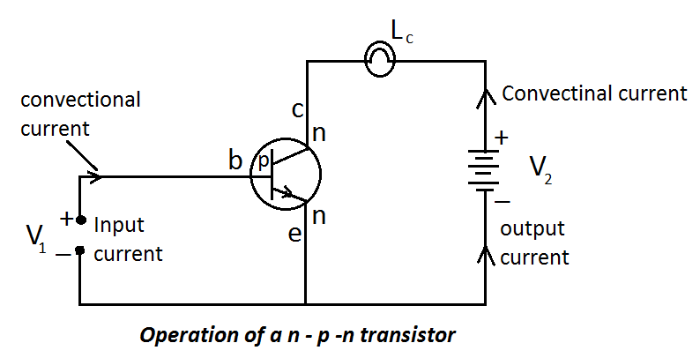
When the input and output circuits are connected as in the figure above. The output collector – base junction is reverse biased since collector (n – side) is connected to the positive terminal of$V_{2}$ and base (p – side) is connected to the negative terminal of $V_{2}$. Hence no current flows.
The input emitter – base junction is forward biased since the emitter (n – side) is connected to the negative terminal of${ V}_{1}$ and base (p – side) is connected to the positive terminal of${ V}_{1}$. Hence current flows in the input connection. This current that flows through the input greatly reduces the current blocking effect of the out (collector – base junction). When this happens, the output circuit starts to conduct and current flows between emitter and collector. Hence$L_{c}$ give light.
Note: a transistor works when a small voltage is applied to the base - emitter$\left(V_{1}\right)$ then high voltage$V_{2}$ makes high current to flow from emitter to the collector (output current). In case of a high voltage to the base – emitter$V_{1}$ a transistor does not work.
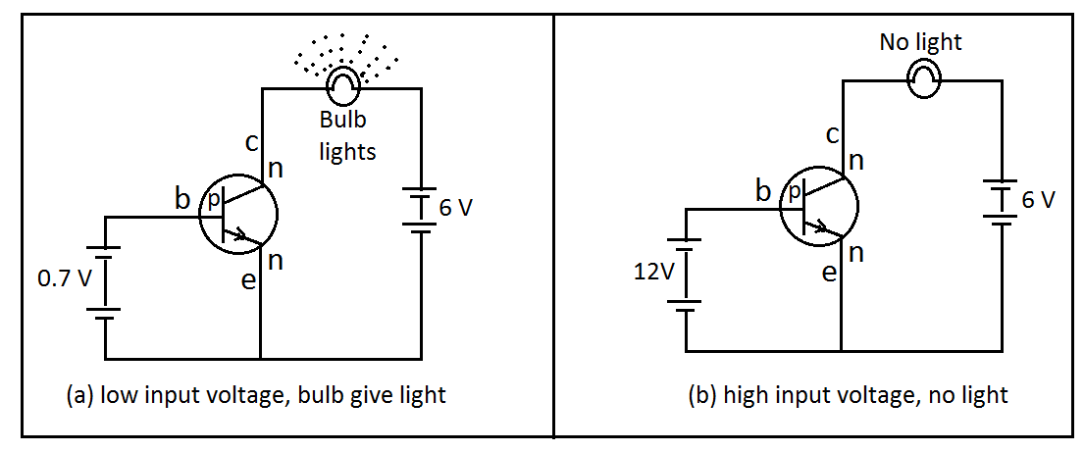
How a n – p – n transistor works as a switch?
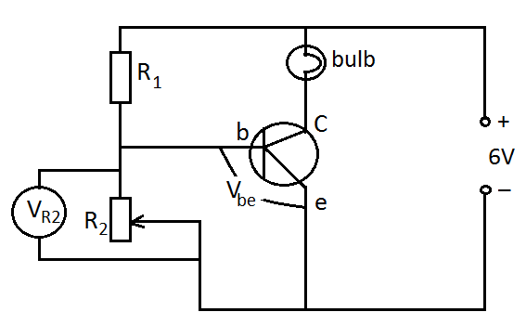
The p.d across resistor $R_{2} \left(V_{R2}\right)$ is equal to the p.d$\left(V_{be}\right)$ across the input (base) that is base emitter voltage because they are parallel arrangement. $R_{2}$is a variable resistor. Varying the resistance of$R_{2}$ from zero to maximum varies the voltage$\left(V_{be}\right)$ between the base and emitter from zero to a maximum value in turn. When $V_{be}$ is zero, no current flows through the output (collector) thus bulb is off. When $V_{be}$ is large enough, b – e junction conducts and so current flows through the output, which makes the bulb to light. In this way a transistor behaves as a switch whereby the input (base) controls the output (collector).
- Light Dependent Resistor (LDR)
Light dependent resistor (LDR) is type of resistors that naturally have high resistance in the dark. When light energy falls on them electrons become more free to conduct and the resistance decreases.
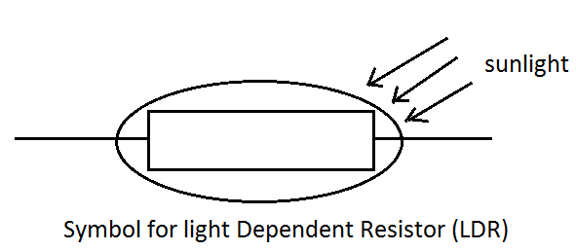
- Light emitting diodes (LEDs)
Light emitting diodes are diodes that emit light when current flows through them.
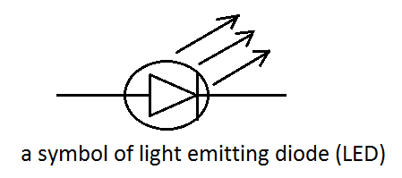
- Thermistor
A thermistor is a temperature sensitive resistor. When the temperature on a thermistor increases, its resistance decreases and vice versa. The thermistor makes part of a potential divider. The thermistor has low resistance at high temperature and allows more current to switch on the transistor in the circuit. The thermistor has high resistance at low temperature and allows low current to switch off the transistor in the circuit.
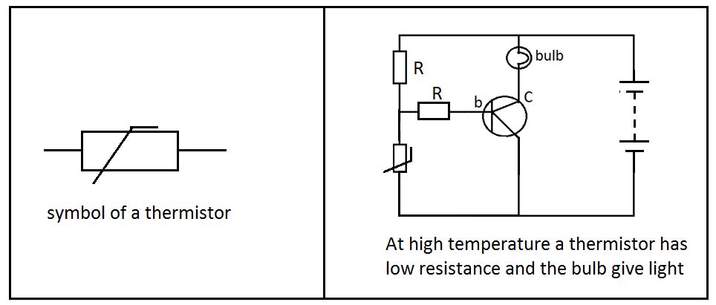
- Photovoltaic cell
A photovoltaic cell is an electrical device that converts light energy directly to electric energy by photovoltaic effect. It is also solar called solar cell.
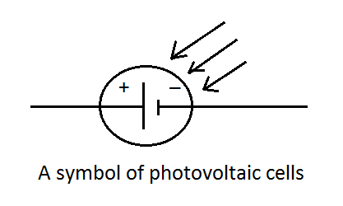
When the sunlight fall on the solar cells, a potential is created across the cells. When the circuit is completed a current flow through the components connected in the circuit.
- Capacitor
A capacitor is a device that stores charges. It consists of two parallel metal plates held together and separated by an insulating medium called the dielectric. Some of the different types of capacitors include: electrolytic capacitors, metal foil capacitors, variable capacitors, etc.
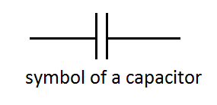
If two plates of a capacitor are connected to a battery, each plate gains equal and opposite charge.
- Inductor
Inductor is an electronic component that stores energy in form of a magnetic field. It consists of a wire loop or coil. The inductor measures inductance which is the behavior of a coil of wire in resisting any change of electric current through the coil.
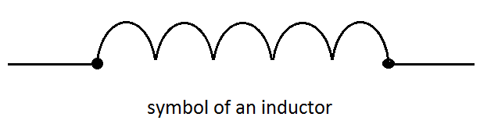
Uses of the electronic components
Capacitor
- Used to maintain power to the memory of devices like mobile phones when batteries are being changed or charged, to avoid loss of data.
- Capacitors are used to absorb electrical signals that cause noise in sound systems.
- Used for smoothing out current changes.
- Used to tune circuits so that they respond to signals of one frequency.
Thermistor
- Used as current limiting devices for circuit protection.
- Thermistors are used in making resistance thermometers used to measure very low temperature.
- Can be used to monitor the temperature of an incubator.
Inductors
- Inductors are used in making traffic light sensors that use loop (coil).
- Used in the red light camera that is used to curb traffic violations. This reduces road accidents.
Light Emitting Diodes (LED)
- Used in aviation lighting.
- Used in automotive headlamps.
- Used in advertising and traffic signals and camera flashes.
Photovoltaic cells
- Photovoltaic cells are used in the manufacture of solar panels.
- Can be used to power solar powered cars, boats and airplanes.
Analogue and digital electronics
- Analogue electronics
Analogue circuits are electronic circuits that operate with currents and voltage that vary continuously with time and have no abrupt transitions between levels. It is a circuit with a continuous variable signal. Analogue circuits are usually complex combinations of operational amplifier, resistors capacitors, inductors transistors and other fundamental electronic components. Analogue circuits are much more difficult to design than digital ones. Some of the characteristics of analogue signal are amplitude, frequency, phase and wavelength.
- Digital electronics
Digital circuits are a circuit where the signal must be one of two discrete levels. The signal must be must be one (1) or zero (0). This digital circuit produce digital signal. Digital circuits are usually made of a combination of transistors and logic gates. Most processors in computers operate in the digital realm. Although digital circuits are generally easier to design, they tend to be a bit more expensive than equally tasked analogue circuit.
Characteristics of digital signal
- Bit interval: this is the time required to send one single bit.
- Digital signals are discrete.
- The signals have limited number of defined values such as 1 and 0.
- Bit rate it’s the number of bit intervals in one second.
Similarities between analogue and digital electronics
- Both are used to transmit information through electric signals.
- Both use building blocks such as input, processor and output.
Differences between analogue and digital electronics
 | analogue | Digital
Signal | Continuous signal which represents  Physical measurements. | Discrete time signals generated by digital modulation.
Waves | Denoted by sine waves | Denoted by square waves
Representation | Uses continuous range of values to represent information | Uses discrete or discontinuous values to represent information
Examples | Human voice in air, analogue electronic devices | Computers, CDs, DVDs, and other digital electronic devices.
Technology | Analogue technology records waveforms as they are. | Samples analogue waveforms into a limited set of numbers and records them.
Data transmission | Subjected to deterioration by noise during transmission and write/read cycle. | Can be noise – immune without deterioration during transmission and write/read cycle. Minimal loss of data. Transmission of data is cheaper than analogue. Digital can be easily compressed and hence and hence transmitted efficiently.
Response to noise | More likely to get affected reducing accuracy. | Less affected since noise response are analogue in nature
Flexibility | Analogue hardware is not flexible. | Digital hardware is flexible in implementation.
Uses | Used in analogue devices only. Best suited for audio and video transmission. | Best suited for computing and digital electronics.
Applications | Thermometer | PCs, PDAs
Bandwidth | Analogue signal processing can be done in real time and consumes less bandwidth. | There is no guarantee that digital signal processing can be done in real time and consumes more bandwidth to carry out the same information.
Memory | Stored in form of wave signal | Stored in the form of binary bit.
Power usage | Uses large power | Use very little power
Cost and portability | Low cost and portable. Give considerable observational errors | High cost and not easily portable. Free from observational errors.

Note: the process by which analogue signal is converted into digital signal is called modulation and the reverse is demodulation.
Digital logic gates
Logic gates are circuits in which transistors act as high speed switches. They are used in devices such as calculators, computers and industrial control systems. Their output depends on the input(s) in which it is either “high” or “low”.
We will consider the following types of logic gates
- AND gate: which gives an output 1 for both two inputs 1.
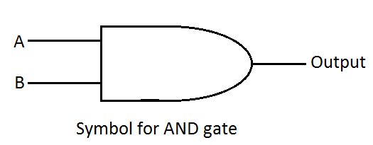
Consider A and B to represent input circuit of a transistor and L to represent the output circuit. Use 1 and 0 to represent the on and off states of any of the three circuits. The table below known as AND truth table summarizes the state of the output for AND gate.
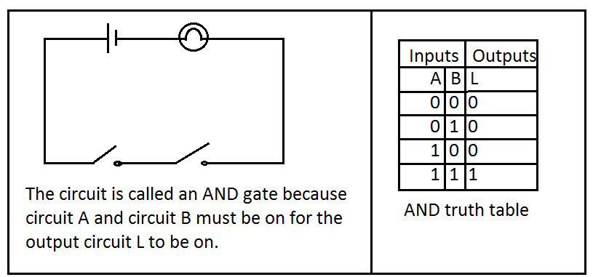
- OR gate: which gives an output 1 for either of two inputs 1or both inputs 1.
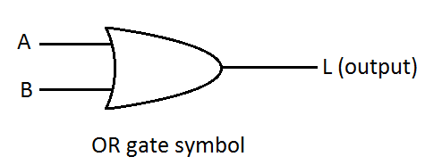
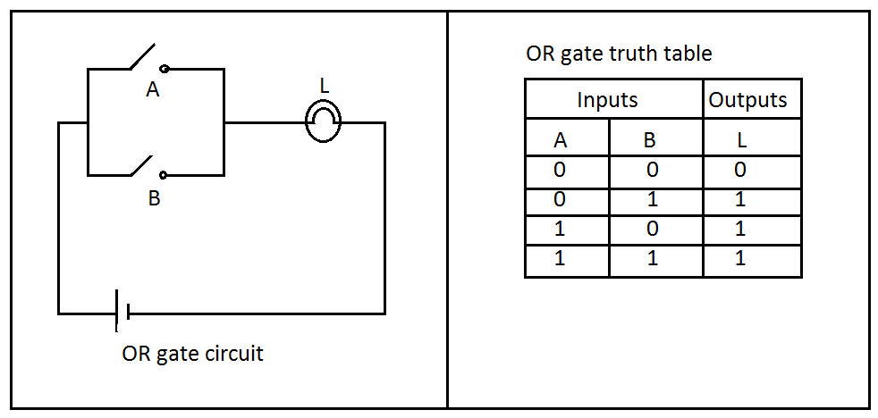
From the truth table of the OR gate we observe that the output circuit represented by the lamp L will only be on when either A or B or both are on.
- NOR gate: which gives an output 1 for neither of two inputs 1.
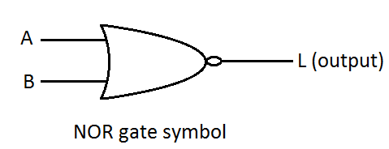
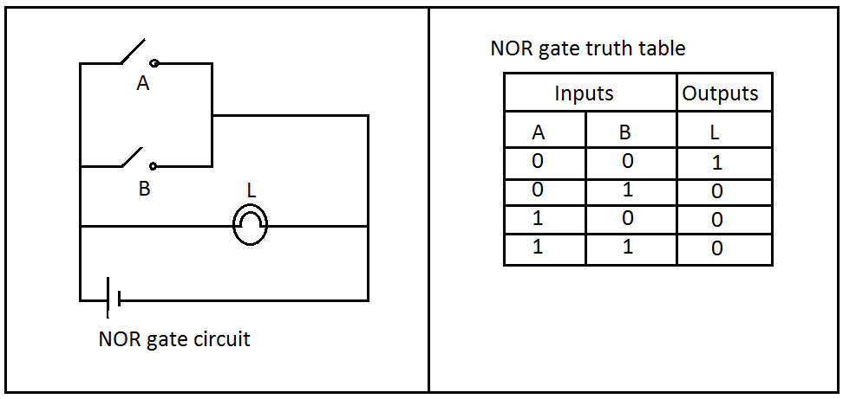
In the NOR gate, neither A nor B should be on for lamp L to be on.
- NOT gate: which gives an output 1 for an input of 0.
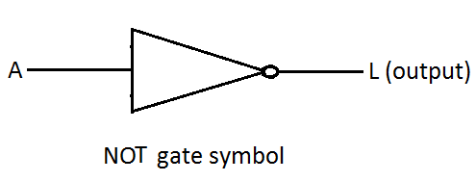
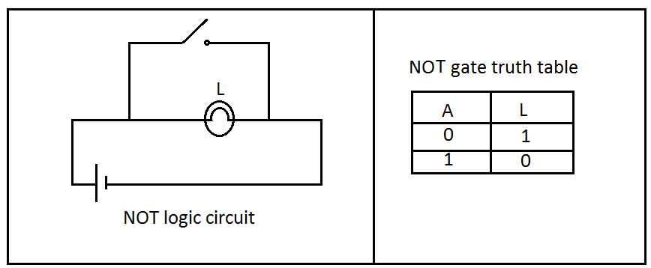
NOT gate logic circuit consists of one input circuit (A) and one output circuit (L). In the NOT logic circuit the output circuit L is on if A is off.
- NAND gate: which gives an output 1 for either but not both of two inputs 1 or both inputs 0.
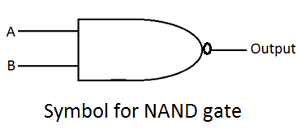
This is a NOT – AND gate which is equal to an AND gate followed by a NOT gate. In the symbol the small circle represents inversion. The NAND gate is considered as a basic building block for a variety of logic circuits. In fact, a number of other logic gates can be constructed from NAND gates.
Truth Table for NAND gate
INPUTS |  | OUTPUTS
A | B | L
0 | 0 | 1
0 | 1 | 1
1 | 0 | 1
1 | 1 | 0

EXAMPLES OF SYSTEMS THAT MAY USE LOGIC GATES
EXAMPLE 1
There is a security flood light at your school for security lighting at night. The lights should be on automatically when it gets darker and off when sunshine is enough in the morning. It should also be possible to switch off the lights manually when there is a fault. Which gates should be used to help make decision and how should they be combined?
Solution
The light should be on either by manual or by sunlight. The light should NOT be on when sunlight has gone. The above two statements suggest that we should use the OR and NOT gates as shown in figure below.
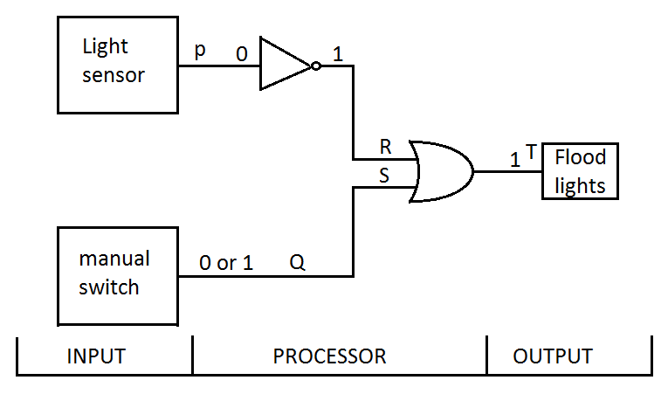
EXAMPLE 2
Your parents have bought a car which can only start when all seat belts are worn and all the doors are closed. Which logic gates can be used and in what combinations.
Solution
The inputs are
- Seat belts use strain or pressure sensor. To get a signal from the seat belt the input must be 0 so that output is 1. Seat belts should be ON when not used (and indicator on the dash board will warn you) and OFF when used. Proper logic gate is NOT.
- Door lock electronic sensor to get a signal 1 from the door, it must be OFF when closed (0) proper gate is NOT.
- The starter key: for the key to work the combination of 1 and 2 should be combined with 3. 1 and 2 use AND logic gate to combine. Then using that combination use another AND with the key. The figure below summarizes the set up.
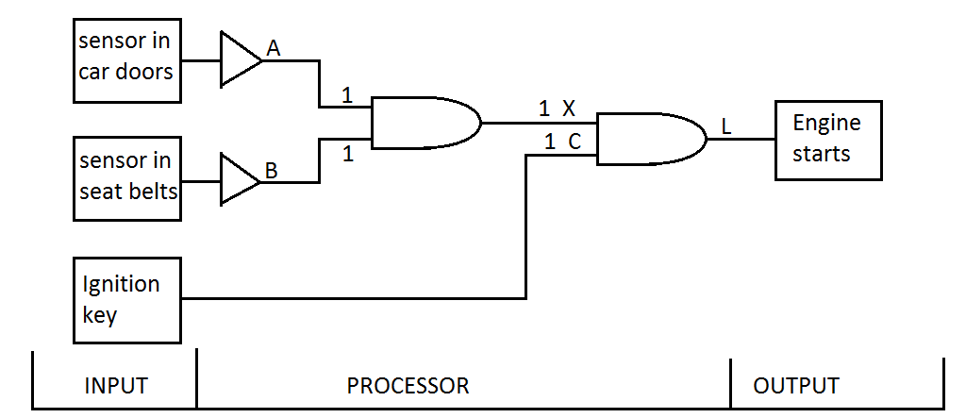

TOPIC 11: ELECTROMAGNETIC WAVES
When charged particles of an atom undergo some change in their energy, they emit this energy in form of waves or radiations. Some of the change in energy include: an electron undergoing transition from an orbit of higher energy to one of lower energy, oscillation of electrons or nuclei. Note that whenever there is an electric field, a magnetic field exists and whenever there is a change in the magnetic field, an electric field is created.
Electromagnetic waves are waves that have both electric and magnetic fields and are capable of travelling through a vacuum.
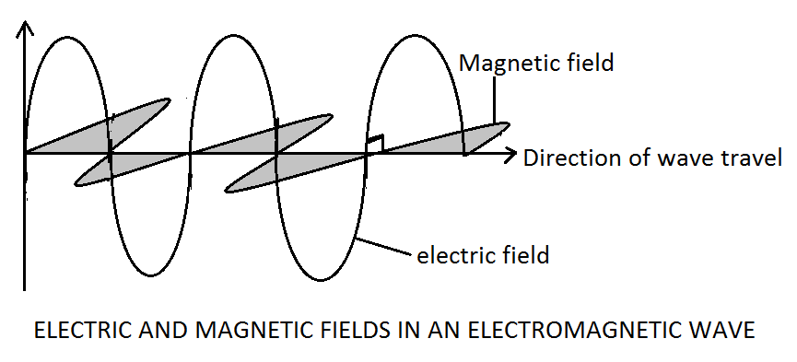
THE LECTROMAGNETIC SPECTRUM
Electromagnetic spectrum is a group of electromagnetic waves with varying frequencies and wavelengths but all travel at the speed of light. Electromagnetic spectrum arranged with increasing wavelength include: gamma rays, X-rays, ultra-violet (UV), visible light, infrared (IR), microwaves and radio waves. The electromagnetic spectrum is a continuous such that there are no distinct boundaries between one radiation and the next.
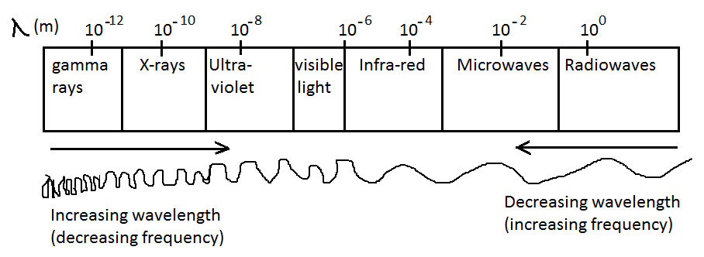
RADIATION | RANGE OF  WAVELENGTH | SOURCE OF  RADIATION | DETECTORS
Gamma rays$\left(γ\right)$ | $${10}^{-15} to {10}^{-11}$$ | - Nuclei of radioactive atoms  - Cosmic rays. | Geiger-Muller tubes, photographic plates/films, Spark counter.
X-rays | $${10}^{-13} to {10}^{-9}$$ | - X-ray tubes.  - When fast moving electrons strike and are stopped by a metal target. | Photographic plates and fluorescent screens. When X-rays falls on Fluorescent screen coated with Zinc Sulphide, the screen grows.
Ultra-violet (UV) | $${10}^{-9} to {10}^{-7}$$ | - Very hot objects.  - Sun, arcs and sparks.  - Mercury vapour lamp. | Photographic plates, Fluorescent screen and photo cells.
Visible light  (VIBGYOR) | $${4×10}^{-7} to$$  $$7×{10}^{-7}$$ | - Very hot objects.  - Sun, lamps, lasers. | Eyes, photographic films, photocells and light-dependent resistor.
Infra-red (IR) | $${10}^{-6} to {10}^{-3}$$ | - Sun  - Warm and hot objects | - Skin.  - Semiconductor devices like LDR and photodiode.  - Certain photographic films.
Microwaves | $${10}^{-3} to {10}^{-1}$$ | - Microwave oven
Radiowaves | $${10}^{-3} to {10}^{6}$$ | - From electrons moving in conductors like in television and radio transimitters | - TV and radio aerials.  - Diodes and earphones in electric circuits. The waves cause a small current to flow in electrical circuits containing such detectors.

PROPERTIES OF ELECTROMAGNETIC WAVES
All electromagnetic waves:
- Have electric and magnetic fields. The wave effect is produced by vibrating charge which generates electric and magnetic fields. These fields are perpendicular to each other.
- Carry no charge.
- Are transverse waves in nature.
- Under suitable conditions, they undergo reflection, refraction, diffraction, polarisation and show interference effect.
- Do not need any material medium to travel i.e. they can travel through a vacuum.
- Travel in a vacuum at a speed of light which is${3∙0×10}^{8}m/s$.
- Transfer energy from one place to another.
- Can be emitted or absorbed by matter.
- Obey the wave equation$c=f×λ$, where c is the speed of light, f is frequency and λ is wavelength.
- Obey the inverse square law, i.e. intensity (I) is inversely proportional to the square of the distance from the source, $r^{2}.$ Therefore; $I∝\frac{1}{r^{2}}$ this holds in a vacuum.
- Possess energy E that is directly proportional to its frequency, i.e.$E∝f.$ Hence,
$E=hf$where h is called Planck’s constant which is equal to${6∙63×10}^{-34}Js$.
APPLICATION OF ELECTROMAGNETIC WAVES
- Gamma rays
- Used as tracers in medicine to locate internal body organs that is not functioning as expected.
- Used in hospitals to sterilize equipment that would otherwise be damaged by heating e.g. plastic syringes.
- In radiotherapy, gamma rays are used to kill cancerous growth.
- In the manufacture of sheets steel, the thickness of the sheets can be controlled by monitoring gamma rays as they pass through the sheets.
- Gamma rays are used to check weak points. For example in in welded joints in materials
- X-rays
- Used by doctors to check on teeth and bones.
- Used by engineers to check the welded metal joints.
- In factories, used to check that food manufactured does not have foreign objects like metals and stones.
- In hospitals, used in the management and treatment of skin disorders.
- Ultra-violet radiation (UV)
- Used to produce vitamin D in our skin.
- Ultra-violet lamps are used to detect forged bank notes. Forged bank notes glow different in ultra-violet light as compared to genuine ones.
- Destroy bacteria, viruses and moulds in the air, in water and on surfaces.
- In medicine, ultra-violet lamps are used for skin treatment.
- Visible light (VIBGYOR)
- Helps us to see.
- Used by plants to make their own food through photosynthesis.
- Laser and optic fibres use it in communication systems.
- Infra-red (IR)
- Used to take photographs called thermographs.
- Used in burglar alarms. The intruder emits infra-red which are detected by the burglar alarm.
- Used for night night vision and security cameras.
- Microwaves
- Used for cooking in microwave ovens, satellite communications and for radar navigation. In microwave oven, the microwaves are absorbed by water molecules in food. On heating up, the water cooks the food.
- Radio waves
- Include Ultra High Frequency (UHF), Very High Frequency (VHF) radio, short waves, medium waves and long waves. Are all used in radio communication.
- UHF waves are used to transmit television programmes.
- VHF waves are used to transmit local radio programmes and ambulances/police message.
- Medium waves are used to transmit messages over long distances because they have a long wavelength and are diffracted around mountains, hills and curves of the earth.
PROBLEMS ASSOCIATED WITH ELECTROMAGNETIC WAVES
- Ultra-violet rays causes sunburn that occurs when skin cells are damaged by the absorption of energy causing problems to aquatic ecosystems.
- Gamma rays may kill living body cells when they are exposed to the rays.
- Both gamma rays and X-rays can cause cell mutation i.e. DNA changes.
- X-rays can cause skin cancer i.e. abnormal growth of living cells.
- X-rays can affect childbirth i.e. the rays can lead to deformity in the infant.
- X-rays can cause baldness i.e. loss of hair on the head.
- Cause global warming. The atmosphere allows the short wave radiation from the sun to pass easily to the earth surface thereby warming it. The warmed ground radiates heat in form of infra-red radiation into atmosphere. The atmospheric gases like${CO}_{2} and H_{2}O$ absorb the infra-red radiation from the earth. In turn atmospheric gases give out heat in which some of the heat is directed towards the earth. Consequently the earth gets warmer.
SOLVING PROBLEMS USING THE WAVE EQUATION
EXAMPLE 1
A radio station broadcasts at a frequency of 590 KHz. What is the wavelength of the radio waves?
Solution
$c=f×λ where c=3×{10}^{8}m/s$ and $f=590×1000 Hz$
$$λ=\frac{c}{f}=\frac{3×{10}^{8}m/s}{590×1000 Hz}=508.47m$$

EXAMPLE 2
What is the frequency of an electromagnetic radiation having a wavelength of${5∙55×10}^{-7}m?$
Solution
$c=f×λ where c=3×{10}^{8}m/s$ and $λ={5∙55×10}^{-7}m$
$$f=\frac{c}{λ}=\frac{3×{10}^{8}m/s}{{5∙55×10}^{-7}m}={5∙40×10}^{14}Hz$$

TOPIC 12: LIGHT AND LENSES
LIGHT
Light is a form of energy that enables us to see things. A path of light is known as a Ray of light. Many rays of light coming from the same source are collectively known as a Beam of light.
LENSES
Lenses are all transparent glass blocks bound between two surfaces of definite geometrical shapes.
TYPES OF LENSES
There are two main types of lenses and these are:
- Diverging (concave) lenses. These are thickest on the edges thinnest at the middle.
- Converging (convex) lenses. These are thickest at the middle and thinnest on the edges.
TYPES OF CONVEX AND CONCAVE LENSES ACCORDING TO THEIR SHAPES
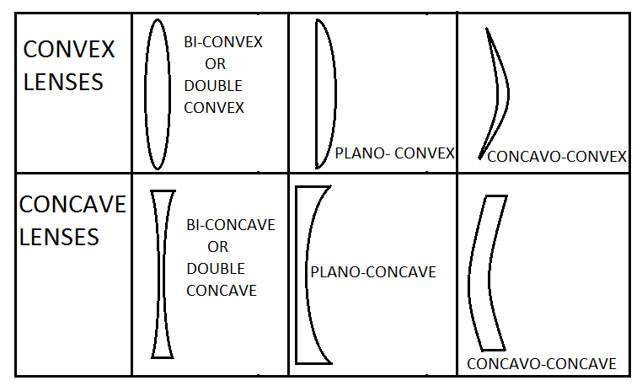
TERMS ASSOCIATED WITH CONVERGING LENSES.
- The centre of curvature (C)
- Centre of curvature is the centre of the sphere of which the surface forms a part.
- For each spherical lens there are two centres of curvature$\left(C_{1} and C_{2}\right)$ due to the two curved surfaces.
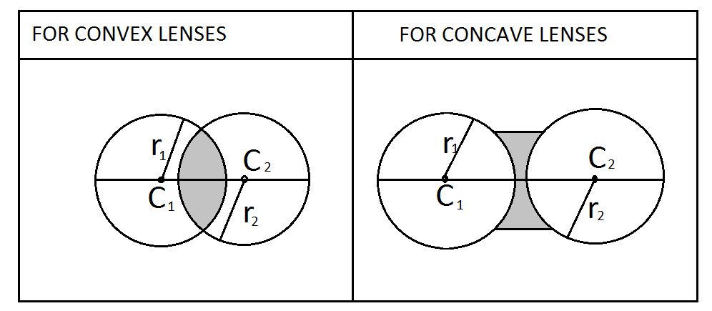
- The radius of the curvature (r)
- Radius of curvature is the radius of the sphere of which the surface forms a part.
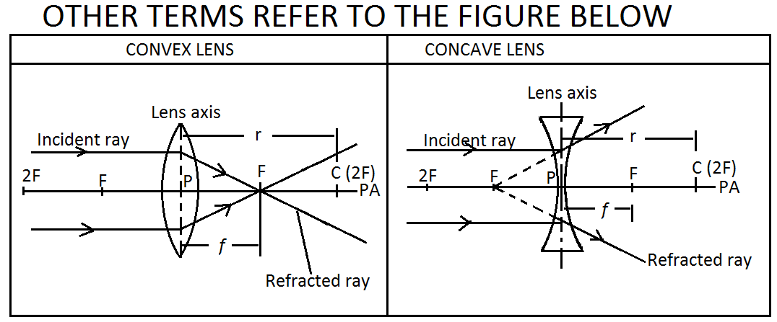
- Principal axis (PA)
- Principal axis is a line passing through the two centres of curvature$\left(C_{1} and C_{2}\right)$. Or
- is an imaginary line through the optical centre of the lens, which is also perpendicular to the plane of the lens.
- Principal focus or Focal point (F)
- Is the meeting point of a beam of light rays after passing through convex lens. Or
- Is a point where parallel incident rays converge after, refraction in the case of convex lens and where they appear to diverge from after a refraction in the case of a concave lens.
- Focal length (f)
- Is the distance between the optical centre (P) and the focal point (F).
- Optical centre (P)
- Is a point which lies exactly in the middle of the lens and light rays through it, are not refracted.
- Focal plane
- Is an imaginary plane passing through the focal point (F) and is perpendicular to the principal axis (PA).
- Note that when light rays are incidented at an angle to principal axis (PA), the refracted rays converge to a point on the focal plane as shown below.
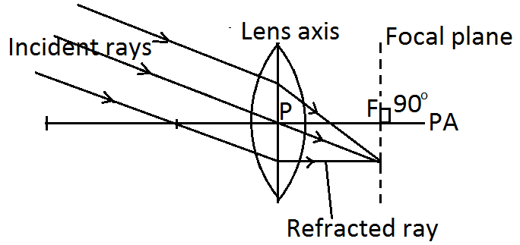

- Object distance (u) Is the distance between lens axis and object.
- Image distance (v) Is the distance between lens axis and image.
- Object (O) Is a real thing.
- Image (I) Is the picture of a real thing.
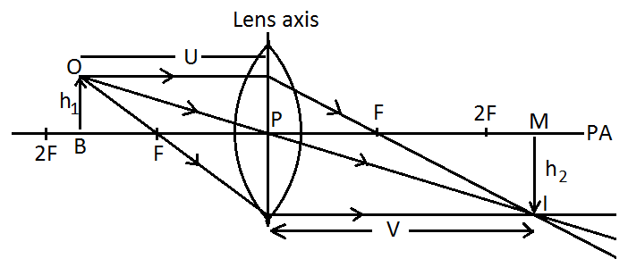
DESCRIBING IMAGE FORMATION USING RAY DIAGRAMS ON CONVEX LENS
Information about the image formed by lens can be obtained by drawing two rays of the following rays:
- A ray parallel to the principal axis (PA) which is refracted through the focal point (F).
- A ray through the optical centre (P) which is not refracted.
- A ray through the focal point (F) which is refracted parallel to the principal axis (PA).
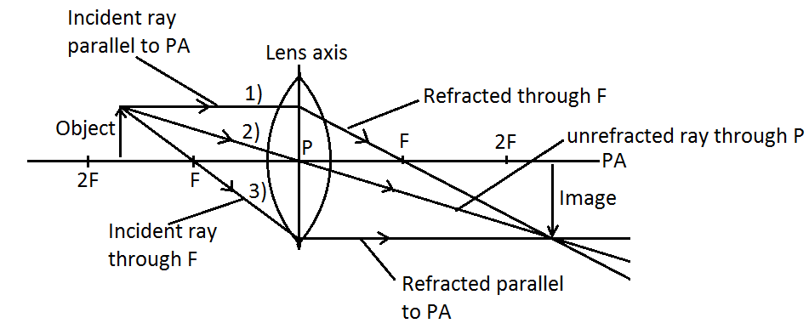
NATURE AND CHARACTERISTICS OF IMAGE
- Virtual or real image
- A virtual image cannot be formed on a screen, for example an image on a plane mirror.
- A real image can be a obtained on a screen, for example an image on a projector.
- Upright (erect) or inverted (upside down)
- Upright/erect: image is in the same direction as object.
- Inverted/upside down: image is in the opposite direction as object.
- Magnified or diminished or same size
- A magnified image has magnification (m) greater than one$\left(m>1\right)$ i.e. image is larger than the object.
- A diminished image has magnification (m) less than one$\left(m<1\right)$ i.e. image is smaller than object.
- Same size image has magnification equal to one$\left(m=1\right)$ i.e. image size is equal to object size.
$$>means "greater than"$$
$$<means "less than"$$
$$m means "magnification"$$
$$u means "object distance"$$
$$v means "image distance"$$
$$h_{1} means "height of object"$$
$$h_{2} means "height of image"$$
$$m=\frac{v}{u} or m=\frac{h_{2}}{h_{1}}$$

RELATIONSHIP BETWEEN THE OBJECT DISTANCE (U), IMAGE DISTANCE (V) AND THE NATURE OF THE IMAGE FORMED USING RAY DIAGRAMS
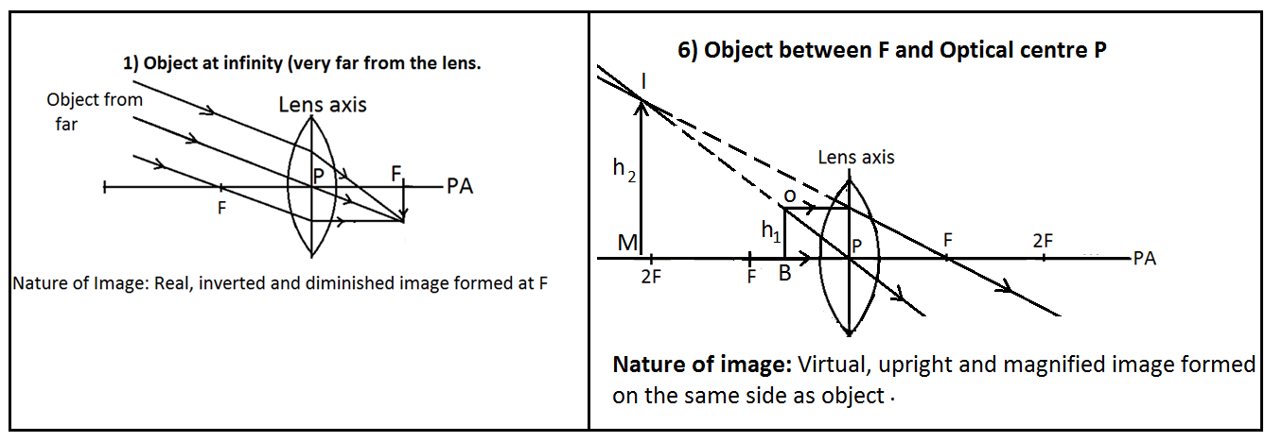

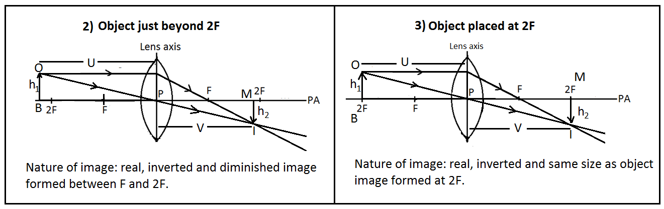
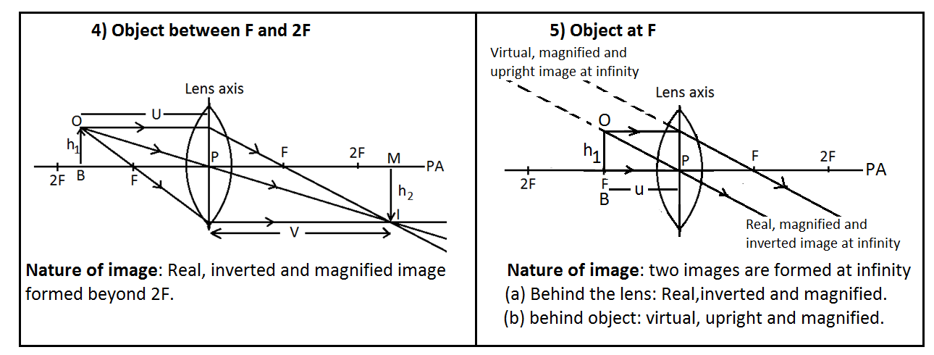
WORKED EXAMPLE ON RAY DIAGRAM
A convex lens has a focal length of$12 cm$ and a real object$6 cm$ tall is placed at$18cm$ from the centre of the lens. By means of an accurate scale diagram, find the position, size and nature of the image formed.
Solution
$$let 1 cm on paper=6 cm on the ground$$
$$\overset{⇒}{} 2 cm on paper=12 cm on the ground$$
$$\overset{⇒}{}3 cm on paper=18 cm on the ground$$
$$∴on paper, focal length \left(f\right)=FP=2 cm, Object height \left(h_{1}\right)=OB=1 cm$$
$$Object distance \left(u\right)=3 cm$$
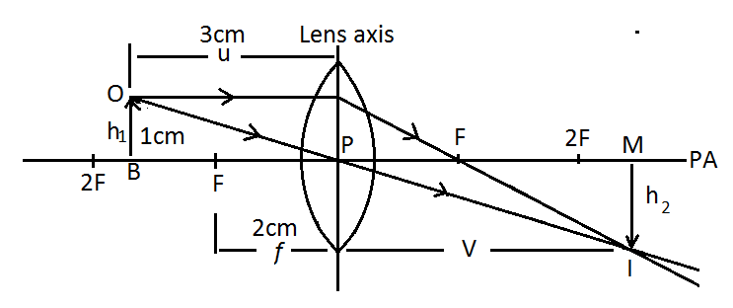$Position of image:6 cm from the lens on paper so V=6cm on paper.$
$$on the ground, V=6×6 cm=36 cm$$
$$size of image:height of image, "h_{2} or IM=2 cm on paper.$$
$$on the ground, =2×6 cm=12 cm$$
$$magnification \left(m\right)=\frac{V}{U} or \frac{h_{2}}{h_{1}}$$
$$magnification \left(m\right)=\frac{6cm}{3cm} or\frac{2cm}{1cm}=2$$
$$Nature of image:real, inverted and magnified.$$
DESCRIBING IMAGE FORMATION USING LENS FORMULA
The lens formula
The lens formula is a formula relating the focal length (f), object distance (U) and image distance (V).
$$The lens formual is: \frac{1}{f}=\frac{1}{u}+\frac{1}{v}$$
When using the lens formula note the following:
- If V is positive, then nature of image is real and inverted.
- If V is negative, the nature of image is virtual and upright.
- If $m=1$i.e. $u=v or h_{1}=h_{2}$then image is of the same size as object which implies that object is at 2F.
- If $m>1,$ then nature of image is magnified and if $m<1,$ then nature of image is diminished.
DERIVATION OF THE LENS FORMULA
Consider a convex lens of focal length (f) which forms a real image,$IM=h_{2} of an object,$
$OB=h_{1}$ as in the figure below:
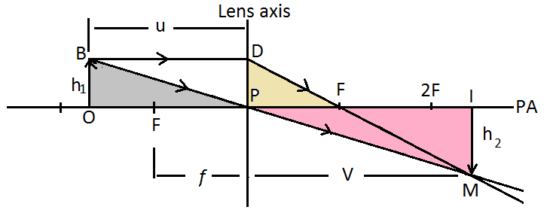
$$∆ OBP⫻ ∆IMP (AAA)$$
$$∴\frac{OB}{IM}=\frac{OP}{IP}$$
$$\frac{OB}{IM}=\frac{U}{V}-----(1)$$
$$Now, ∆PDF⫻∆IMF (AAA)$$
$$∴\frac{DP}{IM}=\frac{PF}{IF}$$
$$Since DP=OB, then$$
$$\frac{OB}{IM}=\frac{f}{v-f}-----(2)$$
$$combining equation \left(1\right)and \left(2\right)gives$$
$$\frac{u}{v}=\frac{f}{v-f}$$
$$u\left(v-f\right)=vf$$
$$uv-uf=vf dividing by uvf throughout gives$$
$$\frac{1}{f}-\frac{1}{v}=\frac{1}{u} hence$$
$$\frac{1}{f}=\frac{1}{u}+\frac{1}{v}$$

MAGNIFICATION
$$magnification (m)=\frac{Height of image}{Height of object}$$
$$magnification \left(m\right)=\frac{IM}{OB}=\frac{h_{2}}{h_{1}}$$
$$Now ∆ IMP ⫻ ∆ OBP \left(AAA\right)$$
$$\frac{IM}{OB}=\frac{IP}{OP}, which implies that \frac{IM}{OB}=\frac{V}{U}$$
$$Hence, mag\left(m\right)=\frac{h_{2}}{h_{1}}=\frac{v}{u}$$

WORKED EXAMPLES ON LENS FORMULA
EXAMPLE 1
An object$6cm$ high is placed$18cm$ from the centre of a convex lens of focal length$12cm$. Find
  - length of image distance,$v$ ?
  - magnification, m?
  - nature of image?
  - height of the image, $h_{2}?$
Solution
- $u=18 cm, h_{1}=6 cm, f=12 cm$
$$\frac{1}{f}=\frac{1}{u}+\frac{1}{v}$$
$$\frac{1}{v}=\frac{1}{f}-\frac{1}{u}$$
$$\frac{1}{v}=\frac{1}{12 cm}-\frac{1}{18 cm}$$
$$\frac{1}{v}=\frac{3-2}{36 cm}$$
$$\frac{1}{v}=\frac{1}{36 cm}$$

$$∴v=36cm$$

- $m=\frac{v}{u}=\frac{36 cm}{18 cm}=2$
- $since v=+ve and m>1, nature of image is real, inverted and magnified.$
- $m=2 and also m=\frac{h_{2}}{h_{1}} given that h_{1}=6 cm$
$$\frac{h_{2}}{6 cm}=2, which implies that h_{2}=2×6 cm=12 cm$$
EXAMPLE 2
An object placed$30 cm$ from a convex lens produces an image of magnification 1. What is the focal length of the lens?
Solution
$$when m=1, u=v, ∴u=v=30 cm, this occur when the object is at 2F i.e. u=2f$$
$$∴2f=30 cm, which implies that, f=\frac{30 cm}{2}, hence f=15cm$$
EXAMPLE 3
An object of height$2 cm$ is placed$8 cm$ from a convex lens and a virtual image is formed on the same side as the object at$24 cm$ from the lens.
    - Calculate the focal length f of the lens?
    - Calculate the height of the image$h_{2}$ formed?
Solution
- $since the image is virtual then, v=-24 cm, u=8 cm. by lens formula$
$$\frac{1}{f}=\frac{1}{u}+\frac{1}{v}$$
$$\frac{1}{f}=\frac{1}{8 cm}-\frac{1}{24 cm}$$
$$\frac{1}{f}=\frac{3-1}{24 cm}$$
$$\frac{1}{f}=\frac{2}{24 cm}$$
$$\frac{1}{f}=\frac{1}{12 cm}$$

$$∴f=12 cm$$

- $m=\frac{v}{u} and also m=\frac{h_{2}}{h_{1}}, h_{1}=2 cm, u=8 cm, v=-24 cm and h_{2}=?$
$$\overset{⇒}{}\frac{h_{2}}{h_{1}}=\frac{v}{u}, which implies that h_{2}=\frac{v}{u}×h_{1} ∴ h_{2}=\frac{-24 cm}{8 cm}×2 cm$$
$$hence h_{2}=-6 cm (-ve sign indicates that the image is virtual)$$
EXAMPLE 4
An object is placed$12 cm$ from the centre of a convex lens and real image is formed at$36 cm$ from the lens.
- Calcualate the focal length f of the lens if height of object$h_{1} is 1∙2 cm.$
- Calculate magnification m produced by the lens.
- Calculate the size of the image,$h_{2}$.
Solution
- $u=12 cm, v=36 cm, so \frac{1}{f}=\frac{1}{12 cm}+\frac{1}{36 cm}, which implies that \frac{1}{f}=\frac{3+1}{36 cm}$
$$\overset{⇒}{}\frac{1}{f}=\frac{4}{36 cm}, which implies that \frac{1}{f}=\frac{1}{9 cm} , hence f=9 cm.$$
- $m=\frac{v}{u}=\frac{36 cm}{12 cm}=3$
- $m=\frac{h_{2}}{h_{1}}, which implies that h_{2}=m×h_{1}, given that m=3 and h_{1}=1∙2 cm$
$$h_{2}=3×1∙2 cm=3∙6 cm, therefore size of the image is 3∙6 cm$$
EXAMPLE 5
A convex lens produces a real image of an object and the image is 3 times the size of the object. The distance between the object and the image is$80 cm$. Calculate the focal length f of the lens.
Solution
$$image size is 3 times size of object means that, h_{2}=3×h_{1}$$
$\overset{⇒}{}m=\frac{h_{2}}{h_{1}} will lead to, m=\frac{3h_{1}}{h_{1}}, hence m=3$
$$also, m=\frac{v}{u}, ∴3=\frac{v}{u}$$
$$\overset{⇒}{} v=3u---------------(1)$$
$$distance between object and image is 80 cm implies that$$
$$u+v=80 cm-------------(2)$$
$$since v=3u,substituting for the value of v in equation \left(2\right)gives$$
$$u+3u=80 cm, so 4u=80 cm, hence u=\frac{80 cm}{4}=20cm$$
$$∴v=3u=3×20 cm=60 cm$$
$$by lens formula, \frac{1}{f}=\frac{1}{u}+\frac{1}{v}$$
$$\frac{1}{f}=\frac{1}{20 cm}+\frac{1}{60 cm}$$
$$\frac{1}{f}=\frac{3+1}{60 cm}$$
$$\frac{1}{f}=\frac{4}{60 cm}$$
$$\frac{1}{f}=\frac{1}{15 cm}$$

$$∴f=15 cm$$

AN EXAMPLE ON CONCAVE LENS
Note that an image in concave lens is always virtual and$f=-ve$.
An object is placed$12 cm$ from the centre of a concave lens of focal length$20 cm$. Calculate the distance of the image from the lens.
Solution
$$u=12 cm, f=-20 cm and v= ?$$
$$by lens formula, \frac{1}{f}=\frac{1}{u}+\frac{1}{v}$$
$$\frac{1}{-20 cm}=\frac{1}{12 cm}+\frac{1}{v}$$
$$\frac{1}{v}=-\frac{1}{20 cm}-\frac{1}{12}$$

$$\frac{1}{v}=\frac{-3-5}{60 cm}$$
$$\frac{1}{v}=\frac{-8}{60 cm}$$
$$\frac{v}{1}=-\frac{60 cm}{8}$$

$$∴v=-7∙5 cm$$
$$v is negative because the image is virtual.$$
DETERMINING THE FOCAL LENGTH f OF A CONVEX LENS BY EXPERIMENT
EXPERIMENT 1 (ESTIMATION METHOD)
AIM: To find the focal length f of a converging lens by using a distant object like a window.
MATERIALS: converging lens, metre ruler, white paper (screen on the carton), object (window frame)
PROCEDURE
- Set up the apparatus as shown in the figure below where sunlight is coming from.
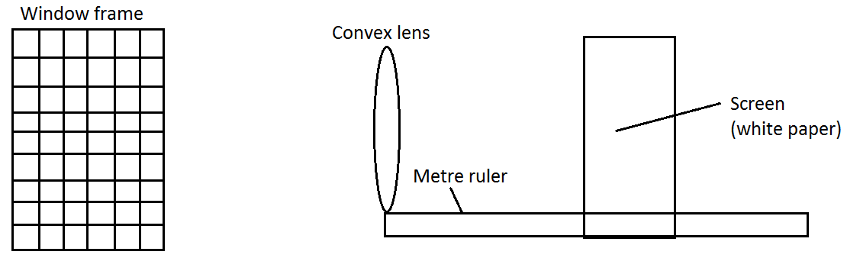
- Adjust the screen until you are able to see a sharp image of the window frame on the screen.
- Measure the distance from the lens to the screen by using a metre ruler.
- Repeat steps 2) and 3) twice and and record distance from the lens to the screen each time.
TABLE OF RESULTS
trial | 1st trial | 2nd trial | 3rd trial
Image distance v

- Find the average of image distance v.

EXPECTED RESULTS AND EXPLANATION
When the screen is moved, an image is formed on the screen. This image is real, inverted and diminished. The distance from the lens to the screen is the focal length f of the lens. Note that Focal length f depends on thickness of the lens in that thick lens has shorter f while thin lens has longer f.

EXPERIMENT 2
AIM: To determine the focal length f of a convex lens by using an illuminated object and a mirror.
APPARATUS: Plane mirror, cross wire on screen, convex lens and candle.
PROCEDURE
- Set up the apparatus as shown below:
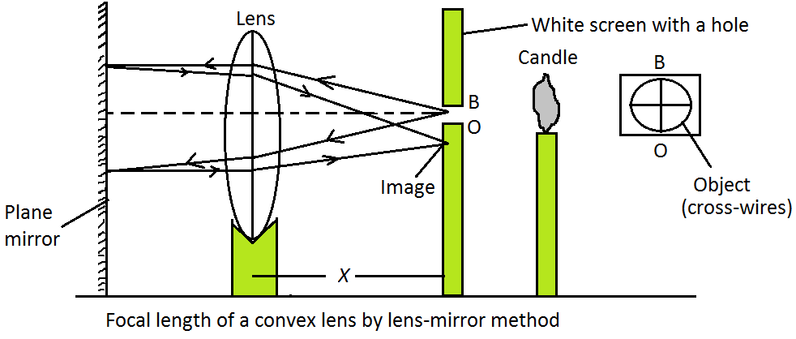
- Adjust the position of the lens until a sharp image IM of the cross wire is formed alongside the object OB.
- Measure the distance x between the optical centre P of the lens and the screen.
- Record the value of x.
- Repeat the procedures above two more times.
- Work out the average value of x. i.e.
$$x_{av}=\frac{x_{1}+x_{2}+x_{3}}{3}=_ _ _$$
CONCLUSION
The average value of x is the focal length of the lens.

EXPERIMENT 3
AIM: To determine the focal length f of a converging lens by using graphical method.
MATERIALS: Converging lens, lens holder, metre ruler, candle (object), matches and screen.
PROCEDURE
- Arrange the apparatus as shown below:
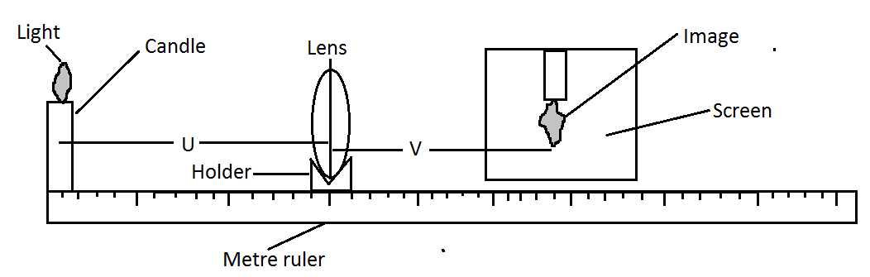
- Light the candle.
- Move the lens to the candle until it is$20 cm$ from the candle. This distance is object distance, u.
- Move the screen until a clear image of the object is formed on the screen.
- Measure the distance from the lens to the image on the screen. This distance is image distance v so record it in column of v.
- Repeat the experiment with other object distances of$25cm, 30cm, 35cm, 45cm and 50 cm$ and record value of v in each case.

TABLE OF RESULTS
$$U (cm)$$ | $$V (cm)$$ | $$U+V (cm)$$ | $$\frac{1}{U} ({cm}^{-1})$$ | $$\frac{1}{V} ({cm}^{-1})$$
20
25
30
35
40
45
50

EXPECTED RESULTS AND DISCUSSION

- Plot a graph of$\left(U+V\right)$ against$U$. The graph is expected to be of the shape as the one below:
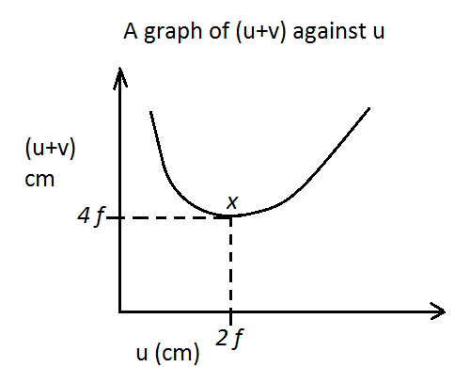
- The most important point on the graph is point x (the minimum point).
- Point x is produced when the object is at 2f, the image will also be formed at 2f.
- $∴at point x, u=2f, v=2f and u+v=4f$
- $f=\frac{Value of U at point x}{2} or f=\frac{Value of \left(U+V\right) at at point x}{4}$
$$Hence the focal length can be found by using either the value of U or$$
$$\left(U+V\right)at minimum point in a graph of \left(U+V\right)against U.$$

- Plot a graph of$\frac{1}{V}$ against$\frac{1}{U}$ or $\left(\frac{1}{U} against \frac{1}{V}\right)$
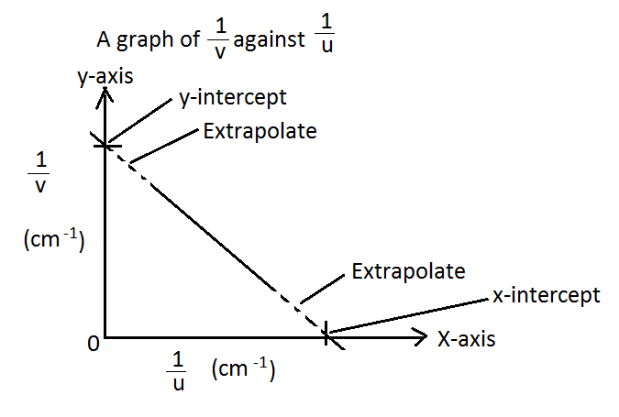
- The graph is expected to be straight line graph of gradient$-1.$
- The most important points are the$y-intercept$ and the$x-intercept$ of the graph.
- By using the lens formula: $\frac{1}{f}=\frac{1}{u}+\frac{1}{v}$
- When $\frac{1}{U}=0, then \frac{1}{f_{1}}=\frac{1}{V} (y-intercept value from the graph then f_{1} can be found.$
- When $\frac{1}{V}=0, then \frac{1}{f_{2}}=\frac{1}{U} (x-intercept value from the graph then f_{2} can be found.$
- $Take the average of the focal length f found above i.e. f=\frac{f_{1}+f_{2}}{2}$
$$Hence focal length can be found by using either the y-intercept or x -intercept in$$
$$a graph of \frac{1}{V} against \frac{1}{U} or \frac{1}{U}against \frac{1}{V}. Note:in order to minimise errors the average of$$
$$the focal length f found by using the two intercepts is considered.$$

APPLICATIONS OF LENSES IN OPTICAL DEVICES
      - THE LENS CAMERA
The camera is a device used to take photographs (images) of objects.
DIAGRAM OF PARTS OF THE LENS CAMERA
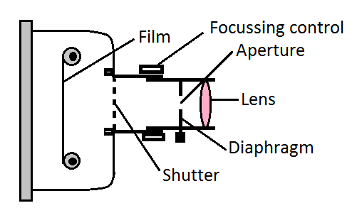
FUNCTIONS OF THE PARTS OF A CAMERA
- Shutter – it opens and closes very fast to allow light into the camera.
- Diaphragm – it controls the size of the aperture in the process controlling the amount of light entering the camera.
- Aperture (hole) – it allows light rays to enter the camera.
- Focussing control – for adjusting the lens in order to produce a good image on the film.
- Lens – converges light rays onto the film.
- Film – images are formed on the film. A film is a plastic material that is coated with light sensitive chemical called Silver bromide. When the film is exposed to light , the chemical reacts at different intensities of colour of light which causes varying chemical chnges on the film. The camera box is dark inside to prevent damage to the film.

HOW A CAMERA WORKS?
Light rays from the object are refracted by the lens and meet on the film where an image is produced. The image is always diminished, inverted and real.
      - THE HUMAN EYE
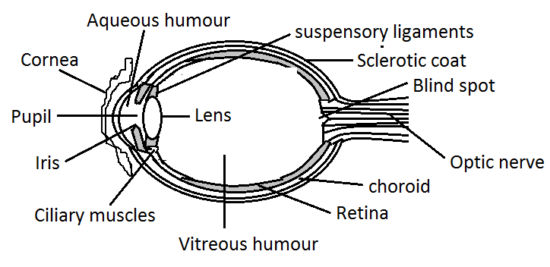
FUNCTIONS OF THE PARTS OF THE HUMAN EYE
- Cornea – allows light to enter the eye and helps in refraction of light rays.
- Iris – are muscles thet control the size of the pupil.
- Pupil – is a black hole in the front of the eye to allow light into the eye.
- Ciliary muscles – control the shape of the lens by relaxation and contarction.
- Suspensory ligaments – is where lens are suspended and the ligaments are fastened to the ciliary muscles.
- Lens – Focusses sharp and inverted image on the retina
- Retina – this is a black and light sensitive tissue on the back inner surface of the eye.
Real, diminished and inverted images are formed on the retina.
- Optic nerve – carries visual messages to the brain for the body to act.
ACCOMODATION OF THE EYE
- This is the process of changing the focal length of the lens by contraction and relaxation of the ciliary muscles. Or
- This is the ability of the eye lens to focus the images from objects at different distances onto the retina.
IMAGE FORMATION IN THE EYE
- When one looks at far objects, the eye lens becomes thinner and focal length of the lens increases. Ciliary muscle is relaxed and the lens has the longest focal length. Therefore the lens focusses rays from distant objects onto the retina.
- To view closer objects, the lens becomes thicker and the focal length of the lens decreases. The ciliary muscles contract to reduce tension in the lens and the lens becomes more curved with short focal length as more powerful. The lens focusses images of near objects onto the retina.
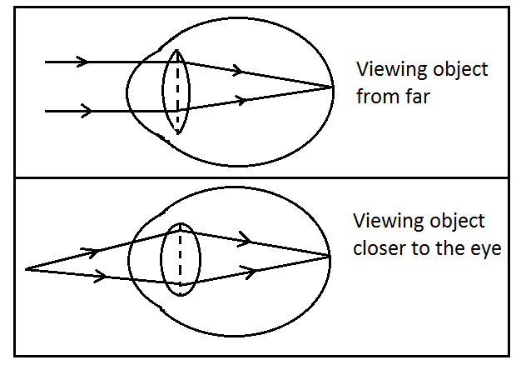
EYE DEFECTS
- Short-sight or Myopia
A person sees near objects clearly but cannot see objects far away. Image of a distant object is formed in front of the retina.
Causes of short-sight
- Eyeball being too long.
- More refraction taking place at the cornea.
- Lens being too thick.
- Ciliary muscles inelastic due to old age.
- Focal length of the lens being too short.
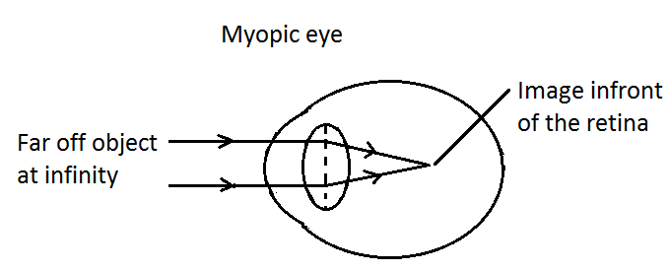
Correction of short-sight
Use diverging lens. The lens diverges the rays from a distant objects so that they apper to come from a virtual image formed at a point closer to the eye.
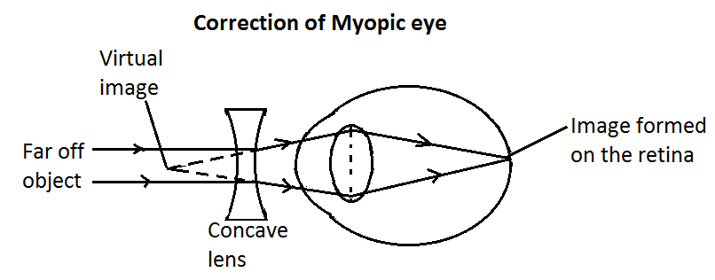
- Long-sight or Hypermetropia
A person sees distant objects clearly but cannot see near objects. Image of a nearby object is formed behind the retina.
Causes of long-sight
- Eyeball being too short
- The curvature of the camera being defective.
- Lens being too thin.
- Focal length of the lens being too long.
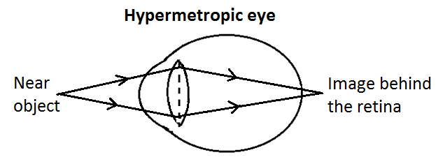
Correction of long-sight
Use converging lens. The lens converges the rays from near object so that they appear to come from a virtual image formed at a point far off from the lens.
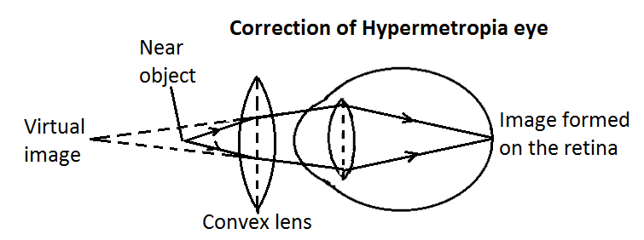
SIMILARITIES BETWEEN AN EYE AND CAMERA
- Both have converging lens.
- Both produce real, inverted and diminished images.
- Both have black inside surface.
- Both control the amount of light entering the device.
- Both have light sensitive parts. An eye has a retina and a camera has a film.
DIFFERENCES BETWEEN THE HUMAN EYE AND THE CAMERA
- Focal length of the eye changes while that of camera is fixed.
- The eye has fixed image distance while that of the camera changes.
- The eye produces clear images by the process of accommodation while the camera produces clear images by focusing.
- The human eye has fluids while the camera has no fluids inside.
- The eye has an optic nerve while the camera does not have one.
- The eye form temporary images at the retina while the camera form permanent images on the film.
- Lens of the eye are flexible while that of the camera is rigid.

      - THE SLIDE/FILM PROJECTOR
The slide projector is used for producing large images on a screen from a small pictures on a slide.
PARTS OF A SLIDE PROJECTOR
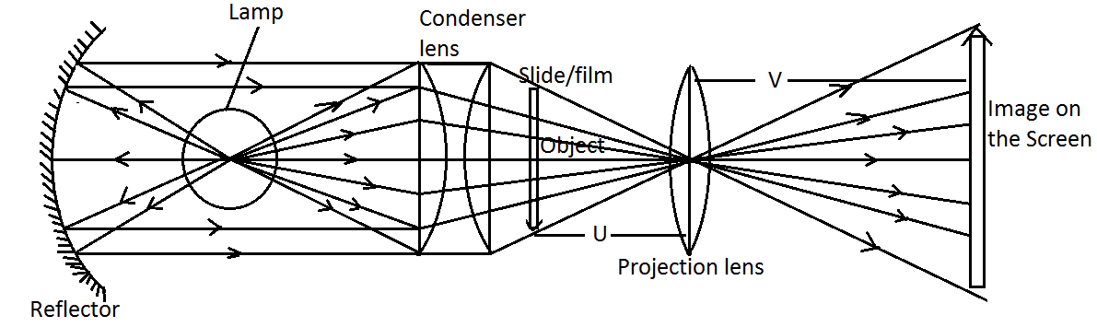
FUNCTIONS OF THE PARTS OF A PROJECTOR
- Curved mirror/Reflector/Concave mirror – It reflect back stray light..
- Lamp/Bulb – produces light for illuminating the object (film).
- Condenser lens – consists of plano-convex lens. Converges (concentrate) light rays onto the film (object).
- Film/Slide – contains small pictures that act as object.
- Projection lens – to converge (refract) light rays on the screen.
- Screen – where images are formed.
The nature of image formed in a slide projector is real, inverted and magnified.
RAY DIAGRAM FOR A SLIDE PROJECTOR
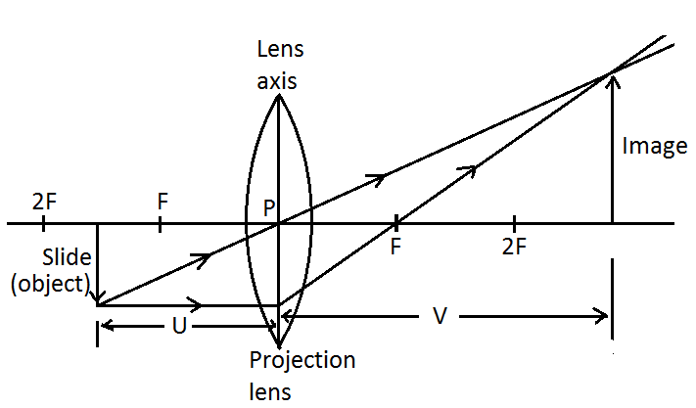
HOW THE SLIDE PROJECTOR WORKS?
The object placed in the projector transparent is usually a kind of a negative of a film with a picture on it. When the light from the source and the mirror passes through the object it forms an image on the screen with help from the focusing lens. Usually the pictures are still (stationary) ones. In a moving picture projector, several closely similar pictures are flashed quickly so that the eye of an observer will see it as if it is moving.
      - TELESCOPE
A telesope is an instrument used to observe distant objects like stars, planets and the moon.
PARTS OF A TELESCOPE AND THEIR FUNCTIONS
- Objective lens – has a long focal length (thin lens). It is used to produce a real, inverted and diminished image.
- Eyepiece lens – has a short focal length (thick lens). It acts as a magnifying lens. The final image is a large virtual image magnifying the first image.
$$In telescope, Magnification \left(m\right)=\frac{Focal length of objective lens}{Focal length of eyepiece lens}$$

RAY DIAGRAM OF A TELESCOPE
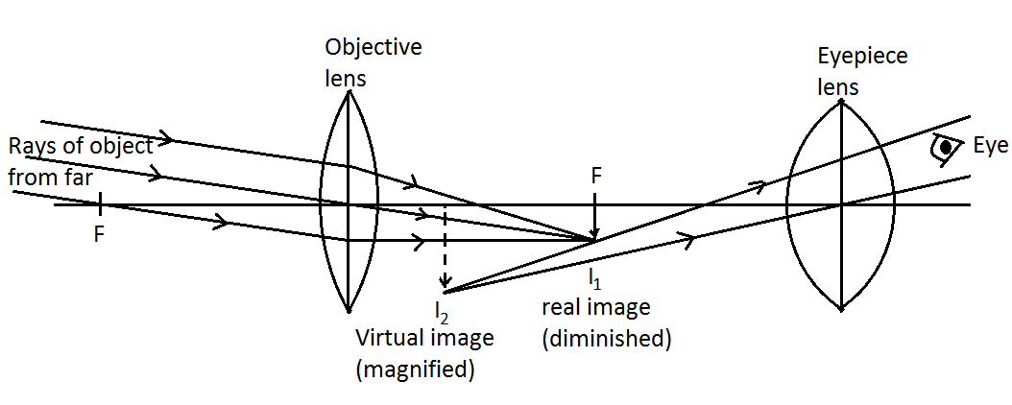

TOPIC 13: NUCLEAR PHYSICS
Nuclear Physics is the study of vast amount of energy that can be obtained from the nucleus of an atom and which can be released in nuclear reactions.
STRUCTURE OF AN ATOM
The three subatomic particles of an atom are protons, neutrons and electrons.
SYMBOL, CHARGE, MASS, RELATIVE MASS AND WHERE THE THREE SUBATOMIC PARTICLES ARE FOUND
SUBATOMIC  PARTICLE | SYMBOL | CHARGE | WHERE  FOUND | MASS (KG) | RELATIVE  MASS
Protons | P | $$+1$$ | Nucleus | $${1∙6726×10}^{-27}$$ | 1
Neutrons | n | $$0$$ | Nucleus | $${1∙6749×10}^{-27}$$ | 1
Electrons | e | $$-1$$ | Shells/orbits | $${9∙1094×10}^{-31}$$ | $$\frac{1}{1836}$$

For example the structure of sodium$Na$ atom is as follows.
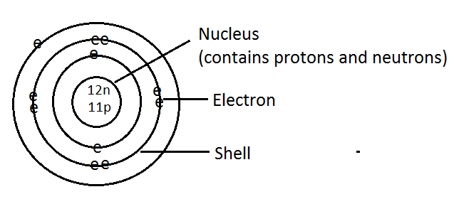
Note that naturally all atoms are electrically neutral that is to say$number of protons=number of electrons$. For example in sodium atom above we have eleven protons which gives us charge$+11$ and eleven electrons which gives us a charge of$-11$
$$∴Total charge of Na=+11-11=0 charge which is neutral.$$
DEFINITION OF SOME TERMS
- A proton is a positively charged particle that is found in the nucleus.
- An electron is a negatively charged particle that rotates around the nucleus in orbits at very high speed.
- A neutron is a zero charged particle that is found in the nucleus of an atom.
- Nucleons number also known as atomic mass (A) is the total number of protons and neutrons in the nucleus of an atom.
- Atomic number (Z) is the number of protons in the nucleus of an atom.
- Nuclides are atoms which have different nucleon number whether the difference is in the number of neutrons, the number of protons or both.
NUCLEAR NOTATION
Conventionally an atom is generally represented by the nuclear notation
$$For example Uranium with a chemical symbol of U can be represented as$$
$${}_{92}^{235}U which implies that atomic mass of uranium is 235 and atomic number is 92.$$
Another notation is to use the name of the element followed by the atomic mass of the atom. For example Uranium – 235 (U -235), Carbon – 12.
Relationship between mass number (atomic mass) A, atomic number Z, and the number of neutrons n is as in the equation below:
$$n=A-Z$$
A proton has$+ve charge and mass number of 1,$ therefore the nuclear notation of a proton is
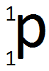
An electron consists of a single negative charge, but does not contain any nuclides (protons and neutrons) and therefore its atomic number is$-1$ while its mass number is zero (considered to have zero mass since its mass is very small about$\frac{1}{1836}$ which approximately zero. Therefore nuclear notation for an electron is
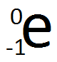
A neutron has no charge and hence its atomic number is zero while its mass number is 1. Therefore nuclear notation for a neutron is
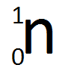
ISOTOPES AND ISOBARS
ISOTOPES are atoms of the same element with different mass numbers due to different numbers of neutrons in their nuclei. Isotope was derived from Greek word ISO- same, TOPS-place.
Isotopes have similar chemical properties i.e. isotopes have same number of protons = number of electrons in a neutral a neutral atom. Hence same chemical properties.
Examples of isotopes
- $Carbon-12, Carbon-13 and Carbon-14 are isotopes of carbon.$
- $Hydrogen-1 \left(Hydrogen\right), Hydrogen-2\left(Deuterium\right)and Hydrogen-3\left(Tritium\right)are isotopes of Hydrogen.$
- $Helium-4 and Helium-3 are isotopes of Helium.$
- $Chlorine-35 and Chlorine-37 are isotopes of Chlorine.$
$$3/4 of Chlorine have 35 amu and 1/4 of chlorine have 37 amu$$
$$∴average amu of chlorine=\left(3/4×35\right)+\left(1/4×37\right)=35∙5$$

ISOBARS are elements with nuclei with the same mass number A, but different number of protons. These are different elements hence have different chemical properties. Examples of isobars are Iodine – 131$\left({}_{53}^{131}I\right)$ with 53 protons and 78 neutrons and Xenon – 131$\left({}_{54}^{131}{Xe}\right)$ with 54 protons and 77 neutrons.
TYPES OF ISOTOPES
There are two types of isotopes
- Natural isotopes – these occur naturally like C – 12 and C – 14.
- Artificial isotopes – they occur artificially like Oxygen-17.

RADIOACTIVITY
Radioactivity is the random spontaneous disintegration of certain atomic nuclei which are unstable. When an unstable nucleus disintegrates to acquire stability, other elements are produced and energy is emitted in form of radiation. In this process the nucleus is said to have undergone a radioactive decay. The particles and waves radiated from the nucleus are called nuclear radiation.
Radioactivity can be due to the spontaneous emission of radiation by an element due to the splitting of its atomic nucleus. Elements that do undergo the process of radioactivity are known as radioisotopes or radioactive substances or radionuclides. Some of the examples of radioisotopes are radium (Ra), Polonium (Po), Radon (Rn), Uranium (U), Thorium (Th), Barium (Ba), etc.
TYPES OF RADIOACTIVITY
- Natural radioactivity
This refers to nuclear reactions which occur spontaneously. Nuclei are naturally occurring, for example earth (soil) contains traces of uranium and potassium – 40. Nuclear reactions in the upper atmosphere continuously produce a stream of carbon – 14 into the air. Other radioisotopes undergoing natural radioactivity include Lead, Bismuth, Rubidium, etc. Elements that under undergo natural radioactivity have a long half – life.
- Artificial/induced radioactivity
This is induced by radiation with other particles such as neutrons. The transformation of a stable nucleus into different elements is called transmutation. Transmutation can be achieved by bombarding a nucleus with a neutron hence the neutron penetrates into the nucleus. The result is a radioactive change since the delicate balance of neutrons is disturbed. For example Technetium can be produced by colliding Molybdenum with a neutron as in the equation below:
$${}_{0}^{1}n+Mb \underset{→}{ } Te$$
Most artificial radioisotopes have a short half – life.
NUCLEAR STABILITY
- Stability of an atom is determined mainly by the heaviness of its nucleus and the difference between number of protons and number of neutrons in the nucleus.
- Light nuclei or nuclei with the same number of protons and neutrons are relatively stable while too heavy nuclei or those with a greater difference between the number of protons and neutrons are relatively unstable.
- Normally the elements that have atomic numbers greater than that of Bismuth (Z=83) are unstable regardless of the difference in number of protons and neutrons.
- The ration of protons to neutrons of stable atom is about 1 and for unstable atoms is about$1∙5$ or less than 1
- Nucleus that are unstable spontaneously or randomly disintegrate (break down) to release energy in order to achieve stability.
TYPES OF RADIATION/RADIOACTIVE DECAY
- Alpha radiation/alpha decay$\left(α\right)$

- An alpha particle$\left(α\right)$ consists of two protons and two neutrons.
- An alpha particle $\left(α\right)$ consists of Helium nucleus${}_{2}^{4}{He}$.
- When an alpha particle is emitted i.e. during radioactive decay of alpha; the mass number of an atom is reduced by 4 and the number of protons is reduced by 2. For example alpha decay of Uranium – 238 to Thorium – 234.
$${}_{92}^{238}U\overset{→}{ }{}_{90}^{234}{Th}+{}_{2}^{4}{He}$$
- Alpha particles are relatively heavy and charged.
Note that
- When atomic mass of a radioactive substance is greater than 210, alpha particles are emitted
- The nucleus which decays is the parent nucleus.
- The nucleus which results is the daughter nucleus.
- The daughter and emitted particles are together known as the decay products. For example in the nuclear equation of

$${}_{92}^{238}U\overset{→}{ }{}_{90}^{234}{Th}+{}_{2}^{4}{He}$$

${}_{92}^{238}U is the parent nucleus.{}_{90}^{234}{Th} is the daughter nucleus and {}_{2}^{4}{He} is the alpha particle.$
$${}_{90}^{234}{Th} and {}_{2}^{4}{He} together are known as the decay products$$

In general, alpha decay is represented by the following nuclear equation
$${}_{Z}^{A}X\overset{→}{ }{}_{Z-2}^{A-4}Q+{}_{2}^{4}{He}+energy$$
OR
$${}_{Z}^{A}X\overset{→}{ }{}_{Z-2}^{A-4}Q+{}_{2}^{4}α+energy$$

- Beta radiation/beta decay$\left(β\right)$

- Beta particle$s \left(β\right)$ are the fast moving electrons with high kinetic energy.
- A beta particle has no mass and is negatively charged. A beta particle has smaller mass than alpha particle hence have less energy.
A beta particle is produced when a neutron in the nucleus of an atom breaks up into an electron and a proton. ${}_{0}^{1}n\overset{→}{ }{}_{1}^{1}p+{}_{-1}^{0}e$
- The proton remains in the nucleus of an atom and the electron is what is emitted/radiated as a beta particle.
- During beta decay (beta radiation); the mass number of the parent nucleus remains unchanged while the atomic number increases by one. For example beta decay of Carbon-14 to Nitrogen-14.
$${}_{6}^{14}C\overset{→}{ }{}_{7}^{14}N+{}_{-1}^{0}e$$
Note that
- When atomic mass of a radioactive substance is less than 210, beta particles are emitted

In general, Beta decay is represented by the following nuclear equation
$${}_{Z}^{A}X\overset{→}{ }{}_{Z+1}^{A}Q+{}_{-1}^{0}e+energy$$
OR
$${}_{Z}^{A}X\overset{→}{ }{}_{Z+1}^{A}Q+{}_{-1}^{0}β+energy$$

- Gamma radiation/gamma decay$\left(γ-rays\right)$

- Gamma radiation$\left(γ-rays\right)$ is a stream of electromagnetic radiation that is released when a radioisotope undergoes either alpha or beta decay. With some isotopes, the emissions of alpha or beta particles leave the protons and neutrons in an excited arrangement. As the protons and neutrons rearrange to become more stable, they lose energy. This energy is emitted as a burst of gamma radiation/rays.
- Being energy, gamma – particle has neither mass nor charge. This implies that atomic mass (A) and atomic number (Z) of parent nucleus are not changed during gamma decay.
- Gamma radiation is represented as${}_{0}^{0}γ$ as or just$γ$. For example, gamma emission of barium
$${}_{56}^{137}{Ba}\overset{→}{ }{}_{56}^{137}{Ba}+{}_{0}^{0}γ$$

In general, gamma decay is represented by the following nuclear equation
$${}_{Z}^{A}X\overset{→}{ }{}_{Z}^{A}X+{}_{0}^{0}γ+energy$$
OR
OR
$${}_{Z}^{A}X\overset{→}{ }{}_{Z}^{A}X+γ+energy$$
Where X is the parent as well as the daughter nucleus.

Nuclear equation
When writing nuclear equations make sure that the total mass, total atomic number and total charges are equal on both sides of the equation.
The following are some of the examples of nuclear equations
$${}_{88}^{226}{Ra}\overset{→}{ }{}_{86}^{222}{Rn}+{}_{2}^{4}{He}+energy$$
Radium Radon alpha-particle
Parent daughter decay particle

$${}_{38}^{90}{Sr}\overset{→}{ }{}_{39}^{90}Y+{}_{-1}^{0}β+energy$$
Strontium Yttrium Beta-particle
Parent daughter decay particle

$${}_{82}^{210}{Pb}\overset{→}{ }{}_{83}^{210}{Bi}+{}_{-1}^{0}e+energy$$
Lead Bismuth Beta-particle
Parent daughter decay particle

$${}_{56}^{137}{Ba}\overset{→}{ }{}_{56}^{137}{Ba}+{}_{0}^{0}γ+energy$$
Radium Radon alpha-particle
Parent daughter decay particle

PROPERTIES OF THE DIFFERENT TYPES OF RADIATION
Alpha-radiation | Beta-radiation | Gamma-radiation
- Have least penetration power.  - Cause more ionization.  - Are deflected in both magnetic and electric field.  - Are readily absorbed by air, paper and body’s skin.  - Are emitted with the same velocity.  - Traavel in a straight line in free space | - Have greater penetration power than alpha but less than gamma because are lighter.  - Cause less ionization in air  - Are deflected in both magnetic and electric field.  - Are absorbed by thin metal such as tin foil or aluminium.  - Have varying velocities and ranges in air.  - Do not have a well-defined path like alpha particle. | - Have greatest penetration power because they carry no charge.  - Cause little ionization of air compared to alpha and beta.  - Are not deflected in both magnetic and electric field.  - Are absorbed by thick lead or concrete.  - Travel with a velocity of light$\left(3×{10}^{8}m/s\right)$ in air.  - Travel in a straight line, but have no well-defined path.

NOTE THAT
- Generally, the smaller the mass, the more the penetration power of a particular type of radiation. Therefore, gamma rays have highest penetration power because of their less mass.
- Generally unlike charges attract. In an electric field, alpha-particles are deflected to the negative plate because are positively charged and with a small angle because are heavy.
Beta – particle are deflected to the positive plate because they are negatively charged and with a bigger angle because are lighter. Gamma are not deflected because have no charge.
- In a magnetic field, the direction of deflection of radiation – particle is determined by Fleming’s left hand rule. The left hand rule states that when the first three fingers of the left hand are set at right angles to each other, such that the first finger points in the direction of magnetic field (B) and the second finger points in the direction of current (I), then the thumb points in the direction of force (F).

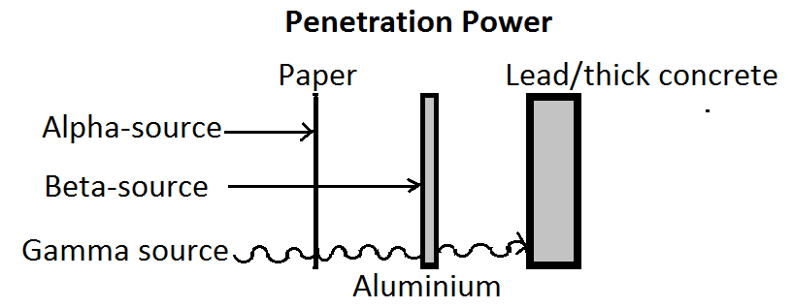
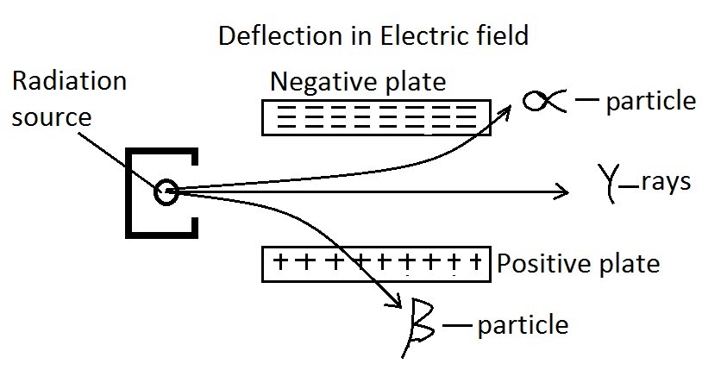

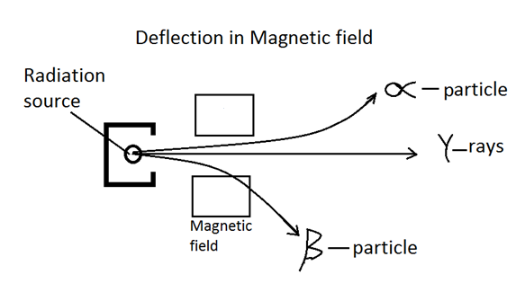
HALF – LIFE
- Half – life is the time taken for half of the radioactive material to decay.
Or
- Half – life is time taken for half of the number of radioactive nuclei present to decay.
Or
- Half – life is the time taken for the activity of any given sample to fall to half its original value.
- Activity is the average number of nuclear disintegrations per second of a radioactive substance. Activity is measured in a unit called Becquerel with the symbol Bq.
$$1 Bq=1 decay or 1 disintegration per second.$$
- For example radium – 226 has a half – life of 1600 years, polonium – 218 has a half-life of 3 minutes and radon – 220 has a half – life of 54 seconds.
If we plot a graph of activity against time taken for a radioactive sample, the graph will generally look as follows:
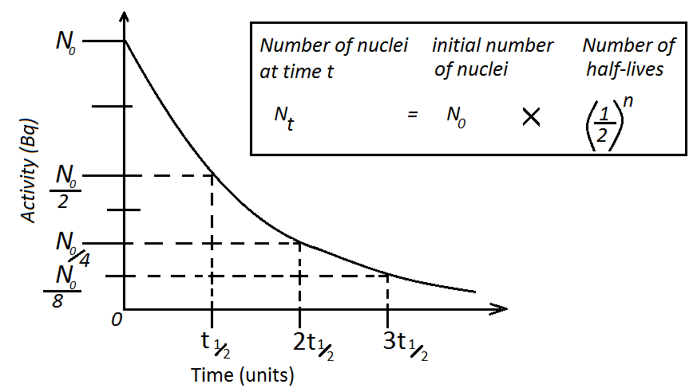
PRACTICAL EXAMPLES ON DECAY CURVE
In an experiment to measure the decay of a radioactive source the following results are taken over an 8 minute period.
Time (min) | 0 | 1 | 2 | 3 | 4 | 5 | 6 | 7 | 8
Count rate (per min) | 850 | 680 | 544 | 435 | 348 | 278 | 219 | 175 | 140

- Plot a graph of count rate against time?
- From the graph find half-life of the radioactive source?
- What is the count rate at the time$6∙2 min.$
Solution
- The graph is on the next page.
- The half – life of the radioactive sample is found as follows:
$$half-life is time when count rate=\frac{N_{0}}{2}=\frac{850}{2}=425 per min$$
$$∴half-life of the sample is 3∙1\min{as shown in the graph.}$$
- What is the count rate at the time$6∙2 min.$
$$when the time is 6∙2 min, the count rate=210 per\min{as shown in the graph.}$$

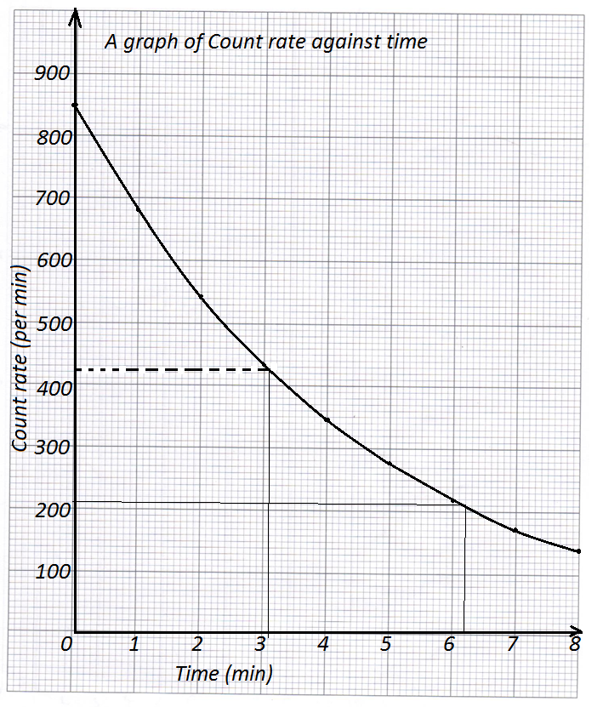

CALCULATION INVOLVING HALF – LIFE
SOME OF THE IMPORTANT FORMULAE INVOLVING HALF – LIFE CALCULATION

- $If initial nuclei is N_{0} or Initial activity is A_{0} then$
$$N_{0} after 1st half-life reduces to \frac{N_{0}}{2} after 2nd half-life reduces to \frac{N_{0}}{4}$$
$after 3rd half-life reduces to \frac{N_{0}}{8} after 4th half-life reduces to \frac{N_{0}}{16}$
$$\left(N_{0}\overset{→}{{ t}_{1/2 }}\frac{N_{0}}{2}\overset{→}{{ 2t}_{1/{2 }}}\frac{N_{0}}{4}\overset{→}{{ 3t}_{1/2} }\frac{N_{0}}{8}\overset{→}{{ 4 t}_{1/2} }\frac{N_{0}}{16}\right)$$

$$A_{0} after 1st half-life reduces to \frac{A_{0}}{2} after 2nd half-life reduces to \frac{A_{0}}{4}$$
$after 3rd half-life reduces to \frac{A_{0}}{8} after 4th half-life reduces to \frac{A_{0}}{16}$
$$\left(A_{0}\overset{→}{{ t}_{1/2 }}\frac{A_{0}}{2}\overset{→}{{ 2 t}_{1/{2 }}}\frac{A_{0}}{4}\overset{→}{{ 3 t}_{1/2} }\frac{A_{0}}{8}\overset{→}{{ 4 t}_{1/2} }\frac{A_{0}}{16}\right)$$

- $Number of nuclei at time t=initial number of nuclei ×number of half-lives$
Or
$$activity at time t=initial activity×number of half lives$$
$$N_{t} = { N}_{0} × {\left(\frac{1}{2}\right)}^{\frac{t}{t_{1/2}}}$$

- $fraction remaining=\frac{N_{t}}{{ N}_{0}} or {\left(\frac{1}{2}\right)}^{\frac{t}{t_{1/2}}} \overset{⇒}{ } \frac{N_{t}}{{ N}_{0}}={\left(\frac{1}{2}\right)}^{\frac{t}{t_{1/2}}}$

- $fraction decayed=\frac{N_{0}-N_{t}}{{ N}_{0}}$

- $rate of radioactive decay=\frac{-∆N}{∆t}$

EXAMPLE 1
A radioactive element has a half – life of 5 minutes.
- If the initial count rate measuring the intensity of radiation given out is 624 per minute. How long does it take to reach a count rate of 39 per minute?
- What fraction of the original number of the atoms is left?
Solution

1st method  - Initial count rate, $N_{0}=624 per min$  - After 1st half – life ( 5min)  $count rate=\frac{N_{0}}{2}=\frac{624}{2}=312 per min$  - After 2nd half – life (10 min)  $$count rate=\frac{N_{0}}{4}=\frac{624}{4}=156 per min$$  - After 3rd half – life (15 min)  $$count rate=\frac{N_{0}}{8}=\frac{624}{8}=78 per min$$  - After 4th half – life (20 min)  $$count rate=\frac{N_{0}}{16}=\frac{624}{16}=39 per min$$  $$∴it takes 20\min{to reach a count rate}$$  $$of 39 per minute$$ | 2nd method  $$N_{0}=624 per min, N_{t}=39 per min$$  $$t_{\frac{1}{2}}=5 min, t=?$$  $$\frac{N_{t}}{N_{0}}={\left(\frac{1}{2}\right)}^{\frac{t}{t_{\frac{1}{2}}}}$$  $$\frac{39}{624}={\left(\frac{1}{2}\right)}^{\frac{t}{5}}$$  $$\frac{1}{16}={\left(\frac{1}{2}\right)}^{\frac{t}{5}}$$  $${\left(\frac{1}{2}\right)}^{4}={\left(\frac{1}{2}\right)}^{\frac{t}{5}}$$  $$\frac{t}{5}=4 (since bases are the same)$$  $$∴t=5×4$$  $$Hence, t=20 min$$

1 st method  $half-life=5 min, t=20 min$  - After 1st half – life ( 5min)  $fraction remaining=\frac{1}{2}$  - After 2nd half – life (10 min)  $$fraction remaining=\frac{1}{4}$$  - After 3rd half – life (15 min)  $$fraction remaining=\frac{1}{8}$$  - After 4th half – life (20 min)  $$fraction remaining=\frac{1}{16}$$ | 2 nd method  $$t_{\frac{1}{2}}=5min,{ } t=20 min$$  $$fraction remaining={\left(\frac{1}{2}\right)}^{\frac{t}{t_{1/2}}}$$  $$fraction remaining={\left(\frac{1}{2}\right)}^{\frac{20}{5}}$$  $$fraction remaining={\left(\frac{1}{2}\right)}^{4}=\frac{1}{16}$$  Or  $$N_{0}=624 N_{t}=39$$  $$fraction remaining=\frac{N_{t}}{N_{0}}=\frac{39}{624} =\frac{1}{16}$$

EXAMPLE 2
An iodine isotope was found to have an activity of 200 Bq. 75 minutes later the activity had reduced to 25 Bq. What is the half – life of this iodine?
Solution
1st method  We need to find the number of halves from 200Bq to 25Bq, and then divide total time by number of halves.  - Initial activity, $A_{0}=200 Bq$  - After 1st half – life $activity=\frac{200 Bq}{2}= 100 Bq$  - After 2nd half – life $activity=\frac{100 Bq}{2}= 50 Bq$  - After 3rd half – life $activity=\frac{50 Bq}{2}= 25 Bq$  - This implies that there are 3 halves.  $$half-life=\frac{total time}{number of halves}$$  $$∴half-life=\frac{75min}{3}=25 min$$ | 2nd method  $$A_{t}=25Bq, { A}_{0}=200Bq and$$  $$t=75 min$$  $$\frac{A_{t}}{{ A}_{0}}={\left(\frac{1}{2}\right)}^{\frac{t}{t_{1/2}}}$$  $$\frac{25}{200}={\left(\frac{1}{2}\right)}^{\frac{75}{t_{1/2}}}$$  $$\frac{1}{8}={\left(\frac{1}{2}\right)}^{\frac{75}{t_{1/2}}}$$  $${\left(\frac{1}{2}\right)}^{3}={\left(\frac{1}{2}\right)}^{\frac{75}{t_{1/2}}}$$  $$3=\frac{75}{t_{1/2}}$$  $$3×t_{1/2}=75$$  $$t_{1/2}=\frac{75 min}{3}$$  $${∴t}_{1/2}=25 min$$

EXAMPLE 3
A radioactive substance has decayed to$\frac{1}{128}th$ of its original activity after 49 days. What is its half – life?
Solution
1st method  We need to find the number of halves from initial activity to its fraction of$\frac{1}{128}$, and then divide total time by number of halves.  - After 1st half – life $fraction remaining=\frac{1}{2}$  - After 2nd half – life $fraction remaining=\frac{1}{4}$  - After 3rd half – life $fraction remaining=\frac{1}{8}$  - After 4th half – life $fraction remaining=\frac{1}{16}$  - After 5th half – life $fraction remaining=\frac{1}{32}$  - After 6th half – life $fraction remaining=\frac{1}{64}$  - After 7th half – life $fraction remaining=\frac{1}{128}$  - This implies that there are 7 halves.  $$half-life=\frac{total time}{number of halves}$$  $$∴half-life=\frac{49 days}{7}=7 days$$ | 2nd method  $$t=49 days$$  $$\frac{A_{t}}{{ A}_{0}}={\left(\frac{1}{2}\right)}^{\frac{t}{t_{1/2}}}$$  $$\frac{1}{128}={\left(\frac{1}{2}\right)}^{\frac{49}{t_{1/2}}}$$  $${\left(\frac{1}{2}\right)}^{7}={\left(\frac{1}{2}\right)}^{\frac{49}{t_{1/2}}}$$  $$7=\frac{49}{t_{1/2}}$$  $$7×t_{1/2}=49$$  $$t_{1/2}=\frac{49 days}{7}$$  $${∴t}_{1/2}=7 days$$

EXAMPLE 4
Carbon – 14 has a half –life of 5 730 years. Suppose in 2 000 we buried 15 kg of Carbon – 14 somewhere and someone digs it up in the year 13 460. How much Carbon – 14 would they find?
Solution
$$time at the beginning was the year 2000, initial mass=15 kg$$
$$after 1st half-life, \left(2000+5730=yr 7730\right), mass remaining=\frac{1}{2}×15kg=7∙5kg$$
$$after 2nd half-life, \left(7730+573=yr13460\right), mass remaining=\frac{1}{4}×15kg=3∙75kg$$
$$∴they would find 3∙75 kg$$
DETECTION AND IDENTIFICATION OF NUCLEAR RADIATION
Some of the instruments that are used to detect radiation or radioactivity are photographic plate, Geiger Muller tube, scintillation counter, electroscope, spark counter, cloud chamber, ionization detector, etc.
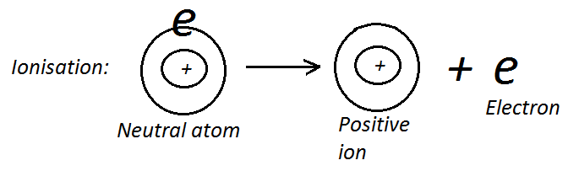
- PHOTOGRAPHIC PLATES
Photographic films become “fogged” or darkened when alpha particles, beta particles or gamma rays strike them. Thus, they are used to detect these particles and rays. The type of ionization that results when photosensitive material is exposed to radiation blackens the emulsion when the material is developed.
- GEIGER MULLER TUBE (G-M TUBE)
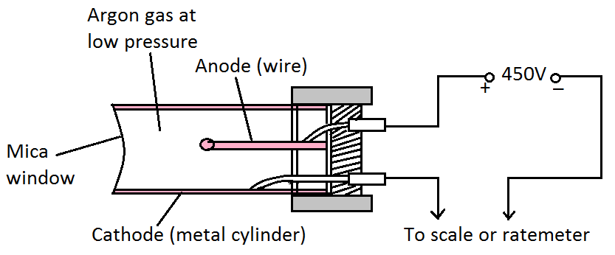
Radiation enters the G-M tube through the mica window. When radiation enters the G-M tube it causes ionization of argon gas. The electrons are attracted to the positive rod (anode) while positive (argon) ions are attracted to the tube walls (cathode). A high voltage spark across the gas is produced when the gas is ionized. This results in a pulse of current which then flows in the circuit. This current is fed into the a rate meter/scale which shows how many particles enter a tube every second or is fed to an amplifier and speaker which clicks every time a particle enters the tube. G-M tube is usually used to control thickness of papers, plastics and metal sheet during manufacturing.
- SCINTILLATION COUNTER
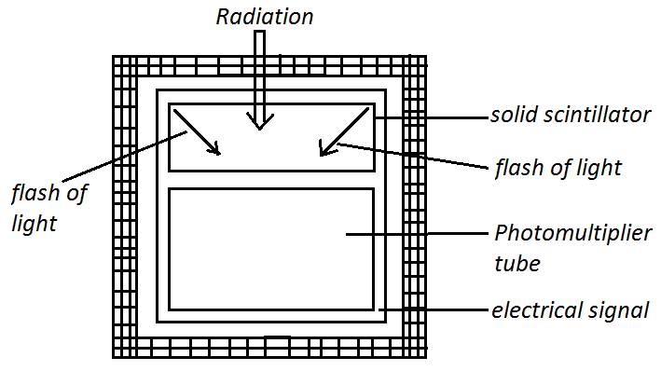
This is a device that uses materials such as sodium iodide which produces flashes of light (scintillates) when it is heated by radiation. The flashes of light produced are detected by a photomultiplier tube which converts the flashes of light to a flow of electricity. A microscope placed in contact with photomultiplier aids us to see the flashes of light.
- ELECTROSCOPE
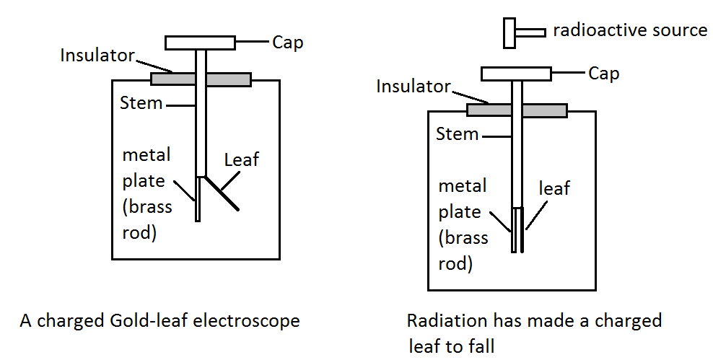
When the source of radiation or a flame is brought near the cap of a charged leaf electroscope, the air around the cap becomes ionized. Ions with a charge opposite to that on the electroscope move (from the air) to the cap, thereby neutralizing the charge on the cap. The leaf on the electroscope falls.
- SPARK COUNTER
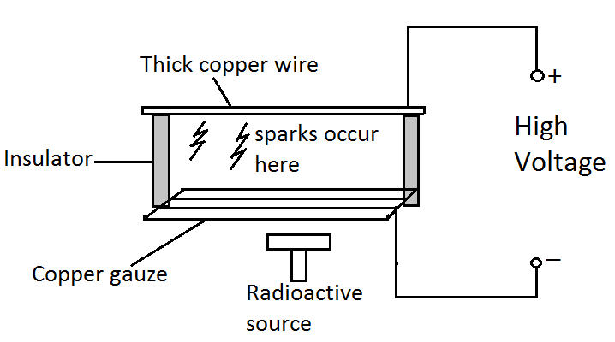
The spark counter has metal base gauze and a thick copper wire which are separated by insulators. The two are connected to a high supply voltage. A high voltage is applied between the metal gauze and the copper wire until sparks are produced. Thereafter voltage is reduced until sparking stops. At this moment when a radioactive source is brought closer to the wire, the radiation cause ionization of the air molecules between the wire and metal gauze causing sparks in the process. This method is more effective with alpha radiation as it cause more ionization.
- CLOUD CHAMBER
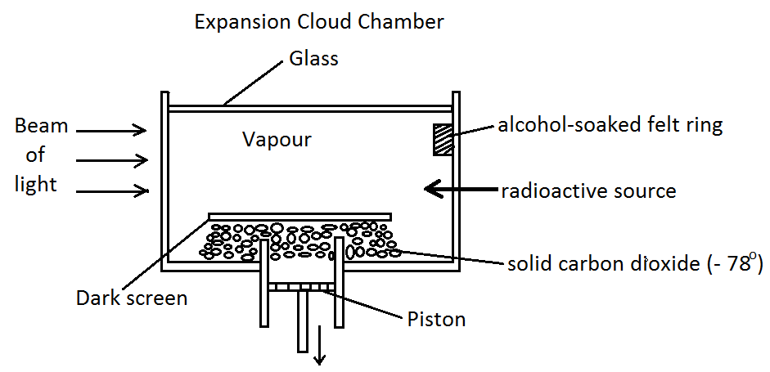
There are two types of cloud chamber which are expansion cloud chamber and diffusion cloud chamber.
A cloud chamber contains a gas cooled to a temperature below its usual condensation point (point at which it becomes a liquid). When a radioactive substance is put inside the chamber, droplets of gas condense around the radioactive particles. The droplets formed around the particles of radiation in a cloud chamber leave a trail that shows up along the chamber lining. Different types of radiation leave different forms of trails. For example alpha particles leave a short fat trail, whereas beta particles leave a long and thin trail. The cooling is produced continuously by solid carbon dioxide at the base of the chamber.
- IONISATION DETECTOR
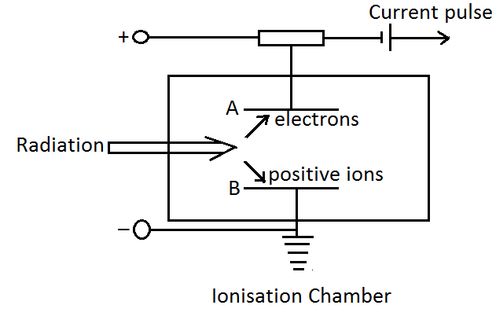
When ionization occurs in air, the air becomes electrically conductive. When radiation enters the ionization chamber through the small window, it causes the ionization of the air molecules in the chamber. The electrons are attracted to the positively charged plate while the positively charged ions are attracted to the negatively charged plate. A current is generated in the circuit that is registered by the sensitive ammeter. The current indicates the presence of radiation in the chamber.
NUCLEAR REACTIONS
- Nuclear fusion
Nuclear fusion is a nuclear reaction in which lighter nuclei “combine” (fuse) together to produce a heavy nucleus releasing energy in the process. Examples of nuclear fusion are reactions of isotopes of hydrogen.
$$Deuterium+Tritium \overset{→}{ } Helium+neutron+energy$$
$${}_{1}^{2}H + {}_{1}^{3}H\overset{→}{ } {}_{2}^{4}{He} + {}_{0}^{1}n + energy$$
$${}_{1}^{2}H + {}_{1}^{2}H\overset{→}{ } {}_{2}^{3}{He} + {}_{0}^{1}n + energy$$

Nuclear fusion reaction takes place at a very high temperature to overcome the repulsive forces of the positively charged nuclei which fuses. Fusion is believed to be the source of the sun’s energy. To use the high energy produced by fusion directly on earth requires careful control of the fusion process.
- Nuclear fission
Nuclear fission is a nuclear reaction in which heavier nuclei are broken into lighter ones and energy is given out. Example of a nuclear fission reaction is bombarding of Uranium – 235 with a neutron.
$${}_{92}^{235}U + {}_{0}^{1}n\overset{→}{ } {}_{56}^{144}{Ba} + {}_{36}^{90}{Kr} +2 {}_{0}^{1}n + energy$$
The two neutrons produced hit and split two other Uranium – 235 nuclides to produce 4 neutrons. The 4 neutrons in turn hit and split 4 nuclides to produce 8 neutrons. This process continues as before releasing large amount of energy. This kind of reaction is called chain reaction. If chain reaction is not controlled it results in atomic bomb. The chain reaction process is controlled by neutron absorbing Boron steel rods. Graphite is also used to slow down the chain reaction. Controlled nuclear fission is used to generate electricity in a nuclear reactor.
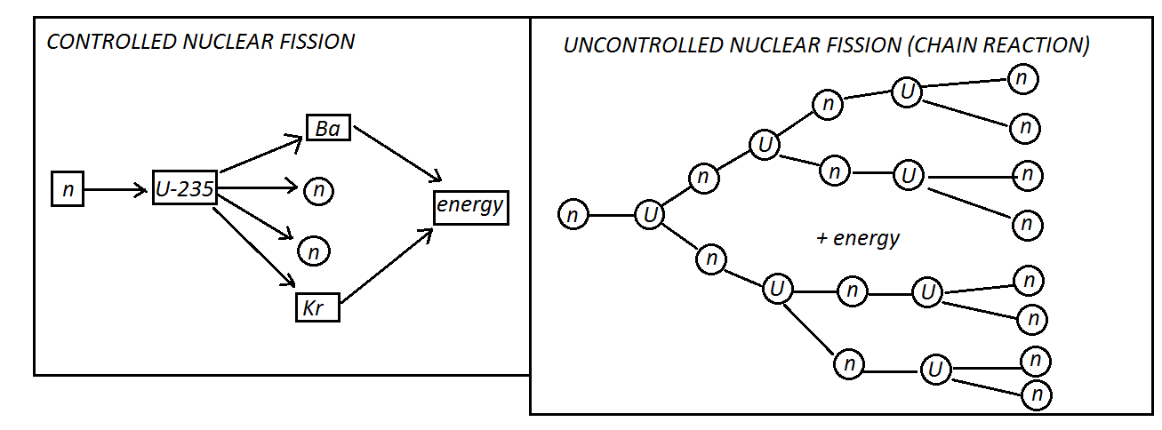

NUCLEAR ENERGY
When nucleons that is protons and neutrons are bound together or separated apart, the resulting nucleus has a mass slightly less than that of the total initial nucleus. This difference of mass is radiated as enormous energy according to Einstein equation:
$$E=mc^{2} where E=energy in Joules, m=mass in kg and c=velocity of light in m/s$$
APPLICATION OF NUCLEAR RADIATION
- Archaeology
In carbon dating archaeologists uses the idea of half – life to determine the age of dead organisms.
- Medical applications

- Treatment of cancer and tumor for example$γ-rays$from radium.
- For investigation of thyroid gland for example Iodine – 151.
- For diagnosis of circulatory problems for example sodium – 24.
- For sterilization of surgical instruments for example Cobalt – 60.

- Industrial applications

- For examining wear in machinery.
- Radioactive isotopes can be added to fluids in pipelines in an industrial plant to determine the flow rate of the fluid and to detect leakage/breakage in the pipes.
- For measuring thickness of plastic film and paper.
- For stopping flow of liquid or powder in machinery.

- In agriculture

- Obtaining information about animals or plant nutrition. For example radioactive phosphorus is used as a tracer to show how well plants are absorbing phosphorus.
- To sterilize male insects thus reducing insect population.

- Power generation
Nuclear power stations use carefully controlled chain reactions to produce heat energy. The heat energy produced is used to boil water to make steam at high pressure. The steam at high pressure is then used to rotate or drive turbines for power generation.
- Food preservation
Gamma radiation can be used to kill bacteria in order to preserve food.
DANGERS/HAZARDS OF RADIATION
- Sterility: radiation can interfere with the production of proteins and other essential cellular material in the body cells. The results may be death of the cell especially the reproductive cells.
- Too much exposure to radiation or stronger doses can cause skin burns, loss of hair, ulceration and redness of the skin.
- Large doses can cause long term and delayed effects like cancer, eye cataract and genetic change leading to heredity defects.
- When human body is exposed to radiation, the radiation can cause ionization of molecules in the body and the body cells may be killed in the process.
SAFETY PRECAUTIONS WHEN HANDLING RADIOACTIVE SUBSTANCES
- Weak sources should be handled with forceps always.
- Never handle a radioactive substance with bare hands and held near the eyes.
- Radioactive materials should be kept in their boxes when not in use.
- Sources should be handled so that they point away from the body.
- After holding sources, wash hands before handling anything else.
- In industries sources are handled with long tongs and transported in thick lead containers.
- In industries very thick concrete walls are used to contain radiation.
- In industries workers should be protected by lead and concrete walls and should wear radiation dose badges to constantly check the amount of radiation they are being exposed to.

